FOR THE MEDIA
ASMPT introduces pick & place system DALA for all camera module components
Ideal Solution for Sensing and Imaging Applications
Singapore, March 24, 2026 – ASMPT, a global leader in semiconductor and electronics manufacturing hardware and software, introduces DALA, its latest pick and place system for all camera module components. With a modular structure and cutting-edge quality bonding solutions, DALA offers flexibility, ensuring consistent quality while optimizing the total cost of ownership through efficient practices and adaptable in-line processes. Its advanced features position it as the preferred choice for today's leading-edge AI consumer sensing and imaging applications.
Best solution for all camera module components
DALA emerges as a versatile solution catering to a wide array of camera module components, serving applications in consumer sensing and imaging, like smartphone cameras, smart electronics sensors, and automotive technologies such as ADAS. Featuring a modular structure that emphasizes adaptability for process and package conversions, DALA offers diverse dispensing systems and material input options, and effortlessly adjusts to various production needs with its different bonding modes. This fully automated system excels in tasks ranging from die, lens holder, or glass attachment, achieving precise bonding accuracy of ±7 µm, setting a new standard in its class. DALA stands out as the dependable choice for all pick-and-place tasks related to camera module components in consumer sensing and imaging applications.
Seamless integration with CMOS image sensor packaging inline
ASMPT leads the industry in delivering complete manufacturing solutions for CMOS image sensor packaging. DALA seamlessly integrates into ASMPT Smart COB Inline, a specialized chip-on-board (COB) inline solution designed for packaging CMOS image sensors. DALA plays a critical role within this system, managing high-precision die attachment at the beginning of the inline process and acting as the lens holder attach bonder at the conclusion of operations. This pivotal position establishes DALA as a core component within the complete COB Packaging Process, guaranteeing efficiency and precision across the assembly line.

Illustrations for downloading
The following print-ready artwork is available on the internet for downloading:
https://kk.htcm.de/press-releases/asmpt/

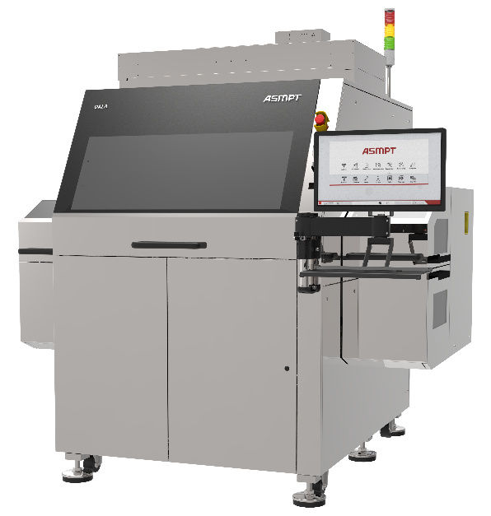
DALA, universal pick-and-place system for camera-module assembly, handling all components – from die and lens holder attachment to glass bonding – with high precision and flexibility for efficient imaging and sensing system production.
Image credit: ASMPT

About ASMPT Limited (“ASMPT”)
ASMPT Limited is a leading global supplier of hardware and software solutions for the manufacture of semiconductors and electronics. Headquartered in Singapore, ASMPT’s offerings encompass the semiconductor assembly & packaging, and SMT (surface mount technology) industries, ranging from wafer deposition to the various solutions that organise, assemble and package delicate electronic components into a vast range of end-user devices, which include electronics, mobile communications, computing, automotive, industrial and LED (displays). ASMPT partners with customers very closely, with continuous investment in R&D helping to provide cost-effective, industry-shaping solutions that achieve higher productivity, greater reliability, and enhanced quality. ASMPT is also a founding member of the Semiconductor Climate Consortium.
To learn more about ASMPT, please visit us at asmpt.com.

About ASMPT Semiconductor Solutions (“ASMPT SEMI”)
ASMPT SEMI is the leading supplier in advanced packaging and semiconductor assembly solutions. With a commitment to innovation and customer satisfaction, ASMPT SEMI provides a comprehensive range of products and services that cater to the evolving needs of the microelectronics industry. Their expertise spans across areas such as flip-chip and wafer-level packaging, advanced interconnect technologies, and more. ASMPT SEMI's cutting-edge solutions enable customers to achieve higher performance, increased reliability, and improved cost-efficiency when producing their semiconductor devices.
ASMPT SEMI sees itself as a pioneer and driving force of the Intelligence Revolution. With its advanced packaging and assembly technologies, the business segment creates the invisible connections that enable intelligent applications in Artificial Intelligence, Smart Mobility and Hyperconnectivity.
For more information about ASMPT SEMI, visit semi.asmpt.com.

Media contacts:
Global ASMPT Semiconductor Solutions Press Office
ASMPT Limited
Jessica Ho
Semiconductor Solutions
E-Mail: semi_stratmkt@asmpt.com
Website: semi.asmpt.com

Global ASMPT Press Office
ASMPT Limited
Susanne Oswald
Rupert-Mayer-Strasse 48
81379 Munich
Germany
Phone: +49 89 20800-26439
E-Mail: susanne.oswald@asmpt.com
Website: asmpt.com

