PRESS RELEASE

Würth Elektronik and Grinn cooperate in the field of edge AI solutions
Faster to market maturity for IoT edge computing
Waldenburg (Germany), Wrocław (Poland), March 11, 2026 – Würth Elektronik and embedded systems developer Grinn announce their collaboration at embedded world 2026. The first product of this collaboration, the Grinn GenioBoard - Edge AI SBC single-board computer, will be on display at booth 110 in hall 2. This board for edge AI in the IoT is now available from Würth Elektronik. With this offering, Würth Elektronik is positioning itself as a competent partner for product development in the field of edge AI. This includes matching products, design tools, and consulting on topics such as EMC, temperature management, sensors, wireless communication, power supply, and cyber security.
The Grinn GenioBoard - Edge AI SBC is a powerful starting point for developing local instances of artificial intelligence with a focus on computer vision. The following use cases illustrate the potential: remote monitoring and control with AI-supported person and/or object detection, computer vision for robotics applications in industry, and HMI with gesture recognition.
Powerful and energy-efficient
To support security-critical applications, the Grinn GenioBoard features Infineon’s OPTIGA™ Trust M SLS32AIA010M security module. As a CPU system-on-module with integrated NPU and GPU, the GenioSOM-700 uses the MediaTek MT8390 platform. The GenioBoard offers an M.2 M-Key slot for AI accelerators such as the DEEPX DX-M1 M and an M.2 E-Key slot for cellular, Wi-Fi, and wireless modules. Würth Elektronik will offer three dedicated M.2 modules for LTE, Wi-Fi, and Bluetooth, as well as matching antennas. Prototypes already available today provide a glimpse of these powerful solutions. In addition, a sensor board will be available for the 40-pin GPIO header, allowing pressure, acceleration, temperature, and humidity sensors to be evaluated quickly and easily.
Strong partnership
"Through our collaboration with Grinn, we are becoming an edge AI design enabler. Whether EMC, power supply, thermal management, wireless, sensors, or cybersecurity – we combine all key competencies under one roof and support our customers on the entire journey from idea to production-ready end product," explains Alexander Gerfer, CTO at the Würth Elektronik eiSos Group. "In Grinn, we have a strong partner that has been developing pioneering systems for 18 years, with a commitment to quality and service orientation that fits us."
"With our Genio Systems-on-Modules and the development board, which can be seen at the Würth Elektronik booth at embedded world, developers can typically reduce the time from concept to finished product by twelve months. The support provided by Würth Elektronik will make it even easier for companies to implement robust, durable IoT solutions with intelligent peripherals," says Robert Orteba, CEO at Grinn sp. z o.o. "We are delighted to have found a strong and highly renowned partner in Würth Elektronik."

Available images
The following images can be downloaded from the Internet in printable quality: https://kk.htcm.de/press-releases/wuerth/
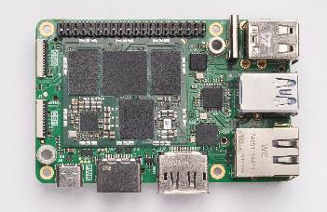  Image source: Grinn sp. z o.o.  The Grinn GenioBoard - Edge AI SBC single-board computer is now available from Würth Elektronik. | 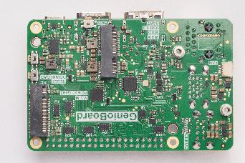  Image source: Grinn sp. z o.o.  Rear view of the Grinn GenioBoard - Edge AI SBC.
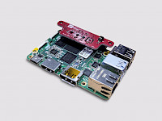  Image source: Grinn sp. z o.o.  Expansion example with a sensor from Würth Elektronik on the Grinn GenioBoard - Edge AI SBC. | 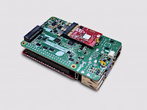  Image source: Grinn sp. z o.o.  Würth Elektronik now offers its wireless modules as M.2 modules so that they can expand the Grinn GenioBoard - Edge AI SBC.

About GRINN sp. z o.o.
Grinn is a full-cycle technology company specializing in the design and development of advanced IoT and embedded solutions. From initial concept to production, Grinn offers comprehensive services in hardware design, embedded software development, mechanical engineering, and manufacturing support. With its own laboratory, state-of-the-art testing equipment, and experienced engineering teams, Grinn ensures that every product meets the highest standards of performance, reliability, and safety. Grinn specializes in edge AI solutions for IoT, robotics, industrial systems, HMI, computer vision, security, and high-performance AI applications, enabling intelligent real-time decisions at the device level.
Through strong partnerships with leading global semiconductor manufacturers and its commitment to technical excellence, Grinn delivers innovative, scalable, and market-ready solutions to companies around the world.
For more information, visit: www.grinn-global.com

About the Würth Elektronik eiSos Group
Würth Elektronik eiSos Group is a manufacturer of electronic and electromechanical components for the electronics industry and a technology company that spearheads pioneering electronic solutions. Würth Elektronik eiSos is one of the largest European manufacturers of passive components and is active in 50 countries. Production sites in Europe, Asia and North America supply a growing number of customers worldwide.
The product range includes passive components, power modules, digital isolators, optoelectronics, electromechanical components, thermal management solutions, sensors and wireless modules. The portfolio is rounded off by customer-specific solutions.
The unrivaled service orientation of the company is characterized by the availability of all catalog components from stock without minimum order quantity, free samples and extensive support through technical sales staff and selection tools.
Würth Elektronik is part of the Würth Group, the global market leader in the development, production, and sale of fastening and assembly materials, and employs around 7,300 people. In 2025, the Würth Elektronik Group generated sales of 1.06 Billion Euro.
Würth Elektronik: more than you expect!
Further information at www.we-online.com

Further information:  Würth Elektronik eiSos GmbH & Co. KG  Sarah Hurst  Clarita-Bernhard-Strasse 9  81249 Munich  Germany  Phone: +49 7942 945-5186  E-mail: sarah.hurst@we-online.de  www.we-online.com | Press contact:  HighTech communications GmbH  Brigitte Basilio  Brunhamstrasse 21  81249 Munich  Germany  Phone: +49 89 500778-20  E-mail: b.basilio@htcm.de  www.htcm.de

