PRESS RELEASE

Würth Elektronik presents new radio module variants
Swiftly implemented or individually developed
Waldenburg (Germany), March 10, 2026 – With the Proteus-IV and Ophelia-IV components, Würth Elektronik presents two new high-performance RF modules based on the latest Nordic nRF54L15-SoC semiconductor. The two modules differ only in terms of their firmware: Proteus-IV is a ready-to-use Bluetooth low-energy 6.0 module with preinstalled firmware, while Ophelia-IV is a flexible developer platform without a specific preinstalled firmware. Individual firmware options for a variety of radio protocols, including proprietary ones, can be developed using nRF Connect SDK and in the Zephyr RTOS (real-time operating system).
Measuring just 8 × 12 × 2.3 mm, the compact radio modules, equipped with a 1.5 MB flash and 256 KB RAM are based on the new nRF54L15 SoC from Nordic. This chip integrates a 128 MHz arm-cortex M33 processor, an RISC-V coprocessor, and a power-saving 2.4 GHz multiprotocol radio chip. The Bluetooth LE 6.0, Matter, Thread, Zigbee, NFC, and IEEE 802.15.4 radio protocols can be used, as can also proprietary 2.4 GHz protocols.
Bluetooth LE module with radio and Bluetooth certifications
Proteus-IV is a ready-to-use Bluetooth 6.0 LE module with preinstalled firmware. It supports all four Bluetooth LE roles (central, peripheral, broadcaster, and observer). The Bluetooth LE functions can be controlled via UART from an external host controller. Thanks to its adaptable functions, integrators can fine-tune a variety of parameters, for example Multiconnect, central and peripheral roles, Bluetooth security modi, UART settings, and Bluetooth connection parameters.
Development freedom
While the Proteus-IV module has been specifically developed to be integrated into ready-for-market products as swiftly as possible, the Ophelia-IV module is conceived as a robust basis for the development of user-defined firmware. With this module, Zephyr RTOS can be used to develop highly specialized networked components for an IoT infrastructure. An important aspect here is the module’s low power input: the transmission of 1 mbps at a transmission power of +8 dBm consumes just 10.0 mA, the reception of the same data rate a mere 3.2 mA, and in the standby mode the power uptake is only 0.8 μA. This aspect makes the Proteus-IV and Ophelia-IV modules particularly interesting for battery-operated devices. With an operating temperature range from -40°C up to +105°C, this new generation of radio modules is very robust. The modules are very versatile regarding their power supply, since they can operate at voltages ranging from 1.7 up to 3.6 V.
“Ophelia-IV is ideal for standalone operation since the microcontroller on the chip can also host the end-use application,” explains Ravindra Singh, Product Manager in the Wireless Connectivity & Sensors division at Würth Elektronik eiSos. “As a certified module, Proteus-IV shortens the time-to-market and cuts the costs of the end device considerably. Both Ophelia-IV and Proteus-IV use the WLCSP version of the Nordic chipset, which helps to reduce the modules’ dimensions to a minimum, thus making them suitable for applications where space is at a premium.“

Available images
The following images can be downloaded from the Internet in printable quality: https://kk.htcm.de/press-releases/wuerth/
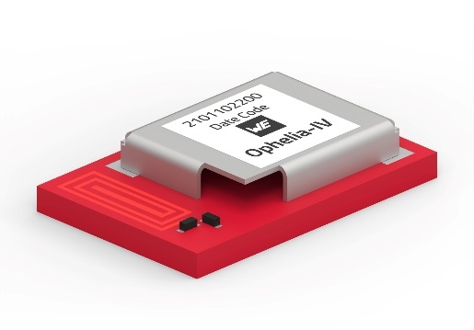  Image source: Würth Elektronik  Ophelia-IV: flexible developer platform without preinstalled firmware | 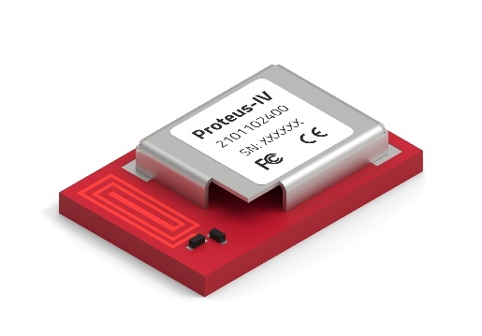  Image source: Würth Elektronik  Proteus-IV: Bluetooth low-energy module with preinstalled firmware

About the Würth Elektronik eiSos Group
Würth Elektronik eiSos Group is a manufacturer of electronic and electromechanical components for the electronics industry and a technology company that spearheads pioneering electronic solutions. Würth Elektronik eiSos is one of the largest European manufacturers of passive components and is active in 50 countries. Production sites in Europe, Asia and North America supply a growing number of customers worldwide.

The product range includes passive components, power modules, digital isolators, optoelectronics, electromechanical components, thermal management solutions, sensors and wireless modules. The portfolio is rounded off by customer-specific solutions.
The unrivaled service orientation of the company is characterized by the availability of all catalog components from stock without minimum order quantity, free samples and extensive support through technical sales staff and selection tools.
Würth Elektronik is part of the Würth Group, the global market leader in the development, production, and sale of fastening and assembly materials, and employs around 7,300 people. In 2025, the Würth Elektronik Group generated sales of 1.06 Billion Euro.
Würth Elektronik: more than you expect!
Further information at www.we-online.com

Further information:  Würth Elektronik eiSos GmbH & Co. KG  Sarah Hurst  Clarita-Bernhard-Strasse 9  81249 Munich  Germany  Phone: +49 7942 945-5186  E-mail: sarah.hurst@we-online.de  www.we-online.com | Press contact:  HighTech communications GmbH  Brigitte Basilio  Brunhamstrasse 21  81249 Munich  Germany  Phone: +49 89 500778-20  E-mail: b.basilio@htcm.de  www.htcm.de

