FOR THE MEDIA
ASMPT at OFC 2026 Los Angeles
Enabling scalable co-packaged optics and photonic integration
Billerica (USA), March 10, 2026 – ASMPT will exhibit at the Optical Fiber Communication Conference and Exhibition (OFC) from March 17–19, 2026, at Booth #221 at the Los Angeles Convention Center. Under the theme “Empower the Intelligence Revolution,” ASMPT will present advanced bonding solutions designed to support the next generation of co-packaged optics (CPO), silicon photonics, and high-density optical modules: AMICRA NANO, the sub-micron precision bonding solution for co-packaged optics assembly, AMICRA NOVA, the high-speed photonics bonding solution, and MEGA, the automatic high-precision multi-chip bonding solution.
As AI-driven applications and cloud infrastructures continue to accelerate data traffic, optical interconnect technologies must deliver higher bandwidth and lower latency. At OFC, ASMPT demonstrates how precision automation enables scalable, reliable, and high-throughput assembly of photonic and optoelectronic devices for data centers and telecommunications networks. “As data demands grow and networks scale, co-packaged optics is redefining high-speed connectivity. ASMPT drives this evolution with precision automation that delivers scalability, energy efficiency, and ultra-low latency for next-generation computing in the era of AI and hyperconnectivity,” says Dr. Johann Weinhändler, Managing Director of ASMPT AMICRA and Regional Head, ASMPT Semiconductor Solutions Europe. “We will present three bonding platforms that are already enabling advanced CPO manufacturing and high-precision photonic integration.”
Sub-micron accuracy for co-packaged optics
AMICRA NANO is ASMPT’s ultra-precision die-bonder engineered for applications requiring sub-micron placement accuracy of ±0.2 µm. Its die-bonding and flip-chip capabilities enable highly accurate integration of optical and electronic components — a critical requirement for high-speed optical transceivers and co-packaged optics (CPO) modules. By ensuring exceptional placement stability and repeatability, AMICRA NANO supports the production of ultra-high-bandwidth, low-loss interconnects used in AI accelerators and advanced data center architectures. The platform provides a reliable foundation for precision assembly in silicon photonics and CPO environments where alignment tolerances are extremely tight.
High-throughput bonding for silicon photonics
For applications requiring higher throughput, ASMPT offers the AMICRA NOVA high-speed photonics bonding solution. The system is designed for fast and reliable bonding of co-packaged optics, silicon photonics devices, and VCSEL components, as well as for the assembly of photodiodes (PDs) and optical transceivers. With placement accuracy of ±1 µm, AMICRA NOVA utilizes fibre-laser technology for high-speed gold-tin (AuSn) eutectic bonding. Dynamic alignment, high-resolution imaging, and a vibration-damped granite base ensure stable and repeatable process performance. Optimized for production efficiency, AMICRA NOVA enables shorter cycle times and a high degree of automation, helping manufacturers scale photonic device production while maintaining precision and process reliability.
Flexible multi-chip integration for advanced photonic modules
Also on display at OFC is the highly versatile MEGA multi-chip bonding solution. MEGA uses patented look-through pattern recognition technology to ensure precise alignment and high-throughput integration of multiple chips. The system supports a wide range of multi-chip packages, including the assembly of complex photonic devices for data centers and telecommunications networks. It offers various epoxy dispensing and stamping functions, as well as the ability to process multiple adhesives simultaneously while monitoring their application with an integrated 3D inspection system. This combination of alignment capability, adhesive flexibility, and in-line inspection supports controlled and repeatable multi-chip assembly in advanced photonic packaging environments.

Illustrations for downloading
The following images are available for download in printable format at:
https://kk.htcm.de/press-releases/asmpt/
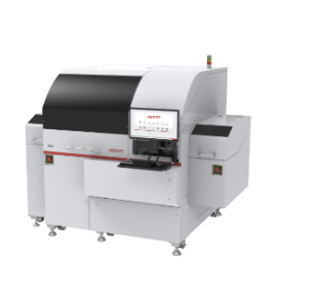 | 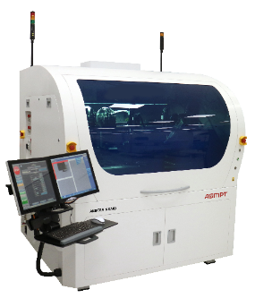
The MEGA’s customizable options meet the packaging requirements of sophisticated multi-chip components, making it the bonder of choice for optical transceivers, photonics, sensors, and other highly advanced applications.  Image credit: ASMPT | AMICRA NANO was the first bonding solutions in the industry to achieve a placement accuracy of< ± 0.2 μm at 3 sigma.  Image credit: ASMPT
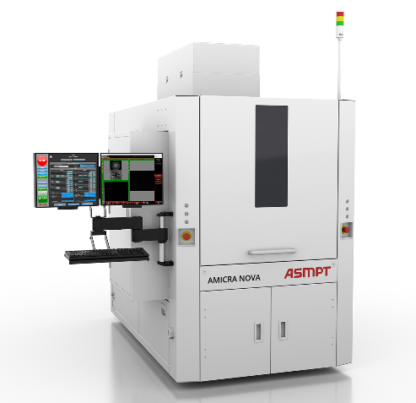
AMICRA NOVA combines high placement accuracy with short cycle times and innovative bonding technologies.

Image credit: ASMPT

About ASMPT Limited (“ASMPT”)
ASMPT Limited is a leading global supplier of hardware and software solutions for the manufacture of semiconductors and electronics. Headquartered in Singapore, ASMPT’s offerings encompass the semiconductor assembly & packaging, and SMT (surface mount technology) industries, ranging from wafer deposition to the various solutions that organise, assemble and package delicate electronic components into a vast range of end-user devices, which include electronics, mobile communications, computing, automotive, industrial and LED (displays). ASMPT partners with customers very closely, with continuous investment in R&D helping to provide cost-effective, industry-shaping solutions that achieve higher productivity, greater reliability, and enhanced quality. ASMPT is also a founding member of the Semiconductor Climate Consortium.
To learn more about ASMPT, please visit us at asmpt.com.

About ASMPT Semiconductor Solutions (“ASMPT SEMI”)
ASMPT SEMI is the leading supplier in advanced packaging and semiconductor assembly solutions. With a commitment to innovation and customer satisfaction, ASMPT SEMI provides a comprehensive range of products and services that cater to the evolving needs of the microelectronics industry. Their expertise spans across areas such as flip-chip and wafer-level packaging, advanced interconnect technologies, and more. ASMPT SEMI's cutting-edge solutions enable customers to achieve higher performance, increased reliability, and improved cost-efficiency when producing their semiconductor devices.
ASMPT SEMI sees itself as a pioneer and driving force of the Intelligence Revolution. With its advanced packaging and assembly technologies, the business segment creates the invisible connections that enable intelligent applications in Artificial Intelligence, Smart Mobility and Hyperconnectivity.
For more information about ASMPT SEMI, visit semi.asmpt.com.
Media contacts:
Global ASMPT Press Office
ASMPT Limited
Susanne Oswald
Rupert-Mayer-Strasse 48
81379 Munich
Germany
Phone: +49 89 20800-26439
E-Mail: susanne.oswald@asmpt.com
Website: asmpt.com

HighTech communications GmbH
Barbara Ostermeier
Brunhamstrasse 21
81249 Munich
Germany
Phone: +49-89 500778-10
E-Mail: b.ostermeier@htcm.de
Website: www.htcm.de

