PRESS RELEASE

IQD Frequency Products Ltd Earns Gold Medal from EcoVadis for Sustainability Performance
EcoVadis Rating validates IQD’s business sustainability commitments and performance
Crewkerne (UK), Waldenburg (Germany), March 3, 2026 – IQD, part of the Würth Elektronik eiSos Group, announced that it has achieved Gold medal status from EcoVadis, a global leader in business sustainability assessments.
IQD scored 82% placing the company in the top 3% of companies evaluated worldwide in the last 12 months. Key contributing factors in this success are the documented assessments of suppliers regarding environmental criteria, strong sustainable and ethical measures and procurement procedures.
The EcoVadis assessment evaluates 21 sustainability criteria across four core themes: Environment, Labor & Human Rights, Ethics and Sustainable Procurement. More than 130,000 companies globally have been rated by EcoVadis.
Jay Warnes, Quality Manager and Sustainability Lead at IQD said, “Achieving the EcoVadis Gold Medal demonstrates our dedication to ongoing improvement and enhances the visibility of our sustainability efforts with customers and partners.”
EcoVadis’ business sustainability ratings are based on international sustainability standards such as the Ten Principles of the UN Global Compact, the International Labour Organization (ILO) conventions, the Global Reporting Initiative (GRI) standards and the ISO 26000 standard. The ratings provide an evidenced-based analysis on performance and an actionable roadmap for continuous improvement.

Available images
The following images can be downloaded from the Internet in printable quality:
https://kk.htcm.de/press-releases/wuerth/

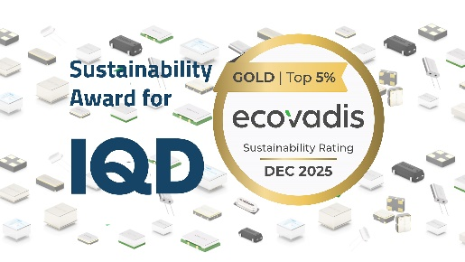Image source: IQD Frequency Products Ltd
EcoVadis Gold status for sustainability performance for IQD

About IQD
Backed by over 50 years’ experience in the manufacture of frequency products, IQD is a recognised market leader in the frequency control market and part of the Würth Elektronik eiSos Group, one of the leading European manufacturers of passive components. With active customers in over 80 countries, IQD offers one of the most comprehensive frequency product ranges available, from low cost commercial grade product to that used in high reliability industrial and automotive applications including: Quartz Crystals, Clock Oscillators, AEC-Q200 Crystals & Oscillators, VCXOs, TCXOs, OCVCSOs & OCXOs, GPS Disciplined OCXOs, and Rubidium Oscillators.
Further info at www.iqdfrequencyproducts.com

About the Würth Elektronik eiSos Group
Würth Elektronik eiSos Group is a manufacturer of electronic and electromechanical components for the electronics industry and a technology company that spearheads pioneering electronic solutions. Würth Elektronik eiSos is one of the largest European manufacturers of passive components and is active in 50 countries. Production sites in Europe, Asia and North America supply a growing number of customers worldwide.
The product range includes passive components, power modules, digital isolators, optoelectronics, electromechanical components, thermal management solutions, sensors and wireless modules. The portfolio is rounded off by customer-specific solutions.
The unrivaled service orientation of the company is characterized by the availability of all catalog components from stock without minimum order quantity, free samples and extensive support through technical sales staff and selection tools.
Würth Elektronik is part of the Würth Group, the global market leader in the development, production, and sale of fastening and assembly materials, and employs around 7,300 people. In 2025, the Würth Elektronik Group generated sales of 1.06 Billion Euro.
Würth Elektronik: more than you expect!
Further information at www.we-online.com

Further information:  IQD Frequency Products Ltd  Liz Thompson  Station Road  Crewkerne  Somerset  TA18 8AR  United Kingdom  Phone: +44 1460 270270  E-mail: Liz.Thompson@iqdfrequencyproducts.com  www.we-online.com  www.iqdfrequencyproducts.com | Press contact:  HighTech communications GmbH  Brigitte Basilio  Brunhamstrasse 21  81249 Munich  Germany  Phone: +49 89 500778-20  E-mail:  b.basilio@htcm.de  www.htcm.de

