PRESS RELEASE


Hufschmied machining systems at JEC World 2026
Machining composites without post-processing
Booth 6N52
Bobingen (Germany), February 19, 2026 – As a leading manufacturer of material- and process-optimized milling tools, Hufschmied will once again be exhibiting at JEC World in Paris from March 10 to 12, 2026. At booth 6N52 of the Paris Nord Villepinte Exhibition Centre, Hufschmied will present tools that tackle the special challenges posed by plastics and fiber-reinforced plastics during machining. Co-exhibitor is SoniCut, a manufacturer of ultrasonic cutting systems for which Hufschmied supplies the blades.
A partnership is also behind one of the exhibits at the booth: a urethane mold for laying CFRP fabric for a flying wing drone. The same milling example is also on display at the booth of machine manufacturer CMS (5N58). This is a joint project from an aerospace event at Hufschmied. The highly efficient machining was carried out using Blockbuster, Mini-Graftor, and T-REX tools.
Without delamination
"When machining CFRP components with standard tools, you have to expect delamination and reworking of uneven edges. Our tools, which have been specially developed for composite materials, produce perfect surfaces right from the start – this has already saved many of our customers a complete step in the process," says Christl Hufschmied, Managing Director of Hufschmied Zerspanungssysteme GmbH, referring to the T-REX and HEXACUT tools that are being showcased at JEC World. An example of the application of these tools, which are particularly notable for their cutting geometry and coating, is a CFRP battery tray.
Processing lightweight materials
Another focus of the trade fair presentation is the processing of aerospace materials such as honeycomb. For this purpose, Hufschmied is presenting durable ultrasonic cutting blades and, with the Fiber Cracker, a specialized milling tool. It is particularly suitable for honeycomb materials without cover layers.

Available images
The following images can be downloaded from the Internet in printable quality:
https://kk.htcm.de/press-releases/hufschmied/
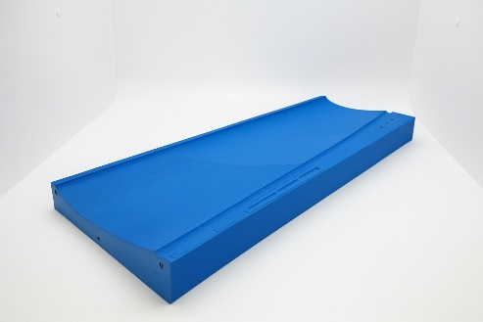  Image source:  Hufschmied Zerspanungssysteme  This urethane mold for laying the CFRP fabric for a tailless drone was produced highly efficiently using the Blockbuster, a roughing and finishing tool for plastic block materials. | 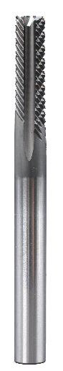  Image source:  Hufschmied Zerspanungssysteme  The ‘T-Rex’ end mill 194H060 DIP6P is an example of special tools from Hufschmied that enable delamination-free machining of CFRP.

About Hufschmied Zerspanungssysteme GmbH
Established in 1991 and headquartered in Bobingen near Augsburg, Hufschmied Zerspanungssysteme GmbH is a manufacturer of high-quality tools for machinable production and friction stir welding. By specializing at an early stage in the machining of plastics, fiberglass materials and carbon fiber, Hufschmied has become a leader in Europe in the development of solutions for new materials. The company is an established system supplier to renowned machine tool manufacturers. Tools and manufacturing process consulting from Hufschmied are particularly valued in the automotive and aerospace industries as well as in medical technology. The company is involved in numerous organizations, including Composites United Deutschland e. V. Hufschmied's manufacturing operations are located in Bobingen, Winterlingen and Sigmaringen on the Swabian Alb. Hufschmied is certified according to ISO 9001:2015 (quality management) and ISO 14001:2015 (environmental management).

Hufschmied Zerspanungssysteme GmbH – One Cut Ahead
For more information: www.hufschmied.net

Additional information:  Hufschmied Zerspanungssysteme GmbH  Marco Beigl  Edisonstrasse 11d  86399 Bobingen  Germany  Phone: +49 8234 9664-0  Telefax: +49 8234 9664-99  E-Mail: info@hufschmied.net  www.hufschmied.net | Press contact:  HighTech communications GmbH  Brigitte Basilio  Brunhamstrasse 21  81249 Munich  Germany  Phone: +49 89 500778-20  E-Mail: b.basilio@htcm.de  www.htcm.de

