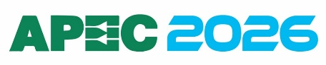
PRESS RELEASE

Würth Elektronik participates in IEEE APEC
March 22–26, 2026
Stand 1241
For innovative power electronics
Watertown (USA), February 24, 2026 – Würth Elektronik is excited to join the 41st IEEE Applied Power and Electronics Conference (APEC) as an Emerald partner, taking place March 22–26 2026 at the Henry B. Gonzales Convention center in San Antonio, Texas. This thrilling event promises the latest presentations and seminars about the newest topics in the power electronics world. APEC offers abundant opportunities for power electronics professionals from across North America and around the globe to connect, exchange ideas, and spark collaborations that lead to impactful partnerships and technological advancements.
Workshops and Presentations
The conference kicks off with the 10th Annual Magnetics @ High Frequency Workshop, co-organized by PSMA and PELS, on Saturday before the exhibition. During this workshop, Würth Elektronik’s experts will present advanced technical perspectives, as well as moderate discussion groups.
Throughout the APEC exhibition, Würth Elektronik will further contribute to the industry’s knowledge base with the following presentations:
- Octavian Tudor Stroe; Optimizing Modern Power: The Role of Parasitics in High Performance Design
- Jon Izkue; How Capacitors are Qualified and How to Interpret Datasheet Values
- Claudio Cañete Cabeza; Low-Power and High-Power Transformer Solutions to Support the Power Delivery Network for AI in Data Centers
- David Ruiz Gomez; Voltage Rating of Metal Alloy Molded Inductors
- Jared Quenzer; EMI Filter Success - Smart Inductor Selection
Würth Elektronik will also deliver Exhibitor Presentations on the show floor, including:
- Efrain Bernal Alzate; Percolation: Temperature and Voltage Influence on Molded Inductors
- Octavian Tudor Stroe; EMI Optimization of a Buck Converter
- Vidal Gonzales; Parasitic in Push-pull transformers: How Interwinding Capacitance and Leakage Inductance Drive EMI/EMC Results on Auxiliary Power Supplies
- George Slama; Interfacing to Current Transformers
Booth Experience
As attendees have come to expect, the Würth Elektronik booth will once again go all in with immersive, hands-on demonstrations and technical showcases designed for you to explore firsthand, including:
- Roulette
- High/Low Game
- Slot Machine and Card Shuffler
- REDEXPERT Component Selection Exhibit
- EMC/EMI Debugging Demonstration
- And more engaging, hands-on experiences

Networking Opportunities
As part of the conference’s festivities, Würth Elektronik will host its legendary Tuesday Night Party—an exclusive event that provides a valuable opportunity for customers and industry professionals to connect. Attendees are invited to meet with Würth Elektronik’s experts at APEC 2026 to learn about current technologies, discuss industry challenges, and engage with leaders in the power electronics community. Invitations to the Tuesday Night Party may be requested directly at the Würth Elektronik booth during the exhibition.

Available images
The following images can be downloaded from the Internet in printable quality: https://kk.htcm.de/press-releases/wuerth/
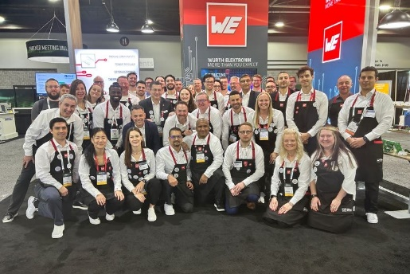Image source: Würth Elektronik
As in the previous year, Würth Elektronik will once again be attending APEC 2026 with a large team to present the company's solutions in the fields of EMC and power electronics.

About the Würth Elektronik eiSos Group
Würth Elektronik eiSos Group is a manufacturer of electronic and electromechanical components for the electronics industry and a technology company that spearheads pioneering electronic solutions. Würth Elektronik eiSos is one of the largest European manufacturers of passive components and is active in 50 countries. Production sites in Europe, Asia and North America supply a growing number of customers worldwide.
The product range includes passive components, power modules, digital isolators, optoelectronics, electromechanical components, thermal management solutions, sensors and wireless modules. The portfolio is rounded off by customer-specific solutions.
The unrivaled service orientation of the company is characterized by the availability of all catalog components from stock without minimum order quantity, free samples and extensive support through technical sales staff and selection tools.
Würth Elektronik is part of the Würth Group, the global market leader in the development, production, and sale of fastening and assembly materials, and employs around 7,300 people. In 2025, the Würth Elektronik Group generated sales of 1.06 Billion Euro.
Würth Elektronik: more than you expect!
Further information at www.we-online.com

Further information:  Wurth Electronics Midcom, Inc.  Amelia Thompson  121 Airport Drive  PO Box 1330  Watertown, SD 57201 USA  Phone: +1 605 886 4385  Toll-free (in the U.S.):  Phone: +1 800 643 2661  E-mail: amelia.thompson@we-online.com  www.we-online.com | Press contact:  HighTech communications GmbH  Brigitte Basilio  Brunhamstrasse 21  81249 Munich  Germany  Phone: +49 89 500778-20  E-mail: b.basilio@htcm.de  www.htcm.de

