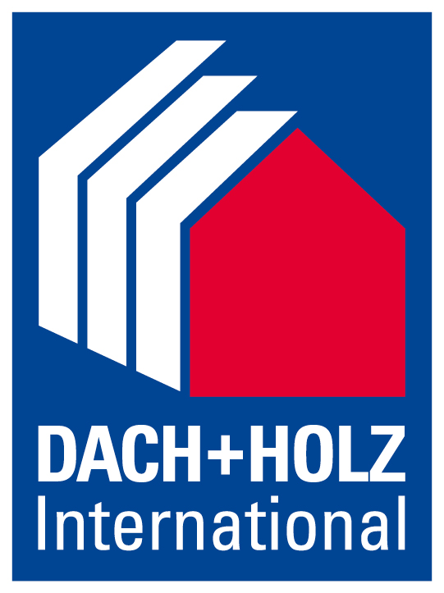
Press release
Schröder Group upgrades the MAKU folding machine
Clamping at record speed
24–27 February 2026
Hall 8, Stand 8.326
Wessobrunn-Forst (Germany), 24 February 2026 – If Hans Schröder Maschinenbau has its way, getting started with motorized folding will be much faster and more versatile in the future: The MAKU motorized folding machine has been equipped with a new safety laser system directly on the bending line and clamps the sheet metal much faster before folding. A new clamping beam option also enables the use of goat foot tools and thus the production of boxes.
A comparison test with a similar machine from another manufacturer for thin sheet metal processing has shown that, thanks to the new laser safety concept, the MAKU clamps a sheet almost twice as fast as a conventional folding machine. The light barrier eliminates the need for the pre-stop and the second operation of the foot switch, and the clamping beam lowers at full speed of 65 mm/s. If the safety function is triggered, for example because the hand gets too close to the danger zone, the machine automatically switches to the classic safety mode with pre-stop and the extra slow closing at 10 mm/s.
Rail and goat’s foot
The new clamping beam package opens up the possibility of manufacturing box-shaped workpieces. Instead of the permanently bolted single-piece tinsmith's or sharpnose blade, a tool clamping system accommodates segmented goat's foot tools at any position. To make room for this, the zero point of the clamping beam drive is offset by 130 mm in just a few simple steps. In this case, the laser safety system is switched off using the “box folding” function, as a workpiece bent up at the side would otherwise trigger it.
Other special features
The robust MAKU for plumbing and repair shops is available in the versions 2500 × 2.0/3200 × 1.5 (working length × sheet thickness in mm). This folding machine became well-known thanks to its popular two-axis backgauge for automatic tapered bending. In addition to the simple and precise production of plug-in profiles, the machine also offers a function for step-by-step radius bending. Both functions are available with both the standard Classic Bend control and the frequently selected POS2000 Professional graphical control.

Available images
The following images are available for download in printable format at:
https://kk.htcm.de/press-releases/schroeder/
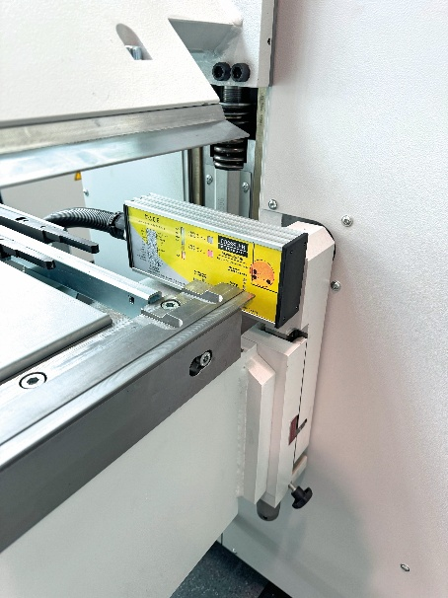  Image source: Schröder Group  A new safety laser system makes the MAKU significantly faster | 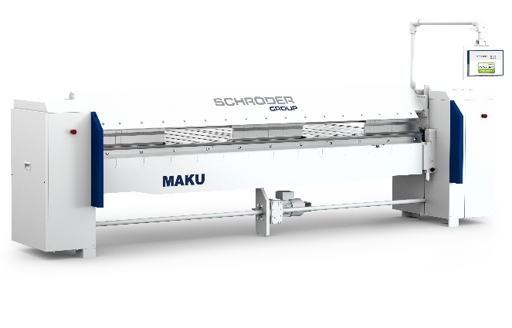  Image source: Schröder Group  The new clamping beam package for the MAKU folding machine opens up the possibility of manufacturing box-shaped workpieces.

About Schröder Group
The Schröder Group consists of Hans Schröder Maschinenbau GmbH, which is located in Wessobrunn-Forst, Germany, SCHRÖDER-FASTI Technologie GmbH, located in Wermelskirchen, Germany and the SMU GmbH, located in Leinburg-Weißenbrunn.
Founded in 1949, Hans Schröder Maschinenbau GmbH unifies traditional and modern approaches in machine building: Successfully managed as a quality and customer-oriented, family-owned company, Hans Schröder Maschinenbau is specialized in the development of modern machine concepts for bending and cutting sheet metal.
The successful integration of the Fasti Company in 2006 and its worldwide presence make the Schröder Group one of today‘s leading providers of machines for bending, cutting, beading, flanging, and circular bending all types of sheet metal. The company‘s precision machines range from proven solutions for craftsmen to innovative, high-performance machines for automatic industrial production processes. 2021 the Schröder Group was expanded by the tool manufacturer SMU GmbH. Overall, the Schröder Group currently employs more than 300 people at various locations at home and abroad.
Further information is available at https://www.schroedergroup.eu/en/.

Press contact:
Schröder Group
Hans Schröder Maschinenbau GmbH
Janina Biró
Feuchten 2
82405 Wessobrunn-Forst
Germany
T: +49 8809 9220-68
E-mail: jj@schroedergroup.eu
Website: www.schroedergroup.eu

HighTech communications GmbH
Brigitte Basilio
Brunhamstraße 21
81249 München
Germany
T: +49 89 500778-20
E-mail: b.basilio@htcm.de
Website: www.htcm.de

