FOR THE MEDIA
New analytics functions in SMT Analytics from ASMPT SMT Solutions
AI-supported analyses increase transparency and line throughput
Atlanta (USA), February 10, 2026 – ASMPT SMT Solutions is further enhancing its SMT Analytics software solution with expanded analytics capabilities. A key new feature is Line Balance Analysis, which for the first time enables a station-spanning evaluation of time utilization across entire SMT lines. In addition, the existing use cases, Theoretical Cycle Time Comparison and Reject Analysis, have been functionally expanded.
SMT Analytics consolidates production data from multiple lines and correlates it with theoretically optimal reference values. The objective is to reliably identify bottlenecks, imbalanced line configurations and hidden optimization potential – even in complex manufacturing environments.
Advanced analysis functions for line optimization
The new Line Balance Analysis compares the actual cycle time of a product at each individual station with reference values calculated by the WORKS Programming software. Deviations and throughput-limiting process steps become immediately visible. Users can quickly identify which stations constrain line performance and how different programs affect overall line balance.
The enhanced Theoretical Cycle Time Comparison additionally reveals where programming parameters such as waiting times or acceleration settings deviate from the theoretical optimum. Since such parameters typically influence thousands of placement cycles, the resulting optimization potential is substantial.
The Reject Analysis use case has also been expanded. In addition to reject rates, evaluations can now be performed on a component cost basis, enabling a more precise assessment of economic impact. Through integration with the Factory Equipment Center, maintenance-related information, such as feeder maintenance status, cycle counters and remaining time until the next service interval, is available directly within the analysis context.
AI-supported reporting for actionable decision-making
Another significant development step is the introduction of AI-supported reporting. An integrated assistant automatically analyzes production data and provides clearly structured, prioritized recommendations for action aimed at improving performance, component efficiency and equipment availability. This allows users to derive targeted corrective measures without the need to manually interpret complex dashboards.
Furthermore, SMT Analytics will support the integration of machines from other manufacturers, provided they support the IPC-2591 Connected Factory Exchange (CFX) protocol. This enables consistent, line-level analysis and optimization across heterogeneous production environments.
“With SMT Analytics, we systematically translate our extensive process expertise into our customers’ manufacturing operations,” says Jim Leather, Director of IoT Solutions at ASMPT. “Our goal is to simplify data-driven decision-making and consistently support manufacturers on their path toward intelligent SMT production.”

Illustrations for downloading
The following print-ready artwork is available on the internet for downloading:
https://kk.htcm.de/press-releases/asmpt/

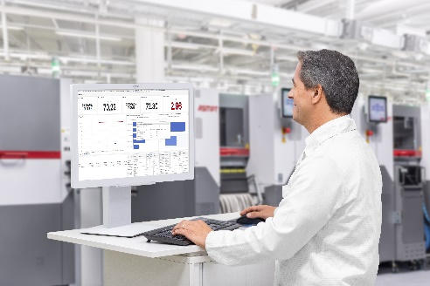 | 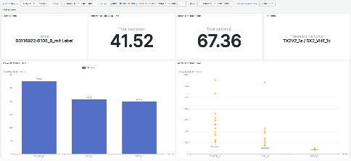
The Theoretical Cycle Time Comparison in SMT Analytics visualizes deviations between current and optimal cycle times in both graphical and tabular form, enabling users to quickly and precisely identify optimization potential.  Image credit: ASMPT | The Line Balance Analysis in SMT Analytics compares the actual cycle times of all stations with their theoretical optimum and makes bottlenecks as well as unbalanced line configurations immediately visible.  Image credit: ASMPT

About ASMPT Limited (“ASMPT”)
ASMPT Limited is a leading global supplier of hardware and software solutions for the manufacture of semiconductors and electronics. Headquartered in Singapore, ASMPT’s offerings encompass the semiconductor assembly & packaging, and SMT (surface mount technology) industries, ranging from wafer deposition to the various solutions that organize, assemble and package delicate electronic components into a vast range of end-user devices, which include electronics, mobile communications, computing, automotive, industrial and LED (displays). ASMPT partners with customers very closely, with continuous investments in R&D helping to provide cost-effective, industry-shaping solutions that achieve higher productivity, greater reliability, and enhanced quality. ASMPT is a founding member of the Semiconductor Climate Consortium.
To learn more about ASMPT, please visit www.asmpt.com.

The ASMPT SMT Solutions segment
The mission of the SMT Solutions segment within ASMPT is to implement and support the Intelligent Factory at electronics manufacturers worldwide.
ASMPT solutions support the networking, automation, and optimization of central workflows with hardware, software and services that enable electronics manufacturers to transition to the Intelligent Factory in stages and enjoy dramatic improvements in productivity, flexibility, and quality. With its integrated open automation concept, ASMPT opens the door for its customers to economically feasible automation, entirely in accordance with their individual requirements – modular, flexible, and vendor-independent.
The product range includes hardware and software such as SIPLACE placement solutions, DEK printing solutions, inspection and storage solutions, and the WORKS Software Suite. With WORKS, ASMPT offers electronics manufacturers high-quality software for planning, controlling, analyzing and optimizing all processes on the shop floor. Maintaining close relationships with customers and technology partners is a central component of ASMPT’s strategy.
For more information about ASMPT SMT Solutions, visit smt.asmpt.com.
Media contacts:
AMCAS ASMPT Press Office
SMT Solutions
Mark Ogden
Phone: +1 (770) 797 3189
E-mail: ogden.mark@asmpt.com
Website: smt.asmpt.com
Global ASMPT Press Office
ASMPT Limited
Susanne Oswald
Rupert-Mayer-Strasse 48
81379 Munich
Germany
Tel: +49 89 20800-26439
E-mail: susanne.oswald@asmpt.com
Website: asmpt.com
HighTech communications GmbH
Barbara Ostermeier
Brunhamstrasse 21
81249 Munich
Germany
Tel.: +49-89 500778-10|
E-mail: b.ostermeier@htcm.de
Website: www.htcm.de

