PRESS RELEASE

Würth Elektronik restructures its spacer product range
Lead-Free and with More Options for SMT Assembly
Waldenburg (Germany), February 11, 2026 – Würth Elektronik restructures its SMT spacers for printed circuit boards to use lead-free alloys. This gives electronics manufacturers greater planning certainty in view of the RoHS (Restriction of Hazardous Substances) exemption expiring at the end of June 2027, as the SMT spacers will comply with the prevailing environmental standards and compliance requirements. The second major innovation is the introduction of additional options for SMT assembly.
Würth Elektronik now provides its customers with lead-free SMT spacers. “Lead-free” refers to the threshold of 0.1 percent in accordance with the European Parliament’s RoHS Directive. The restructuring affects the WA-SMSI product family with internal thread, the WA-SMST push-through system, the WA-SMSR for spacing on the underside of the printed circuit board, as well as the WA-SMSSR with a specially matched expansion rivet. With a lead content of <0.1 percent, these SMT spacers from Würth Elektronik are RoHS-compliant in accordance with 2011/65/EU and 2015/863/EU. To meet its customers’ high quality standards, the lead-free SMT spacers have undergone extensive testing and qualification. They can also be processed without difficulty using lead-free solder pastes.
The introduction of the new SMT spacers with a lead content of <0.1 percent provides electronics manufacturers planning certainty: The layout and design of electronic assemblies that incorporate lead-free SMT spacers are future-proof. The use of lead-free components eliminates the need for costly redesigns, new approvals or certifications and compliance risks.
Additional options for SMT assembly aids
There are also innovations in SMT assembly aids. Where previously only a single assembly aid in the form of a polyimide film with tab (designation R) was available, two additional variants – “RR” and “RX” – have now been added. The circular version “RR” is designed to meet a specific requirement. In this case, the tab used to facilitate removal of the film is omitted in situations where optical inspection of small components in the surrounding area could be impaired.
The “RX” option represents a different approach for mass production at Würth Elektronik. The SMT spacers “RX”, designed for large quantities, are supplied without film: Special nozzles on pick-and-place machines can pick up this SMT spacer variant without difficulty and place it precisely on the printed circuit board. Waste and the time-consuming removal of film are eliminated.
The SMT spacers not only enable multi-level PCB construction, but also serve for mounting sensors, LEDs, or displays. They are also suitable both for attaching printed circuit boards to housings and for use as a support structure for large or mechanically stressed PCBs.
Thanks to their tin surface finish, the SMT spacers can withstand multiple reflow soldering processes without any change in surface characteristics (e.g., discoloration, blistering, or cracking). The appropriate combination of solder pad geometry, solder paste, and the tin thickness of the surface alloy gives rise to reliable mechanical joints with high holding forces and torque resistance.

Available images
The following images can be downloaded from the Internet in printable quality: https://kk.htcm.de/press-releases/wuerth/
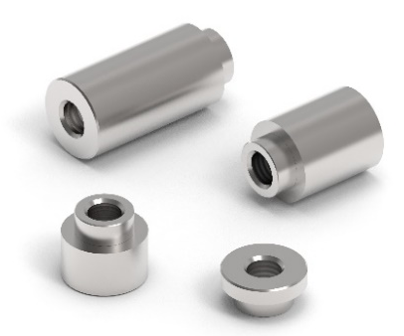 | The lead-free SMT spacers from Würth Elektronik provide planning certainty for electronics manufacturers.  Image source: Würth Elektronik
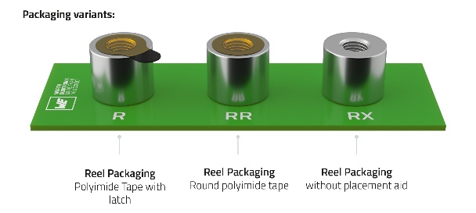 | Two additional SMT assembly aids are now available for the SMT spacers in the “RR” and “RX” variants.  Image source: Würth Elektronik

About the Würth Elektronik eiSos Group
Würth Elektronik eiSos Group is a manufacturer of electronic and electromechanical components for the electronics industry and a technology company that spearheads pioneering electronic solutions. Würth Elektronik eiSos is one of the largest European manufacturers of passive components and is active in 50 countries. Production sites in Europe, Asia and North America supply a growing number of customers worldwide.

The product range includes passive components, power modules, digital isolators, optoelectronics, electromechanical components, thermal management solutions, sensors and wireless modules. The portfolio is rounded off by customer-specific solutions.
The unrivaled service orientation of the company is characterized by the availability of all catalog components from stock without minimum order quantity, free samples and extensive support through technical sales staff and selection tools.
Würth Elektronik is part of the Würth Group, the global market leader in the development, production, and sale of fastening and assembly materials, and employs around 7,300 people. In 2025, the Würth Elektronik Group generated sales of 1.06 Billion Euro.
Würth Elektronik: more than you expect!
Further information at www.we-online.com

Further information:  Würth Elektronik eiSos GmbH & Co. KG  Sarah Hurst  Clarita-Bernhard-Strasse 9  81249 Munich  Germany  Phone: +49 7942 945-5186  E-mail: sarah.hurst@we-online.de  www.we-online.com | Press contact:  HighTech communications GmbH  Brigitte Basilio  Brunhamstrasse 21  81249 Munich  Germany  Phone: +49 89 500778-20  E-mail: b.basilio@htcm.de  www.htcm.de

