PRESS RELEASE

Würth Elektronik service for current sense transformers
Find the Right CST with REDEXPERT
Waldenburg (Germany), February 3, 2026 – Würth Elektronik expands its free design tool REDEXPERT to include the Current Sense Transformer Selector. It enables developers to select the appropriate current sense transformers based on parameters relevant to their application.
Current sense transformers for measuring alternating current offer unique advantages over other current sensing solutions: galvanic isolation, low power loss, high immunity to signal noise, and simple circuit design. Selecting the right current sensor can be a challenge depending on the application. The Current Sense Transformer Selector from Würth Elektronik offers a unique design tool previously not available on the market in this form.
Including simulation
After entering the parameters – current, frequency, signal type, and desired maximum error rate – the Selector finds all available options in Würth Elektronik’s product database that match these criteria. The tool provides a list of components with the corresponding parameters and simulates both the temperature rise and the error as a function of frequency and current. The tool also allows the direct comparison of different options in a simulation view and provides an overview page with all relevant information for the selected component. These simulations, based on actual measurements, save developers from having to conduct their own tests when selecting current sense transformers (CSTs).
The selection process without the REDEXPERT Current Sense Transformer Selector is as follows: First, the CST must be selected with a suitable ET constant to ensure it doesn’t reach saturation even under unfavorable conditions – i.e. low frequencies and high currents. It’s also important to ensure that the CST doesn’t overheat at maximum current. Last but not least, the error characteristics required for the specific application must also be taken into account when selecting the component. As datasheets for CSTs don’t cover all possible application-relevant parameters – and can’t realistically do so in practice – it’s often necessary to test several components to make the best choice.
Applications
Typical applications of current sense transformers include AC current measurement, switched-mode power supplies, overload detection, load shedding/shutdown detection, metering, load measurement, and high-frequency current sensing.

Available images
The following images can be downloaded from the Internet in printable quality: https://kk.htcm.de/press-releases/wuerth/
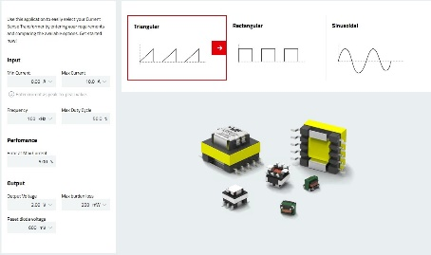Image source: Würth Elektronik  In the REDEXPERT Current Sense Transformer Selector, users enter the desired parameters for the appropriate current sense transformer. | 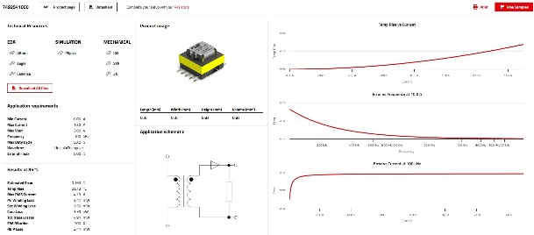Image source: Würth Elektronik  The tool presents the suitable current sense transformer, including simulations of its behavior based on measurement series.

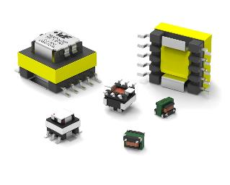Image source: Würth Elektronik
Würth Elektronik offers a wide range of current sense transformers.

About the Würth Elektronik eiSos Group
Würth Elektronik eiSos Group is a manufacturer of electronic and electromechanical components for the electronics industry and a technology company that spearheads pioneering electronic solutions. Würth Elektronik eiSos is one of the largest European manufacturers of passive components and is active in 50 countries. Production sites in Europe, Asia and North America supply a growing number of customers worldwide.
The product range includes passive components, power modules, digital isolators, optoelectronics, electromechanical components, thermal management solutions, sensors and wireless modules. The portfolio is rounded off by customer-specific solutions.
The unrivaled service orientation of the company is characterized by the availability of all catalog components from stock without minimum order quantity, free samples and extensive support through technical sales staff and selection tools.
Würth Elektronik is part of the Würth Group, the global market leader in the development, production, and sale of fastening and assembly materials, and employs around 7,500 people. In 2024, the Würth Elektronik Group generated sales of 1.02 Billion Euro.
Würth Elektronik: more than you expect!
Further information at www.we-online.com

Further information:  Würth Elektronik eiSos GmbH & Co. KG  Sarah Hurst  Clarita-Bernhard-Strasse 9  81249 Munich  Germany  Phone: +49 7942 945-5186  E-mail: sarah.hurst@we-online.de  www.we-online.com | Press contact:  HighTech communications GmbH  Brigitte Basilio  Brunhamstrasse 21  81249 Munich  Germany  Phone: +49 89 500778-20  E-mail: b.basilio@htcm.de  www.htcm.de

