FOR THE MEDIA
ASMPT at SEMICON Korea
Advanced Assembly & Packaging – Empower the Intelligence Revolution
Singapore, February 2, 2026 – ASMPT will exhibit at SEMICON Korea 2026 from February 11 to 13, 2026, at Booth D722 at the COEX Convention & Exhibition Center in Seoul. Under the theme “Empower the Intelligence Revolution”, ASMPT will highlight the critical role of advanced packaging and assembly technologies in enabling developments such as AI systems, smart mobility, and hyperconnectivity. ASMPT Semiconductor Solutions will present three innovative systems for the first time in SEMICON Korea: DALA, a camera module component assembly system; MEGA, a multi-chip bonding solution; and ALSI LASER 1206, a fully automatic laser dicing and grooving system. In addition, ASMPT SMT Solutions will provide information on the placement platforms SIPLACE TX micron and the award winning SIPLACE CA2, both integrating advanced packaging capabilities directly into SMT production lines.
“ASMPT offers some of the most advanced machines for semiconductor production, delivering strong value to companies developing integrated chips for AI, smart mobility, and hyperconnectivity,” says JinWoo Kim, Korea Country Manager for ASMPT Semiconductor Solutions. “The Intelligence Revolution relies on seamless integration, exceptional precision, and reliability at the microscopic level, delivering the invisible electrical and optical connections that bring intelligent systems to life.”
Advanced bonding solutions
DALA is a universal system for camera module component assembly. Featuring high precision and modular design, it can be used for various tasks within a production line, such as attaching chips, lens holders, and glass. With ±7 µm bonding accuracy and flexible configuration, it provides an optimal platform for imaging and sensing systems across consumer and automotive edge-AI applications.
The multi-chip bonding solution MEGA combines epoxy dispensing and stamping with integrated 3D inspection and optional UV curing. Independently operating pick and bond arms with flip-pick and rotation units ensure precise alignment. Being highly configurable, MEGA meets the demands of advanced multi-chip packaging for optical transceivers, photonics, and sensor applications.
Dicing and grooving
The next-generation ALSI LASER1206 platform meets the growing demands of IDM and foundry manufacturers for wafer dicing and grooving, in advanced memory, logic, AI, and power applications. Its patented multi-beam UV laser technology enables high-precision processing with minimal thermal impact, reducing burr formation and preserving die strength. With support for film-framed and bare wafers, it has been validated by multiple customers and leading plasma dicing suppliers.
SMDs and dies on a SMT production line
The award-winning SIPLACE CA2 combines high-speed die assembly directly from the wafer with SMT placement in a single platform. It processes SMDs via shuttle tables or conveyors as well as dies from sawn wafers in one operation, achieving throughput rates of up to 54,000 dies and 76,000 SMDs per hour with placement accuracy of up to ±10 µm @ 3σ.
“With advanced packaging and highly integrated SiP modules, the traditional boundaries between semiconductor manufacturing and SMT processes are increasingly blurring. ASMPT SMT Solutions offers platforms that extend the production spectrum to this next level,” says AnKyong Sung, General Manager for ASMPT SMT Solutions Korea.
SIPLACE TX micron is a placement platform developed for advanced packaging and high-density applications. Combining temperature-stable glass-ceramic scales, high-precision fiducial detection, high-resolution vision systems, and advanced vacuum tooling, it delivers placement accuracy of up to ±10 µm at throughput rates of up to 93,000 components per hour.

Illustrations for downloading
The following images are available for download in printable format at:
https://kk.htcm.de/press-releases/asmpt/
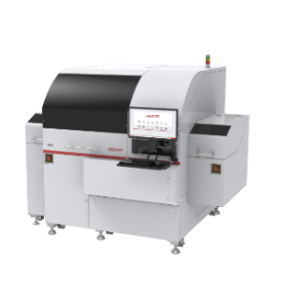 | 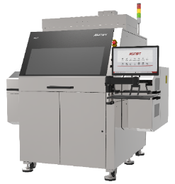
As a multi-chip bonding solution, the MEGA perfectly meets the requirements for the next generation of server clusters and AI edge devices, such as smartphones, data, and telecommunication applications.  Image credit: ASMPT | DALA, universal pick-and-place system for camera-module assembly, handling all components—from die and lens holder attachment to glass bonding—with high precision and flexibility for efficient imaging and sensing system production.  Image credit: ASMPT
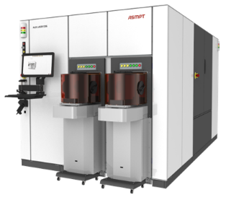 | 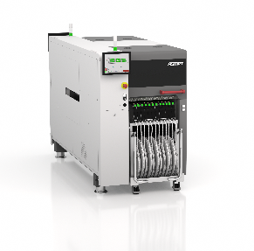
ALSI LASER1206, the fully automatic laser dicing and grooving system, provides an ideal platform for advanced packaging and power automotive applications.  Image credit: ASMPT | The advanced packaging technology of the SIPLACE TX micron assembles dies, bare semiconductor chips, as well as classic SMT components.  Image credit: ASMPT
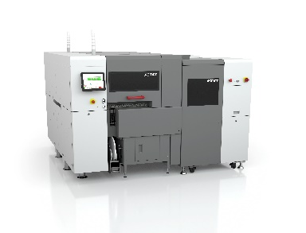
The award-winning SIPLACE CA2 boosts productivity in advanced packaging by combining classic surface-mount technology with die-attach and flip-chip assembly.

Image credit: ASMPT
About ASMPT Limited (“ASMPT”)
ASMPT Limited is a leading global supplier of hardware and software solutions for the manufacture of semiconductors and electronics. Headquartered in Singapore, ASMPT’s offerings encompass the semiconductor assembly & packaging, and SMT (surface mount technology) industries, ranging from wafer deposition to the various solutions that organise, assemble and package delicate electronic components into a vast range of end-user devices, which include electronics, mobile communications, computing, automotive, industrial and LED (displays). ASMPT partners with customers very closely, with continuous investment in R&D helping to provide cost-effective, industry-shaping solutions that achieve higher productivity, greater reliability, and enhanced quality. ASMPT is also a founding member of the Semiconductor Climate Consortium.
To learn more about ASMPT, please visit us at asmpt.com.

About ASMPT Semiconductor Solutions (“ASMPT SEMI”)
ASMPT SEMI is the leading supplier in advanced packaging and semiconductor assembly solutions. With a commitment to innovation and customer satisfaction, ASMPT SEMI provides a comprehensive range of products and services that cater to the evolving needs of the microelectronics industry. Their expertise spans across areas such as flip-chip and wafer-level packaging, advanced interconnect technologies, and more. ASMPT SEMI's cutting-edge solutions enable customers to achieve higher performance, increased reliability, and improved cost-efficiency when producing their semiconductor devices.
ASMPT SEMI sees itself as a pioneer and driving force of the Intelligence Revolution. With its advanced packaging and assembly technologies, the business segment creates the invisible connections that enable intelligent applications in Artificial Intelligence, Smart Mobility and Hyperconnectivity.
For more information about ASMPT SEMI, visit semi.asmpt.com.
Media contacts:
Global ASMPT Semiconductor Solutions Press Office
ASMPT Limited
Jessica Ho
Semiconductor Solutions
E-Mail: semi_stratmkt@asmpt.com
Website: semi.asmpt.com

Global ASMPT Press Office
ASMPT Limited
Susanne Oswald
Rupert-Mayer-Strasse 48
81379 Munich
Germany
Phone: +49 89 20800-26439
E-Mail: susanne.oswald@asmpt.com
Website: asmpt.com

