Press Release
Symeo at LogiMAT 2026 and Crane Conference
Maintenance-free radar sensors for intralogistics solutions
Neubiberg, Germany, 29 January 2026 – At LogiMAT from 24 to 26 March 2026 in Stuttgart, Symeo GmbH is focusing on robust radar sensor technology for position detection, distance measurement, and collision avoidance. Symeo is presenting itself as a partner at the ABF GmbH stand (Hall 4, Stand 4C67) for good reason: The two companies have been implementing intralogistics automation solutions for many years, for instance in steelworks. In addition to its standard products, Symeo will be focusing on LPR-SAFE®, solution for distance measurement and functional safety compliant with EN ISO 13849 PLd, at this year's LogiMAT. The presentation a week earlier at the Crane Conference (Ruhr University Bochum, March 16-17, 2026) has the same focus.
Position determination and collision avoidance on cranes are among the most prominent areas of application for Symeo's industrial LPR® radar sensor technology. A primary radar measures the distance to an object or reflector. A secondary radar boosts safety through communication between two opposing radar sensors. Symeo now offers LPR-SAFE so that crane manufacturers, for example, can have installations certified as functionally safe. Two pairs of LPR-1DHP-291 sensors (60 GHz) and LPR-1D24 sensors (24 GHz) measure the distance. Each of the two redundant measuring sections provides distance values that are passed on to a fail-safe Siemens S7 PLC, where the measured distances are checked for plausibility in the certified function block (EN ISO 13849 PLd).
Functional safety
"The special appeal of LPR-SAFE is that it can be retrofitted wherever our sensors are already in use in secondary mode. Particularly in applications that serve to prevent collisions, functional safety can also be retrofitted to existing installations," explains Benjamin Wuttke, Head of Sales at Symeo. "I am delighted that we are once again taking part in LogiMAT as a guest of ABF, because the intralogistics solutions implemented by this partner with our sensors are always fascinating."
Alexander Meier, Senior Principal Embedded Software Engineer at Symeo, who spoke at last year's Crane Conference: "We are excited about this year's topic 'Megatrend AI - Will the crane soon develop and operate itself?'. We can already say one thing: any form of automation – with or without the use of AI – requires reliable sensor technology, such as the radar sensors from Symeo."
Further information is available at www.symeo.com/en/.

Available image material
The following printable images are available for download on the Internet:
https://kk.htcm.de/press-releases/symeo/

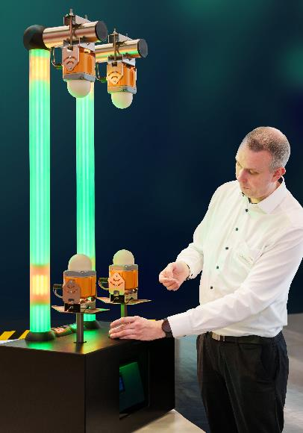
Image source: Symeo
Alexander Meier, Senior Principal Embedded Software Engineer at Symeo, explains how LPR-SAFE works using a demonstrator.

Symeo
Symeo develops and markets products and solutions for precise, non-contact, maintenance-free position detection, distance measurement, and collision avoidance. Symeo’s products feature extremely robust designs to make them suitable for applications in harsh industrial environments.
Symeo's LPR® radar sensor technology offers a wireless and real-time-capable measuring system that is ideally suited for industrial applications. Symeo has many years of experience in the development of cost-efficient and customer-specific industrial solutions on the basis of LPR® technology.
The company delivers standardized products and complete solutions to system integrators, original equipment manufacturers (OEMs), and end customers worldwide.
Headquarters: Symeo GmbH, Prof.-Messerschmitt-Strasse 3 a, 85579 Neubiberg, Germany
Phone: (+49-89) 6607-7960, Fax: (+49-89) 66077-96190
E-mail: info@symeo.com, Website: www.symeo.com

Press contact:
HighTech communications GmbH
Marcus Planckh
Brunhamstrasse 21 (Building 202/2nd floor)
81249 Munich
Germany
Phone: (+49-89) 500-77822
E-mail: m.planckh@htcm.de
Website: www.htcm.de/en/

Disclaimer
The safety functions described are part of a safety-oriented system and do not replace the application-specific risk assessment, professional system integration and validation in accordance with the relevant standards by the machine manufacturer or system integrator.
This press release is for general information purposes only and does not constitute a binding offer or legal commitment. Technical data, specifications, and product features may change in the course of further development.

