PRESS RELEASE

Würth Elektronik offers halogen-free conductive textile gaskets
Self-Adhesive EMC Gaskets
Waldenburg (Germany), January 28, 2026 – Würth Elektronik now also offers its WE-LT conductive textile gaskets in a halogen-free version. These gaskets have proven to be an effective solution for reducing EMC issues in electronic devices. The WE-LT halogen-free conductive textile gaskets feature shielding attenuation of over 80 dB at 100 MHz, a typical surface resistance of less than 0.08 ohms, and IP54 protection against dust and water. They are halogen-free and meet the requirements of EU Ecodesign 2009/125/EC as well as the RoHS Directive. Additionally, they achieve a UL 94 V-0 flammability rating.
The gaskets are available in various standard profile shapes: square, as well as D, C, P, L, M, and blade profiles. Würth Elektronik also offers customized shapes. When two metal parts of a housing need to be conductively connected after assembly, conductive gaskets ensure electrical continuity. As a halogen-free version, the gaskets can now also be used in displays, as the use of halogenated flame retardants in housings and stands for electronic displays is prohibited within the European Union.
The EMC gaskets consist of three main components: a metallized textile, an elastic material, and a pressure-sensitive adhesive (PSA). The metallized fabric consists of a woven polyester material with nickel-plated copper threads. The nickel plating serves to protect the copper and the EMC gasket from corrosion. It also provides protection against abrasion, ensuring long service life. Versions with an aluminum layer are also available. The urethane foam cores are available in various densities between 45 kg/m³ and 150 kg/m³. A compression ratio of approximately 30 percent of the original height of the EMC gasket is recommended.
Broad range of applications
In their dual function as a mechanical seal against dust and splashed water and as a means of improving electromagnetic performance, the gaskets make an important contribution to the final assembly of displays, metal housings, control cabinets, input and output connections, and grounding connections. Würth Elektronik also offers to manufacture custom EMC gaskets in various shapes and cut-to-size formats, without any additional tooling costs.

Available images
The following images can be downloaded from the Internet in printable quality: https://kk.htcm.de/press-releases/wuerth/
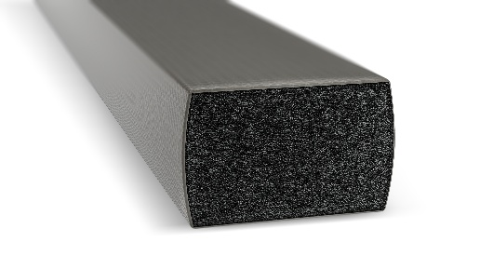  Image source: Würth Elektronik  Halogen-free conductive textile gaskets from Würth Elektronik | 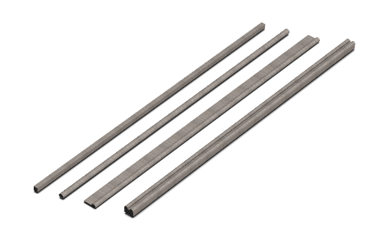  Image source: Würth Elektronik  The gaskets are available as standard in various profile shapes. But Würth Elektronik also offers customized shapes.

About the Würth Elektronik eiSos Group
Würth Elektronik eiSos Group is a manufacturer of electronic and electromechanical components for the electronics industry and a technology company that spearheads pioneering electronic solutions. Würth Elektronik eiSos is one of the largest European manufacturers of passive components and is active in 50 countries. Production sites in Europe, Asia and North America supply a growing number of customers worldwide.
The product range includes passive components, power modules, digital isolators, optoelectronics, electromechanical components, thermal management solutions, sensors and wireless modules. The portfolio is rounded off by customer-specific solutions.
The unrivaled service orientation of the company is characterized by the availability of all catalog components from stock without minimum order quantity, free samples and extensive support through technical sales staff and selection tools.
Würth Elektronik is part of the Würth Group, the global market leader in the development, production, and sale of fastening and assembly materials, and employs around 7,500 people. In 2024, the Würth Elektronik Group generated sales of 1.02 Billion Euro.
Würth Elektronik: more than you expect!
Further information at www.we-online.com

Further information:  Würth Elektronik eiSos GmbH & Co. KG  Sarah Hurst  Clarita-Bernhard-Strasse 9  81249 Munich  Germany  Phone: +49 7942 945-5186  E-mail: sarah.hurst@we-online.de  www.we-online.com | Press contact:  HighTech communications GmbH  Brigitte Basilio  Brunhamstrasse 21  81249 Munich  Germany  Phone: +49 89 500778-20  E-mail: b.basilio@htcm.de  www.htcm.de

