FOR THE MEDIA
ASMPT to show intelligent manufacturing solutions at APEX EXPO 2026
We boost your intelligent factory
Singapore, January 27, 2026 – Market and technology leader ASMPT SMT Solutions will present its innovations in the field of electronics manufacturing at the APEX EXPO 2026 to be held March 17 to 19 in Anaheim, California. At booth 1813, industry visitors can experience the company’s new SIPLACE V placement platform, the new DEK TQ XL solder paste printer, and many other hardware and software innovations. Also represented at the booth will be ASMPT Semiconductor Solutions with information on future-oriented solutions for the semiconductor industry and ASMPT software subsidiary Critical Manufacturing, which will present its modern manufacturing operations platform.
The new SIPLACE V platform, which had its successful premiere at the Productronica 2025 trade fair, will also take center stage in Anaheim. The newly developed system achieves performance increases of up to 30 percent under real-life operating conditions in the production of consumer electronics, automotive and industrial applications, smartphones, and IT and network infrastructure components.
The SIPLACE V combines maximum performance with maximum quality and flexibility while covering a component spectrum ranging from miniaturized 016008M chips to large and/or odd-shaped components. It features 90 available feeder slots regardless of any installed options. Despite the performance increase, the machine is very compact, requiring only 1.1 by 2.4 meters of floor space. The pioneering platform is fully compatible with existing SMT lines and ASMPT’s hardware and software portfolio. Equipped with Gigabit Ethernet, its future-proof architecture is ready for further advances in automation, big data processing and AI integration in intelligent manufacturing. Also on display will be the new SIPLACE V L, which offers additional flexibility for the assembly of oversized printed circuit boards.

A complete production line
ASMPT will show a complete production line consisting of the SIPLACE V, a DEK TQ L solder paste printer, and the Process Lens SPI system at the event. Also on display will be the new DEL TQ XL solder paste printer, which processes circuit boards measuring up to 850 by 610 mm with a thickness of up to 8 mm and weighing up to 12 kilograms. The system prints on the entire PCB surface and delivers consistent, repeatable results even on boards with warpage of up to 4 mm. Another exhibit at the booth will be the proven SIPLACE SX placement platform with its improved OSC Package for the reliable and highly precise assembly of large special components, including ball grid arrays (BGAs) and complex component shapes with increased requirements regarding geometry, weight, and coplanarity.
Software for the intelligent manufacturing
ASMPT's powerful hardware will be complemented by the company’s software portfolio, including the WORKS Software Suite with its applications for controlling and optimizing all workflows on the shop floor, the networked Factory Equipment Center asset and maintenance management system, and the SMT Analytics expert system for in-depth analyses of the manufacturing process with AI-supported reporting.
The manufacturing execution system platform from ASMPT software subsidiary Critical Manufacturing will also be shown at the booth. Developed especially for the requirements of the electronics industry, it supports the practice-oriented end-to-end control and transparency of manufacturing processes.
High-performance bonders and advanced packaging technology
Another area of the ASMPT booth will be dedicated to ASMPT Semiconductor Solutions, whose portfolio includes high-performance bonders and innovative solutions for advanced packaging that address key requirements of the semiconductor and electronics industry related to things like rising integration densities, shorter innovation cycles, and growing requirements for quality and reliability.
“Artificial intelligence, networked communication, electromobility and new high-performance data centers place high demands on electronics manufacturing,” said Mark Ogden, Marketing Manager Americas at ASMPT SMT Solutions. “Powerful, compact and reliable hardware solutions that also offer low operating costs are in demand today. The industry also needs measurable advances in technology and productivity. This is exactly where we come in – with the new SIPLACE V platform, innovative printing and placement solutions like the hybrid SIPLACE CA2 for advanced packaging, and a software portfolio that provides end-to-end support for manufacturing processes.”

Illustrations for downloading
The following print-ready artwork is available on the internet for downloading:
https://kk.htcm.de/press-releases/asmpt/

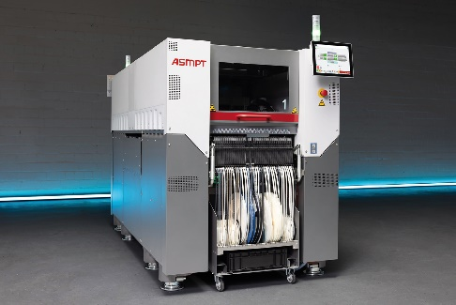 | 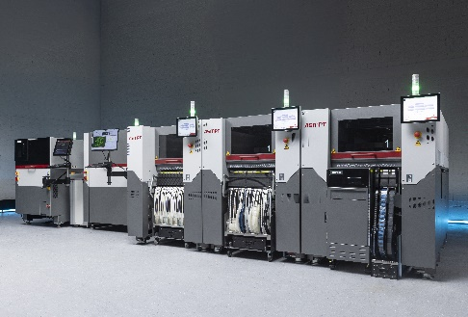
With a footprint of just 1.1 × 2.4 meters, the new SIPLACE V gives electronics manufacturing a decisive boost – not only in real performance, but also in quality, flexibility, and future readiness.  Image credit: ASMPT | The new SIPLACE V platform processes the entire component spectrum – from ultra-small 016008M chips to large-format parts – and proves its strengths especially with challenging or unusually shaped components.  Image credit: ASMPT
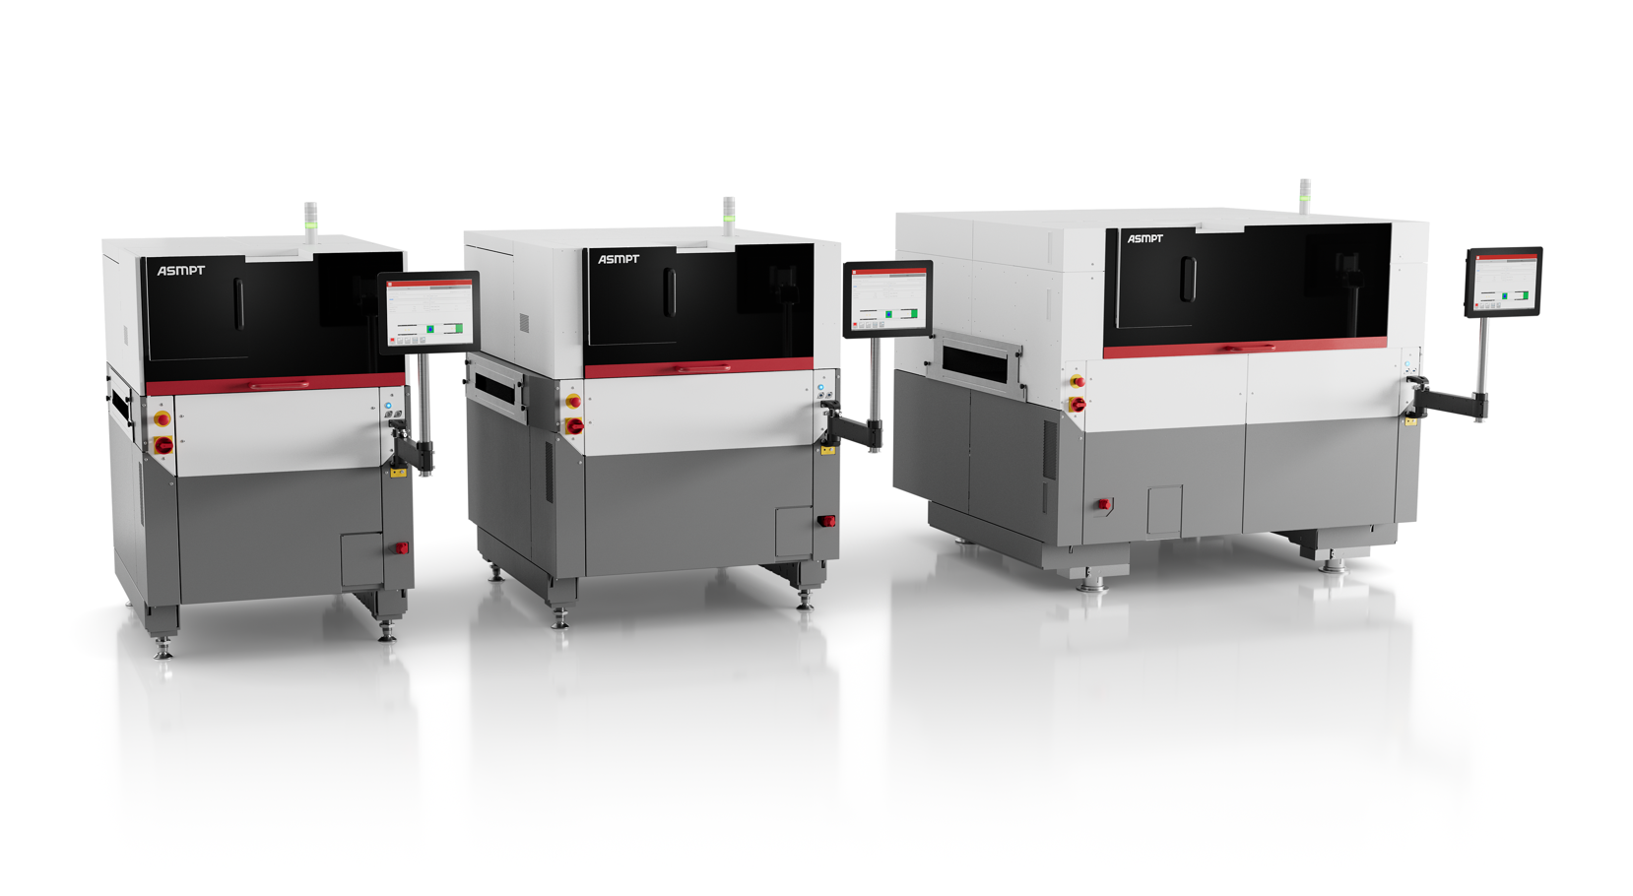 | 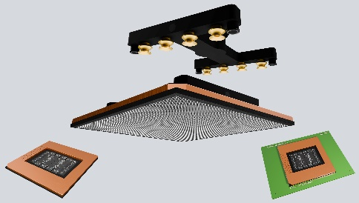
With its three DEK TQ, DEK TQ L and DEK TQ XL models, the DEK TQ XL platform covers the complete product spectrum in electronics manufacturing.  Image credit: ASMPT | The optimized OSC package can process components measuring up to 200 x 150 mm and weighing up to 500 g  Image credit: ASMPT

About ASMPT Limited (“ASMPT”)
ASMPT Limited is a leading global supplier of hardware and software solutions for the manufacture of semiconductors and electronics. Headquartered in Singapore, ASMPT’s offerings encompass the semiconductor assembly & packaging, and SMT (surface mount technology) industries, ranging from wafer deposition to the various solutions that organize, assemble and package delicate electronic components into a vast range of end-user devices, which include electronics, mobile communications, computing, automotive, industrial and LED (displays). ASMPT partners with customers very closely, with continuous investments in R&D helping to provide cost-effective, industry-shaping solutions that achieve higher productivity, greater reliability, and enhanced quality. ASMPT is a founding member of the Semiconductor Climate Consortium.
To learn more about ASMPT, please visit www.asmpt.com.

The ASMPT SMT Solutions segment
The mission of the SMT Solutions segment within ASMPT is to implement and support the Intelligent Factory at electronics manufacturers worldwide.
ASMPT solutions support the networking, automation, and optimization of central workflows with hardware, software and services that enable electronics manufacturers to transition to the Intelligent Factory in stages and enjoy dramatic improvements in productivity, flexibility, and quality. With its integrated open automation concept, ASMPT opens the door for its customers to economically feasible automation, entirely in accordance with their individual requirements – modular, flexible, and vendor-independent.
The product range includes hardware and software such as SIPLACE placement solutions, DEK printing solutions, inspection and storage solutions, and the WORKS Software Suite. With WORKS, ASMPT offers electronics manufacturers high-quality software for planning, controlling, analyzing and optimizing all processes on the shop floor. Maintaining close relationships with customers and technology partners is a central component of ASMPT’s strategy.
For more information about ASMPT SMT Solutions, visit smt.asmpt.com.
Media contacts:
ASMPT ROA Press Office
SMT Solutions
ASMPT SMT Singapore Pte. Ltd.
Janet Loh
Phone: +65 6877 3948
E-mail: Janet.loh@asmpt.com
Website: smt.asmpt.com

Global ASMPT Press Office
ASMPT Limited
Susanne Oswald
Rupert-Mayer-Strasse 48
81379 Munich
Germany
Tel: +49 89 20800-26439
E-mail: susanne.oswald@asmpt.com
Website: asmpt.com

