PRESS RELEASE
DLD 2026: Health-Tech Collaboration for an Active Hand Orthosis
Taking Life Back into Your Own Hands
Waldenburg (Germany), January 23, 2026 – A pioneering collaboration between Würth Elektronik and the startup Powered Orthotics is helping people with limited hand function regain independence. The international medical project was presented at DLD Munich 2026, featuring the smart orthosis MotionMate, which enables users with impaired hand function to perform controlled gripping movements again. For this project, Würth Elektronik developed a custom transformer specifically for the orthosis.
MotionMate is designed as an open glove orthosis for people with limited hand function, for example after a stroke or accident. Around 100 million people worldwide are affected, including 550,000 in Germany alone.
The system uses electric motors and cable-driven mechanisms to actively close the fingers and, unlike many existing solutions, to actively open them as well. This allows controlled support of gripping movements, based on the functional principle of tendons.
Unlike many existing orthoses, MotionMate’s development focuses on low weight and user-friendly handling, with the aim of enabling users to put on the device independently. Batteries and actuators are housed in a separate belt pack (650 g), keeping the orthosis itself light at 160 g. Depending on the user’s level of impairment, the system is controlled via movement signals from the user. A Bluetooth-connected control unit can be attached at different body locations, such as the chin, elbow, or the opposite hand. The system can also be operated via a smartphone app or by voice commands.
From Prototype to Serial Production
The intelligent active orthosis from Powered Orthotics is currently in the prototype stage and is being further developed for long-term use in collaboration with test users, supported by Würth Elektronik. Production is handled by Elbe Electronic GmbH.
During a panel discussion at DLD, Alexander Gerfer, CTO of Würth Elektronik eiSos Group, presented the innovative design alongside Ryan Alicea, Co-founder & CEO, Powered Orthotics, and Prof. Dr. Lorenzo Masia, Professor of Intelligent Bio-Robotic Systems at the Technical University of Munich, who acts as scientific mentor for the project. The panel was moderated by journalist Jennifer Wilton, former Editor-in-Chief of WELT.
Steffi Czerny, Managing Director of DLD Media, stressed that innovation is driven by collaboration across startups, industry, and research. She described DLD’s role as convening these communities, so ideas can be translated into technologies with real-world impact.
More Independence in Daily Life
“When hand function is lost, it’s not just a medical symptom, it’s a daily barrier to independence, dignity, and participation in life,” explained Ryan Alicea. “At Powered Orthotics, we’re closing the gap between what people need and what existing solutions realistically deliver by building MotionMate: a 160g powered hand orthosis that supports intuitive opening and closing in a wearable, practical form. Our goal is simple: give people the ability to do more for themselves, more often, and to put control back where it belongs: in their own hands.”
Custom Solution from Würth Elektronik
“The power supply for an orthosis has to meet some pretty specific requirements,” added Guillermo Regidor, Design Engineer at Würth Elektronik, who led the design work for the project. “It needs to be compact, efficient, and also meet the strictest safety standards of protection classes IEC 60601-1 and 1 MOPP (Means of Patient Protection). After all, the device is worn directly on the body. What was required was a flyback transformer with an input of 12 to 15 V, an output of 12 V, and a power rating of 1.5 A. Our search for an off-the-shelf component quickly showed that none of the solutions exactly met our customers’ requirements. The safety regulations in particular were a critical factor. For this reason, we decided for a specially adapted new development."
The custom transformer measures just 21.5 mm × 29 mm × 12 mm and weighs only 11.2 g. It operates at 98% efficiency and is optimized for automated mass production. In addition to this bespoke development, other components from Würth Elektronik are also used in the orthosis. Further development support includes tests in Würth Elektronik’s Waldenburg labs, for example assessing resistance to shock and vibration and temperature cycling.
On the Way to Serial Production
Following the initial prototype, 15 additional units will be produced and tested by users with relevant hand impairments in everyday life. Insights gained will then inform serial production, scheduled to begin in 2026.
“We are proud to work with Powered Orthotics on the MotionMate hand orthosis,” says Alexander Gerfer, CTO of Würth Elektronik eiSos Group. “Startups often face technical challenges alone, from power and safety to miniaturization and manufacturability. With our experience and custom solutions, we help turn the concept into a device that makes everyday tasks easier and supports users’ independence. MotionMate demonstrates what can be achieved when innovative startups and industry experts collaborate closely to solve challenges end-to-end.”

Please note: A comprehensive factsheet on this topic can be provided.

Available images
The following images can be downloaded from the Internet in printable quality: https://kk.htcm.de/press-releases/wuerth/
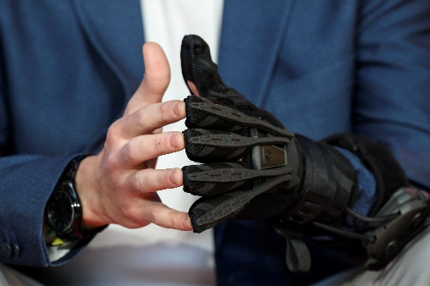  Image source: Philipp Guelland for DLD Hubert Burda Media  For the smart orthosis MotionMate from Powered Orthotics, presented at DLD, Würth Elektronik developed a custom transformer. | 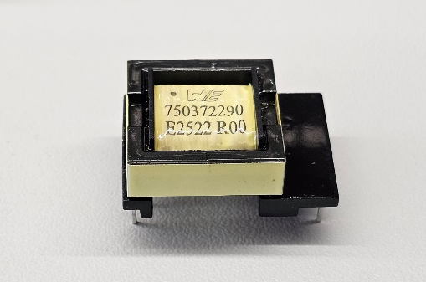  Image source:  Würth Elektronik eiSos Group  Compact, safe, and highly efficient: The flyback transformer from Würth Elektronik was custom-designed for the Powered Orthotics orthosis and operates at 98% efficiency, optimized for serial production.”

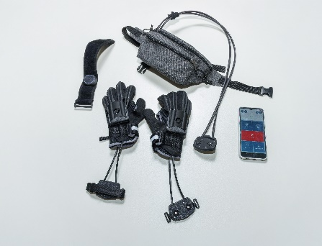  Image source: studio visuell photography (Nico Rademacher), Powered Orthotics UG  Within Reach: The Powered Orthotics orthosis is almost ready for market and aims to enhance the quality of life for more than 100 million people around the world. | 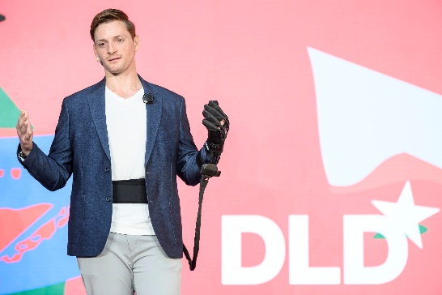 Image source: Philipp Guelland for DLD Hubert Burda Media  User-Friendly Design: MotionMate can be put on independently and operated through a smartphone app (in image: Ryan Alicea, Co-founder & CEO, Powered Orthotics)

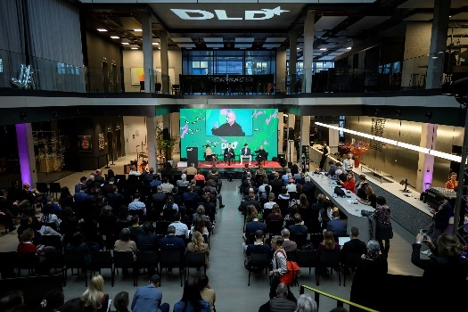Image source: Philipp Guelland for DLD Hubert Burda Media  DLD Munich 2026, Health Tech: Discussion about the MotionMate active hand orthosis with Alexander Gerfer, CTO at Würth Elektronik eiSos Group (right), Ryan Alicea, Co-founder & CEO, Powered Orthotics, (center), and Prof. Dr. Lorenzo Masia, Professor of Intelligent Bio-Robotic Systems at the Technical University of Munich (left). | 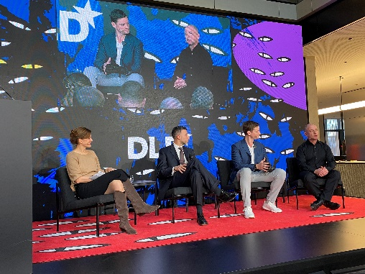Image source:  Würth Elektronik eiSos Group  Moderator Jennifer Wilton and panel participants discuss the future of robotics and prosthetics.

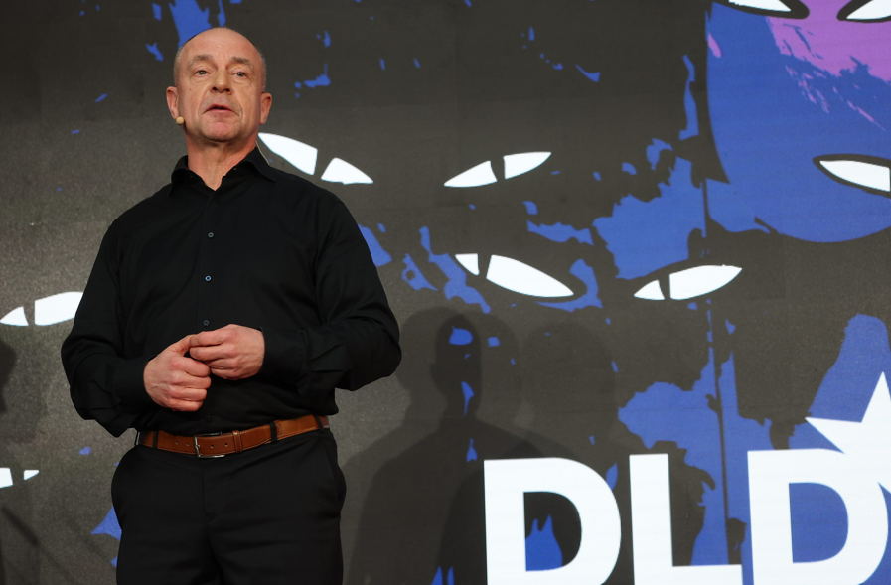  Image source: Karl-Josef Hildenbrand picture alliance for DLD Hubert Burda Media  Alexander Gerfer, CTO at Würth Elektronik eiSos Group: “We are very proud to be part of a project that opens up new possibilities for so many people.” | 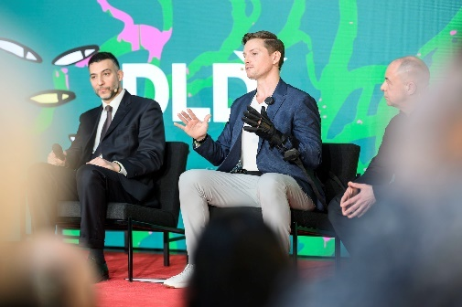Image source: Philipp Guelland for DLD Hubert Burda Media  MotionMate in action: Ryan Alicea, Co-founder & CEO, Powered Orthotics, explains how the promising device works.

About Powered Orthotics
Powered Orthotics was founded to tackle a simple but overlooked reality: when hand function is impaired, even everyday tasks become exhausting or impossible. Our mission is to restore meaningful independence through wearable technology that feels intuitive, is comfortable to wear, and fits naturally into home routines. Today, we’re advancing MotionMate through late-stage prototyping and validation, building the technical, clinical, and quality foundations needed for a medical-grade product. Looking ahead, our focus is on completing verification and certification steps, expanding clinical collaborations, and scaling toward series production so this technology can evolve into a reliable solution used by people around the world.

About the Würth Elektronik eiSos Group
Würth Elektronik eiSos Group is a manufacturer of electronic and electromechanical components for the electronics industry and a technology company that spearheads pioneering electronic solutions. Würth Elektronik eiSos is one of the largest European manufacturers of passive components and is active in 50 countries. Production sites in Europe, Asia and North America supply a growing number of customers worldwide.
The product range includes passive components, power modules, digital isolators, optoelectronics, electromechanical components, thermal management solutions, sensors and wireless modules. The portfolio is rounded off by customer-specific solutions.
The unrivaled service orientation of the company is characterized by the availability of all catalog components from stock without minimum order quantity, free samples and extensive support through technical sales staff and selection tools.
Würth Elektronik is part of the Würth Group, the global market leader in the development, production, and sale of fastening and assembly materials, and employs around 7,500 people. In 2024, the Würth Elektronik Group generated sales of 1.02 Billion Euro.
Würth Elektronik: more than you expect!
Further information at www.we-online.com

Further information:  Würth Elektronik eiSos GmbH & Co. KG  Sarah Hurst  Clarita-Bernhard-Strasse 9  81249 Munich  Germany  Phone: +49 7942 945-5186  E-mail: sarah.hurst@we-online.de  www.we-online.com | Press contact:  HighTech communications GmbH  Brigitte Basilio  Brunhamstrasse 21  81249 Munich  Germany  Phone: +49 89 500778-20  E-mail: b.basilio@htcm.de  www.htcm.de

