PRESS RELEASE

Würth Elektronik expands its online range
Product Navigator Directs You to the Right Component
Waldenburg (Germany), January 14, 2026 – Würth Elektronik introduces a new online tool that significantly simplifies the search for the right components. The Product Navigator helps users select electronic and electromechanical components through practical example applications and typical topologies. With the Navigator, Würth Elektronik refines an approach that has been successfully proven in the Application Guide since 2021. The Application Guide is now fully integrated into the significantly expanded Product Navigator. The advantage: Developers can now find the products relevant to their application area more quickly, without having to work their way through extensive catalogs.
“Selecting electronic and electromechanical components is growing increasingly complex. Electronics developers have to work their way through a wide range of product categories to find the right component. And some components can fulfil different functions across different application areas,” explains Alexander Gerfer, CTO of the Würth Elektronik eiSos Group “With the Product Navigator, we fundamentally solve this problem: Customers can access the online catalog to place an order, or go directly to our REDEXPERT tool, where component variants can be precisely selected on the basis of stored, tested measurement data.”
From the application to the component
The Würth Elektronik Product Navigator makes it easy to explore components by application and quickly find the right solution. The tool’s navigation offers the following application areas to choose from: Shielding and grounding, cable assembly solutions, line filters, power supplies, DC filters, thermal management, optoelectronics, power distribution, IC peripherals, human–machine interaction (switches and displays), high-frequency and wireless communication, as well as measurement and sensor technology. Each area offers typical topologies and plenty of useful additional content to support electronics developers in designing their applications.
Since the products in the Product Navigator are directly linked to the online catalog, free samples, available for almost all Würth Elektronik products, can be ordered with just a few clicks. Components are generally available from stock. For manufacturers of low-volume products: Würth Elektronik has no minimum order quantity requirement.

Available images
The following images can be downloaded from the Internet in printable quality: https://kk.htcm.de/press-releases/wuerth/
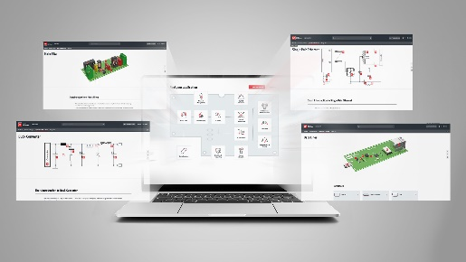
Image source: Würth Elektronik
The Würth Elektronik Product Navigator helps users select electronic and electromechanical components through practical example applications and typical topologies.

About the Würth Elektronik eiSos Group
Würth Elektronik eiSos Group is a manufacturer of electronic and electromechanical components for the electronics industry and a technology company that spearheads pioneering electronic solutions. Würth Elektronik eiSos is one of the largest European manufacturers of passive components and is active in 50 countries. Production sites in Europe, Asia and North America supply a growing number of customers worldwide.
The product range includes passive components, power modules, digital isolators, optoelectronics, electromechanical components, thermal management solutions, sensors and wireless modules. The portfolio is rounded off by customer-specific solutions.
The unrivaled service orientation of the company is characterized by the availability of all catalog components from stock without minimum order quantity, free samples and extensive support through technical sales staff and selection tools.
Würth Elektronik is part of the Würth Group, the global market leader in the development, production, and sale of fastening and assembly materials, and employs around 7,500 people. In 2024, the Würth Elektronik Group generated sales of 1.02 Billion Euro.
Würth Elektronik: more than you expect!
Further information at www.we-online.com

Further information:  Würth Elektronik eiSos GmbH & Co. KG  Sarah Hurst  Clarita-Bernhard-Strasse 9  81249 Munich  Germany  Phone: +49 7942 945-5186  E-mail: sarah.hurst@we-online.de  www.we-online.com | Press contact:  HighTech communications GmbH  Brigitte Basilio  Brunhamstrasse 21  81249 Munich  Germany  Phone: +49 89 500778-20  E-mail: b.basilio@htcm.de  www.htcm.de

