FOR THE MEDIA
New placement platform from ASMPT SMT Solutions
A new era: The SIPLACE V platform
Munich (Germany), January 20, 2026 – ASMPT SMT Solutions, the global market and technology leader in integrated hardware and software solutions for electronics manufacturers, presents its new SIPLACE V platform. Featuring a significant performance boost of up to 30 percent and combining maximum speed with exceptional quality and flexibility. ASMPT’s new machine sets new standards in electronics manufacturing with its compact footprint, full compatibility with existing ASMPT solutions, and long-term investment security.
The SIPLACE V platform is a new design from the ground up. It features an innovative machine frame, highly efficient linear drives, and measurement systems with improved resolutions that enable significantly higher accelerations and more precision, forming the basis for significant improvements in real-life performance. In sectors that are particularly critical for the electronics industry such as automotive, consumer electronics, smartphones, IT and networking technology, the SIPLACE V makes it possible for users to achieve performance improvements of up to 30 percent under realistic production conditions.
Initial field tests already confirm that the new placement platform delivers this performance increase not only in theoretical benchmarks, but in particular under real production conditions characterized by a broad product spectrum, frequent product changeovers, high variant diversity, and demanding process requirements. ”After some 25,000 assembled flat modules and 7.3 million components placed, we can confirm that the field test of the SIPLACE V platform in our high-mix, low-volume production was a complete success. The new placement machines from ASMPT are once again setting new standards in terms of performance, flexibility, quality and effective placement output,” says Martin Zistler, Vice President, Global Engineering at Zollner Elektronik AG.
New generation of placement heads
A central part of the SIPLACE V platform’s performance boost is the advancement in ASMPT’s placement head technology. By achieving a speed of up to 52,500 components per hour with a precision of 25 µm @ 3 σ, the SIPLACE CP20 collect-and-place head sets a new standard in high-speed applications.
The highly flexible CPP head can switch between collect-and-place, pick-and-place and mixed modes based on software commands. This versatility makes it ideal for complex mixed-assembly applications in which it processes up to 28,000 components per hour with placement forces of up to 15 newtons.
The SIPLACE TWIN VHF head is designed for particularly large and unusually shaped components. It processes components measuring up to 200 × 150 × 28 millimeters and up to 100 newtons reliably and with maximum precision. With a capacity to handle up to 6,000 components per hour, it opens up new possibilities for manufacturers in areas like the assembly of complex components such as BGAs, which play an increasingly important role in AI applications.
Maximum flexibility even in the high-speed segment
With the SIPLACE V platform, ASMPT SMT Solutions is setting new standards in terms of productivity and flexibility. It masters the full component spectrum – from ultra-miniature 016008M chips to large-format parts – and demonstrates its strengths particularly in the placement of complex or unusually shaped components.
A universal head interface allows for the speedy exchange of placement heads even while the SIPLACE V keeps running. It is available in single-gantry and dual-gantry versions and can be configured with single-track or dual-track conveyors. A 3D coplanarity module, which checks components and circuit boards for warping and ensures secure assemblies even at top speeds, is optional. It is supplemented by additional cameras that ensure even more precision in special applications.
The platform also accommodates a broad spectrum of PCB formats. With the dual conveyor, it processes boards measuring up to 400 × 280 millimeters, and with the single conveyor even boards measuring up to 700 × 530 millimeters. In addition, up to two tray units can be attached to each machine. Another highlight is the significantly increased number of feeder slots irrespective of previously installed options like the Smart Pin Support, whose pins are picked up by the placement heads, eliminating the need for a separate pin picker.
ASMPT SMT Solutions combines all these features in a footprint of only 1.1 × 2.4 meters, which sets a new floorspace productivity record in electronics manufacturing.
Proven quality, future-proof investment
ASMPT relies on the proven quality characteristics of the SIPLACE series and advances them with its new platform. Functions like individually rotatable nozzle segments, which are unique in the industry, individual component inspection and seamless traceability continue to be part of each machine’s basic configuration. They are complemented by high-resolution cameras that ensure even more accuracy in the assembly process.
Another major contributor to ASMPT’s legendary process reliability is its closed-loop sensor technology, which scans component heights and PCB profiles in real time and adapts placement forces automatically. This ensures that the placement quality stays consistently high even under high cycle rates.
Compatibility and investment protection
The new SIPLACE V platform fits seamlessly into the current portfolio of ASMPT SMT Solutions. Existing hardware components such as feeders or cameras can continue to be used without restrictions. Likewise, all applications from the comprehensive software world of ASMPT SMT Solutions are fully compatible, ranging from the station software to the applications of the WORKS Software Suite and Factory Solutions.
“Our new SIPLACE V platform fits seamlessly into existing line concepts,” explains Thomas Bliem, Vice President R&D at ASMPT SMT Solutions. “This enables electronics manufacturers to modernize their production environments step by step and with full investment protection. At the same time, the platform is designed to offer ideal conditions for future automation steps and AI-based applications already today.”

Illustrations for downloading
The following print-ready artwork is available on the internet for downloading:
https://kk.htcm.de/press-releases/asmpt/

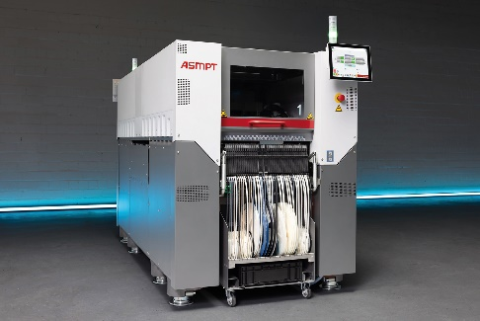 | 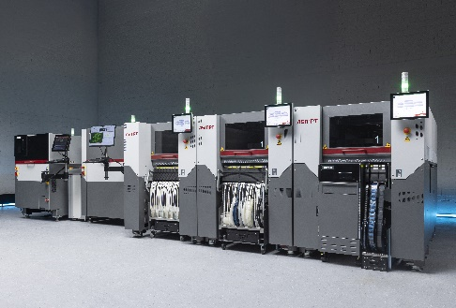
With a footprint of just 1.1 × 2.4 meters, the new SIPLACE V gives electronics manufacturing a decisive boost – not only in real performance, but also in quality, flexibility, and future readiness.  Image credit: ASMPT | The new SIPLACE V platform processes the entire component spectrum – from ultra-small 016008M chips to large-format parts – and proves its strengths especially with challenging or unusually shaped components.  Image credit: ASMPT
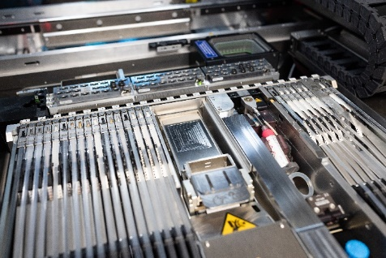 | 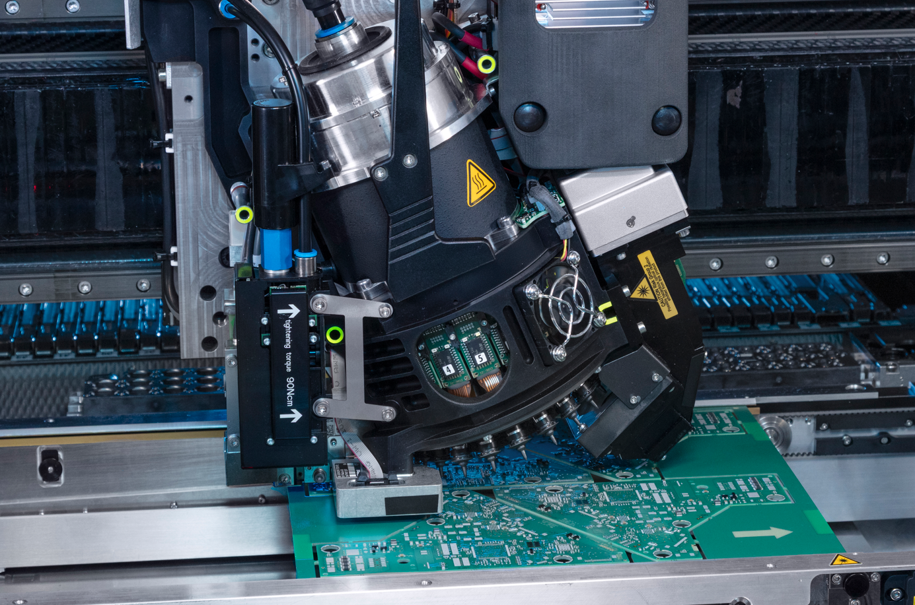
45 available 8 mm slots per location – constant, regardless of the selected options. All existing X-Feeders remain fully compatible, including the Linear Dipping Unit, Power Connector, as well as the SIPLACE Glue Feeder and SIPLACE Measuring Feeder.  Image credit: ASMPT | The new CP20 collect-and-place head has been specifically optimized for maximum performance and precision – delivering up to 52,500 cph at 25 µm @ 3σ, it sets new standards for high-speed applications in electronics manufacturing.  Image credit: ASMPT

About ASMPT Limited (“ASMPT”)
ASMPT Limited is a leading global supplier of hardware and software solutions for the manufacture of semiconductors and electronics. Headquartered in Singapore, ASMPT’s offerings encompass the semiconductor assembly & packaging, and SMT (surface mount technology) industries, ranging from wafer deposition to the various solutions that organize, assemble and package delicate electronic components into a vast range of end-user devices, which include electronics, mobile communications, computing, automotive, industrial and LED (displays). ASMPT partners with customers very closely, with continuous investments in R&D helping to provide cost-effective, industry-shaping solutions that achieve higher productivity, greater reliability, and enhanced quality. ASMPT is a founding member of the Semiconductor Climate Consortium.
To learn more about ASMPT, please visit www.asmpt.com.

The ASMPT SMT Solutions segment
The mission of the SMT Solutions segment within ASMPT is to implement and support the Intelligent Factory at electronics manufacturers worldwide.
ASMPT solutions support the networking, automation, and optimization of central workflows with hardware, software and services that enable electronics manufacturers to transition to the Intelligent Factory in stages and enjoy dramatic improvements in productivity, flexibility, and quality. With its integrated open automation concept, ASMPT opens the door for its customers to economically feasible automation, entirely in accordance with their individual requirements – modular, flexible, and vendor-independent.
The product range includes hardware and software such as SIPLACE placement solutions, DEK printing solutions, inspection and storage solutions, and the WORKS Software Suite. With WORKS, ASMPT offers electronics manufacturers high-quality software for planning, controlling, analyzing and optimizing all processes on the shop floor. Maintaining close relationships with customers and technology partners is a central component of ASMPT’s strategy.
For more information about ASMPT SMT Solutions, visit smt.asmpt.com.
Media contacts:
Global ASMPT Press Office
ASMPT Limited
Susanne Oswald
Rupert-Mayer-Strasse 48
81379 Munich
Germany
Tel: +49 89 20800-26439
E-mail: susanne.oswald@asmpt.com
Website: asmpt.com

HighTech communications GmbH
Barbara Ostermeier
Brunhamstrasse 21
81249 Munich
Germany
Tel.: +49-89 500778-10|
E-mail: b.ostermeier@htcm.de
Website: www.htcm.de

