FOR THE MEDIA
ASMPT SMT Solutions and Shinwa launch cooperation at NEPCON Japan 2026
Strong partnership for innovative Advanced Packaging technologies
Singapore, January 13, 2026 – With the shared objective of addressing the rapidly growing advanced packaging market through innovative, state-of-the-art technologies, ASMPT SMT Solutions have entered into a cooperation agreement with Shinwa Co., Ltd. in Japan to offer a full ASMPT SMT products and solutions portfolio. The partnership will be highlighted at NEPCON Japan from January 21 to 23, 2026, where cutting-edge SIPLACE placement solutions will be exhibited at the Shinwa booth (East Hall 5, Booth E12-16, Tokyo Big Sight).
At NEPCON Japan, Shinwa will present itself as a comprehensive equipment provider for the semiconductor and electronics industries. Alongside its own precision dispensing systems, solder paste solutions, solder joint inspection equipment and advanced packaging technologies, the company will showcase world-leading placement technology from ASMPT SMT Solutions.
Semiconductor and SMT manufacturing converge
Recently honored with a Global Technology Award, ASMPT’s hybrid placement solution SIPLACE CA2 combines semiconductor and SMT processes in a single machine, addressing the growing demand for integrated manufacturing concepts. SIP (System-in-Package) production is seamlessly integrated directly into the SMT line: in a single process step, the system handles both tape-and-reel SMD components and dies directly from sawn wafers. Performance reaches up to 54,000 dies or 76,000 SMT components per hour, with placement accuracy of up to 7 µm @ 3 σ.
Another ASMPT placement solution that will be shown on the booth is the SIPLACE TX micron, a placement platform developed specifically for demanding advanced packaging and high-density applications. Combining placement accuracy of up to ±10 µm with a maximum output of up to 93,000 components per hour, the machine is ideally suited to highly complex and precision-critical production environments.
Visitors can also find out more about ASMPT’s DEK TQ portfolio of solder paste printers, including new automation features such as the DEK TQ GO automatic stencil exchange system.
A partnership driven by collective strength
With its established sales and support network throughout Japan and its strong strategic and technological fit with ASMPT's products and solutions, Shinwa Co., Ltd. is the ideal business partner for ASMPT. The automotive industry is one of Shinwa’s most important customer segments, and there is strong potential to provide assembly solutions for the advanced electronics needed in this market. Shinwa's extensive experience in factory automation complements ASMPT SMT Solutions' commitment to driving digital transformation towards the intelligent factory perfectly.

Illustrations for downloading
The following print-ready artwork is available on the internet for downloading :
https://kk.htcm.de/press-releases/asmpt/

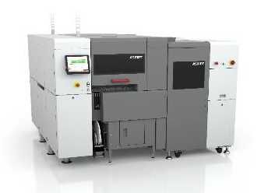 | 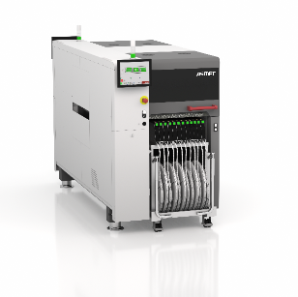
Award-winning SIPLACE CA2 for hybrid high-speed processing of SMDs and dies directly from the wafer.  Image credit: ASMPT | High-performance SIPLACE TX micron placement system: a major innovation step for advanced packaging and high-density applications.  Image credit: ASMPT
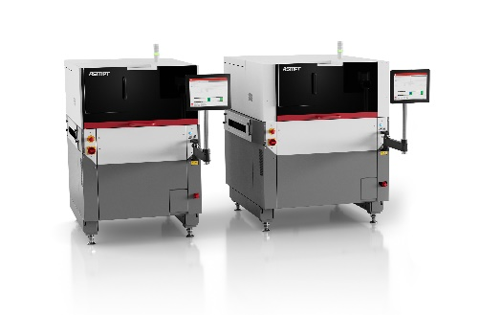
With its many interface standards, the DEK TQ printer platform fits seamlessly into the intelligent factory while its growing number of options automates setup changeovers and minimizes operator assists.

Image credit: ASMPT

About ASMPT Limited (“ASMPT”)
ASMPT Limited is a leading global supplier of hardware and software solutions for the manufacture of semiconductors and electronics. Headquartered in Singapore, ASMPT’s offerings encompass the semiconductor assembly & packaging, and SMT (surface mount technology) industries, ranging from wafer deposition to the various solutions that organize, assemble and package delicate electronic components into a vast range of end-user devices, which include electronics, mobile communications, computing, automotive, industrial and LED (displays). ASMPT partners with customers very closely, with continuous investments in R&D helping to provide cost-effective, industry-shaping solutions that achieve higher productivity, greater reliability, and enhanced quality. ASMPT is a founding member of the Semiconductor Climate Consortium.
To learn more about ASMPT, please visit www.asmpt.com.

The ASMPT SMT Solutions segment
The mission of the SMT Solutions segment within ASMPT is to implement and support the Intelligent Factory at electronics manufacturers worldwide.
ASMPT solutions support the networking, automation, and optimization of central workflows with hardware, software and services that enable electronics manufacturers to transition to the Intelligent Factory in stages and enjoy dramatic improvements in productivity, flexibility, and quality. With its integrated open automation concept, ASMPT opens the door for its customers to economically feasible automation, entirely in accordance with their individual requirements – modular, flexible, and vendor-independent.
The product range includes hardware and software such as SIPLACE placement solutions, DEK printing solutions, inspection and storage solutions, and the WORKS Software Suite. With WORKS, ASMPT offers electronics manufacturers high-quality software for planning, controlling, analyzing and optimizing all processes on the shop floor. Maintaining close relationships with customers and technology partners is a central component of ASMPT’s strategy.
For more information about ASMPT SMT Solutions, visit smt.asmpt.com.
Media contacts:
ASMPT ROA Press Office
SMT Solutions
ASMPT SMT Singapore Pte. Ltd.
Janet Loh
Phone: +65 6877 3948
E-mail: Janet.loh@asmpt.com
Website: smt.asmpt.com

Global ASMPT Press Office
ASMPT Limited
Susanne Oswald
Rupert-Mayer-Strasse 48
81379 Munich
Germany
Tel: +49 89 20800-26439
E-mail: susanne.oswald@asmpt.com
Website: asmpt.com

