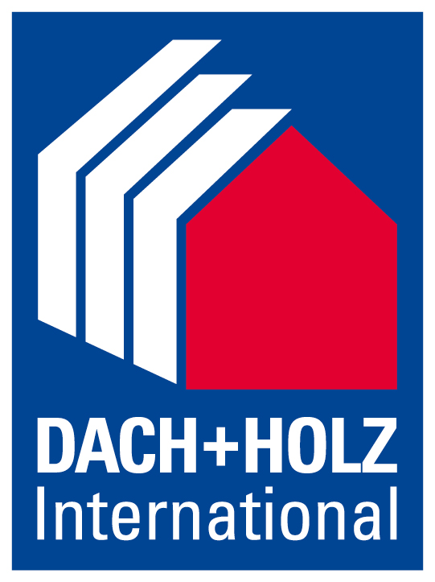
Press release
Schröder Group at Dach+Holz International 2026
Efficiency-enhancing solutions for the roofing industry
24–27 February 2026
Hall 8, Stand 8.326
Wessobrunn-Forst (Germany), 17 December 2025 – When the doors of Dach+Holz International open in Cologne from February 24 to 27, 2026, the Schröder Group will once again be represented with pioneering technologies for sheet metal processing. In Hall 8, Booth 8.326, the machine manufacturer will showcase its broad portfolio, ranging from proven manual machines to high-precision motorized folding machines. The focus will be on how efficiency, repeat accuracy, and flexibility in the sheet metal industry can be further increased.
The two motorized folding machines on display, MAKU and PowerBend Multi, showcase an innovation from Hans Schröder Maschinenbau that makes work significantly easier for roofing workers: tapered bending. An electronically controlled, two-axis backgauge with an accuracy in the tenth of a millimeter range allows tapered and pluggable profiles to be bent. This makes it possible to effortlessly and precisely reproduce, for example, parapet or wall copings and roof edge finishes or cladding with a slope in the workshop, which previously had to be done manually on site. The MAKU is the versatile basic machine for folding up to 2.0 mm thick sheets. A new version will be on display at Dach+Holz, which allows for significantly faster clamping of the sheets.
Innovative way of folding hems
The PowerBend Multi (PBM) folds up to 2.5 mm thin sheets. Schröder demonstrates another innovation with this machine. It has a rotating clamping beam that allows you to switch to a different geometry or tool station. This clamping beam also enables a patented process for folding hems. It is reset and the sheet metal is clamped so that the folding beam has space beyond the vertical. In this way, folding hems can be bent and pressed in a single operation – precisely and in a time-saving manner. The model on display at the exhibition demonstrates this on a 2 mm thick steel sheet with a length of 3200 mm.

A classic craft machine
With the AK (2000 × 1.5 mm) and the ASK 3 (1250 × 1.5 mm), Schröder presents two tried-and-tested machines for the roofing industry. The AK has a foot lever mechanism and optional equipment such as a manual backgauge with digital display, folding angle stop, and a pneumatic folding aid. The ASK 3 segment folding machine offers maximum flexibility for a wide variety of workpiece shapes with its patented eccentric quick-clamping system and large clearance heights of up to 180 mm for the clamping beam, 120 mm for the bottom beam, and 142 mm for the folding beam.
Motorized shear with control option
In addition to folding machines, the Schröder Group is also exhibiting a motorized shear. Although the MHSU is the entry-level model among motorized shears, it is very convenient and precise thanks to its 750 mm backgauge, which can be adjusted from the front and features a digital display. The machine on display at the exhibition shows what is possible with optional extras. It is equipped with an NC positioning gauge that allows different gauge lengths to be programmed. The variable sheet metal hold-up device also allows the user to specify at the touch of a button whether the sheet metal being cut is ejected forwards or backwards.

Available images
The following images are available for download in printable format at:
https://kk.htcm.de/press-releases/schroeder/
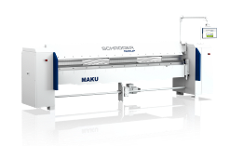  Image source: Schröder Group  The MAKU folding machine with the option of tapered bending of form-fitting pluggable profiles with precision in the range of tenths of a millimeter. | 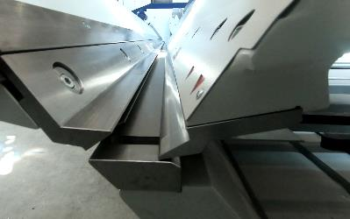  Image source: Schröder Group  Ingenious hemming function: With the PowerBend Multi, hollow folds can be created in a single step using the folding beam.

Available videos
You can find videos on this topic on our YouTube channel:
https://www.youtube.com/watch?v=0pb6ZUd6HxY
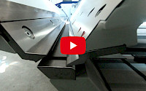
Source: Schröder Group

The clamping function of the PowerBend Multi is demonstrated on YouTube.

About Schröder Group
The Schröder Group consists of Hans Schröder Maschinenbau GmbH, which is located in Wessobrunn-Forst, Germany, SCHRÖDER-FASTI Technologie GmbH, located in Wermelskirchen, Germany and the SMU GmbH, located in Leinburg-Weißenbrunn.
Founded in 1949, Hans Schröder Maschinenbau GmbH unifies traditional and modern approaches in machine building: Successfully managed as a quality and customer-oriented, family-owned company, Hans Schröder Maschinenbau is specialized in the development of modern machine concepts for bending and cutting sheet metal.
The successful integration of the Fasti Company in 2006 and its worldwide presence make the Schröder Group one of today‘s leading providers of machines for bending, cutting, beading, flanging, and circular bending all types of sheet metal. The company‘s precision machines range from proven solutions for craftsmen to innovative, high-performance machines for automatic industrial production processes. 2021 the Schröder Group was expanded by the tool manufacturer SMU GmbH. Overall, the Schröder Group currently employs more than 300 people at various locations at home and abroad.
Further information is available at https://www.schroedergroup.eu/en/.

Press contact:
Schröder Group
Hans Schröder Maschinenbau GmbH
Janina Biró
Feuchten 2
82405 Wessobrunn-Forst
Germany
T: +49 8809 9220-68
E-mail: jj@schroedergroup.eu
Website: www.schroedergroup.eu

HighTech communications GmbH
Brigitte Basilio
Brunhamstraße 21
81249 München
Germany
T: +49 89 500778-20
E-mail: b.basilio@htcm.de
Website: www.htcm.de

