PRESS RELEASE

Hyperloop sponsor Hufschmied uses project for demonstration purposes
Original and model: Machining challenges solved
Bobingen (Germany), December 15, 2025 – Hufschmied Zerspanungssysteme is now using a model of the Hyperloop vacuum magnetic levitation train at trade fairs as a demonstrator for the machining of challenging materials. It was first seen at the leading plastics trade fair K 2025 in Düsseldorf in October. The background to this exhibit is TUM Hyperloop, a project of the Technical University of Munich in which Hufschmied played a key role. In 2023, TUM Hyperloop completed Europe's first passenger-sized Hyperloop test segment, received the first certification for passenger transport from TÜV SÜD, and conducted a manned test run. Most of the molding tools for the innovative vehicle and the transport tube were manufactured at the Hufschmied Zerspanungssystem technology center in Bobingen. The post-processing of the fiber composite components was also mostly carried out by the manufacturer of material-specific tools.
The Hyperloop principle of drag-free transport through vacuum tubes requires the highest precision in the manufacture of the pressurized cabin for passengers. The Hyperloop team at the Technical University of Munich was therefore happy to receive support from Hufschmied Zerspanungssysteme, whose tools and process optimizations in the field of fiber composites enjoy an excellent reputation in the automotive and aerospace industries. TUM Hyperloop Sponsoring was now chosen as the topic for a demonstrator realized in collaboration with KraussMaffei. The manufacturer of machines for plastics production contributed the additively manufactured blank for the transport tube to the Hyperloop model.
Examples of challenges
The tube was made of PETG with 30% glass fiber. In addition to the difficult clamping of the part, it was also the very temperature-sensitive 3D printing filament of the glycol-modified PET that made precise machining difficult. Machining was performed using Proto-Line HC403, a three-edged HSC torus milling tool with low heat generation, which prevents adhesion and melting thanks to its cutting geometry and polished flutes. The tool was also used to finish the chamfers on the model of the rail made from the very dense block material SikaBlock M960. Otherwise, as with the SikaBlock M700 N for the passenger compartment, tools from the Blockbuster series were used. This solution from Hufschmied for model and prototype construction is valued for its high removal rates during roughing and excellent surface finish during finishing.
Finally, the model of the drive unit made of aluminum EN AW-6082 serves as an example of the use of the Wolverine tool, an aluminum roughing tool with an exceptionally high chip volume.
“We were happy to support the TUM Hyperloop project and enjoyed working with KraussMaffei to create this ‘eye-catcher’ for trade fair appearances,” says Wolfgang Rinke, Business Development at Hufschmied Zerspanungssysteme GmbH. “Additive manufacturing and the necessary machining post-processing are highly topical issues to which we can make valuable contributions – because ultimately, the efficiency of the entire process will determine whether additive manufacturing will continue to expand from laboratories into production halls as an economical option.”

Available images
The following images can be downloaded from the Internet in printable quality:
https://kk.htcm.de/press-releases/hufschmied/
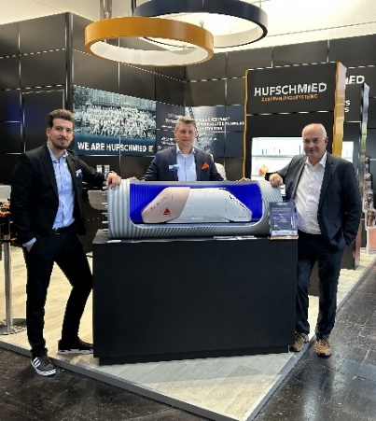  Image source: Hufschmied Zerspanungssysteme  Ender Murat Ferat, Product Manager Additive Manufacturing, and Kristijan Mikic, Expert Sales Manager Additive Manufacturing at KraussMaffei, together with Wolfgang Rinke, Business Development at Hufschmied, and the Hyperloop model at the “K” plastics trade fair in Düsseldorf (from left to right). | 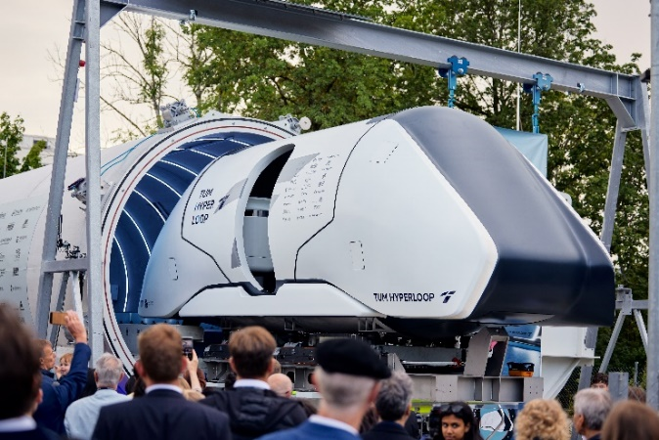  Image source: TUM HYPERLOOP  The model: On July 27, 2023, the Hyperloop test track and capsule were presented to the public.

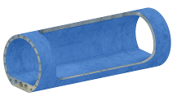  Image source:  Hufschmied Zerspanungssysteme  Additive and machining processes were used to transform the CAD model into a glass fiber-reinforced plastic model of the Hyperloop tube. | 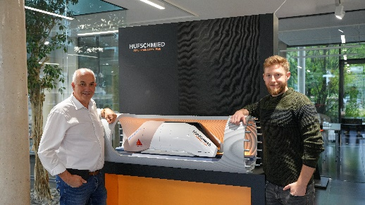  Image source:  Hufschmied Zerspanungssysteme  Staying in touch: Wolfgang Rinke, Business Development at Hufschmied Zerspanungssysteme GmbH, and Florian Janke, CTO at Neoways Technologies GmbH, the start-up that emerged from TUM Hyperloop.

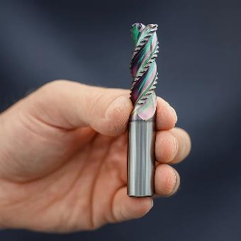  Image source:  Hufschmied Zerspanungssysteme  HC403BDSR Wolverine, a solid carbide high-performance roughing cutter for aluminum | 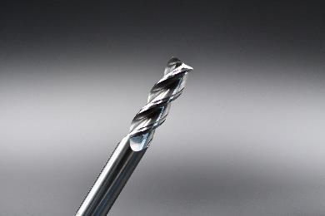  Image source:  Hufschmied Zerspanungssysteme  Proto-Line HC403 is a three-edged HSC torus milling tool with low heat generation, making it ideal for engineering plastics.

About Hufschmied Zerspanungssysteme GmbH
Established in 1991 and headquartered in Bobingen near Augsburg, Hufschmied Zerspanungssysteme GmbH is a manufacturer of high-quality tools for machinable production and friction stir welding. By specializing at an early stage in the machining of plastics, fiberglass materials and carbon fiber, Hufschmied has become a leader in Europe in the development of solutions for new materials. The company is an established system supplier to renowned machine tool manufacturers. Tools and manufacturing process consulting from Hufschmied are particularly valued in the automotive and aerospace industries as well as in medical technology. The company is involved in numerous organizations, including Composites United Deutschland e. V. Hufschmied's manufacturing operations are located in Bobingen, Winterlingen and Sigmaringen on the Swabian Alb. Hufschmied is certified according to ISO 9001:2015 (quality management) and ISO 14001:2015 (environmental management).

Hufschmied Zerspanungssysteme GmbH – One Cut Ahead
For more information: www.hufschmied.net

Additional information:  Hufschmied Zerspanungssysteme GmbH  Marco Beigl  Edisonstrasse 11d  86399 Bobingen  Germany  Phone: +49 8234 9664-0  Telefax: +49 8234 9664-99  E-Mail: info@hufschmied.net  www.hufschmied.net | Press contact:  HighTech communications GmbH  Brigitte Basilio  Brunhamstrasse 21  81249 Munich  Germany  Phone: +49 89 500778-20  E-Mail: b.basilio@htcm.de  www.htcm.de

