FOR THE MEDIA
ASMPT presents optimized Odd Shaped Component (OSC) Package
Mastering OSCs for maximum competitive advantage
Shanghai (China), December 10, 2025 – With the optimized SIPLACE OSC Package, technology and market leader ASMPT SMT Solutions is strengthening the competitiveness of modern electronics manufacturing. The enhanced package ensures reliable placement of complex odd shaped components (OSCs) – from heavy connectors with numerous pins to expensive, large-format ball grid arrays (BGAs) – through the precise interaction of a highly innovative placement head, a powerful vision system, and intelligent control. This enables even sensitive or unusually shaped components to be placed with maximum process reliability while minimizing costly rejects.
“OSCs are commonly placed onto the almost fully assembled circuit board at the end of the production line,” says Petra Klein-Gunnewigk, Senior Product Manager Placement Solutions at ASMPT SMT Solutions. “At this stage, a mistake would make the entire circuit board unusable. With modern processors, each of which can cost several thousand dollars, such a mistake can have huge consequences, which is why investing in reliable placement machines is doubly worthwhile.”
New challenges arising from complex ball grid arrays
In addition to classic OSCs for power electronics, such as plug-in connectors, it is mostly ball grid arrays (BGAs) and complex system-in-package modules that pose special challenges for manufacturers. These components may already have several thousand contacts today, and for AI chips, contact numbers in the five-digit range are no longer a rarity. On top of this, they are often asymmetrically structured so that their functional center of gravity is different from their geometric center.

Improved solutions: SIPLACE OSC Package and SIPLACE placement head TWIN
Selecting SIPLACE placement machines from ASMPT gives users a competitive advantage in this demanding market segment. The SIPLACE OSC Package masters the safe placement of OSCs through the precise interaction of placement head, vision system and intelligent control. To name just one example, the machines determine their optimal placement speed based on the mass inertia of the respective component.
A precise 3D coplanarity measurement system checks the component’s planarity. This is crucial, especially with large components, for ensuring that all of the component’s leads make secure contact with the circuit board. Additional pre- and post-placement inspection capabilities that are into the SIPLACE placement machine detect potential errors such as foreign materials at an early stage. This avoids time-consuming repairs or having to scrap the entire board – without having to invest in special equipment. Even PCB warpage is detected and automatically compensated. The machine reliably detects components with bent pins or fine hair cracks and discards them automatically. Each component gets inspected multiple times. And to move the components, many OSC-specific grippers and nozzles are available.
The SIPLACE placement head TWIN in the VHF version (Very High Force) is another important factor where OSCs are concerned. It handles components weighing up to 500 grams and places them with forces of up to 100 newtons. Additionally, it can place components measuring up to 200 × 150 millimeters. A snap-in control system makes sure that connectors engage correctly.
Many years of experience, customized solutions
“Whether you are dealing with OSC heavyweights for power electronics or highly complex BGAs for AI servers — with our decades of experience in all areas of electronics production we find the right assembly solution for every new technology,” says Petra Klein-Gunnewigk. “And if standard parts are not sufficient, we can develop customer-specific solutions on demand, ranging from special grippers to custom-tailored nozzles.”

Illustrations for downloading
The following print-ready artwork is available on the internet for downloading :
https://kk.htcm.de/press-releases/asmpt/

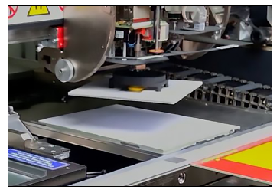 | 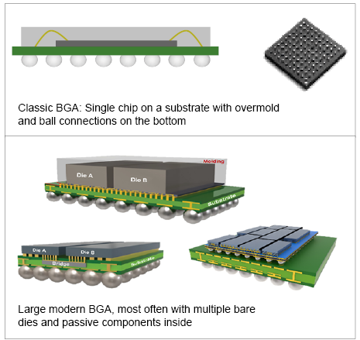
SIPLACE TWIN VHF placement head picking up a 150 × 150 mm component.  Image credit: ASMPT | BGA packages range from compact, simple designs to highly complex variants with large form factors and lots of solder balls.  Image credit: ASMPT
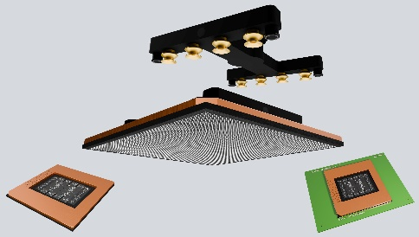

The optimized OSC package can process components measuring up to 200 x 150 mm and weighing up to 500 g.

Image credit: ASMPT

About ASMPT Limited (“ASMPT”)
ASMPT Limited is a leading global supplier of hardware and software solutions for the manufacture of semiconductors and electronics. Headquartered in Singapore, ASMPT’s offerings encompass the semiconductor assembly & packaging, and SMT (surface mount technology) industries, ranging from wafer deposition to the various solutions that organize, assemble and package delicate electronic components into a vast range of end-user devices, which include electronics, mobile communications, computing, automotive, industrial and LED (displays). ASMPT partners with customers very closely, with continuous investments in R&D helping to provide cost-effective, industry-shaping solutions that achieve higher productivity, greater reliability, and enhanced quality. ASMPT is a founding member of the Semiconductor Climate Consortium.
To learn more about ASMPT, please visit www.asmpt.com.

The ASMPT SMT Solutions segment
The mission of the SMT Solutions segment within ASMPT is to implement and support the Intelligent Factory at electronics manufacturers worldwide.
ASMPT solutions support the networking, automation, and optimization of central workflows with hardware, software and services that enable electronics manufacturers to transition to the Intelligent Factory in stages and enjoy dramatic improvements in productivity, flexibility, and quality. With its integrated open automation concept, ASMPT opens the door for its customers to economically feasible automation, entirely in accordance with their individual requirements – modular, flexible, and vendor-independent.
The product range includes hardware and software such as SIPLACE placement solutions, DEK printing solutions, inspection and storage solutions, and the WORKS Software Suite. With WORKS, ASMPT offers electronics manufacturers high-quality software for planning, controlling, analyzing and optimizing all processes on the shop floor. Maintaining close relationships with customers and technology partners is a central component of ASMPT’s strategy.
For more information about ASMPT SMT Solutions, visit smt.asmpt.com.
Media contacts:
China ASMPT Press Office
SMT Solutions
Guan Jing
Phone: +86 (755) 26934550-2109
E-mail: jing.guan@asmpt.com
Website: smt.asmpt.com

Global ASMPT Press Office
ASMPT Limited
Susanne Oswald
Rupert-Mayer-Strasse 48
81379 Munich
Germany
Tel: +49 89 20800-26439
E-mail: susanne.oswald@asmpt.com
Website: asmpt.com

