PRESS RELEASE

Würth Elektronik presents its film capacitors for noise suppression
Certified Component for the Mains Input
Waldenburg (Germany), December 3, 2025 – Würth Elektronik expands its portfolio of components for the mains input: The new series of WCAP-FTY2 film capacitors is optimized for use in noise suppression and complies with X1 or Y2 safety classes in accordance with IEC 60384-14. The very high impulse dielectric strength compared to X2 capacitors, along with other product-specific parameters, is confirmed by VDE with ENEC10 certification.
Würth Elektronik's new WCAP-FTY2 series film capacitors are interference suppression capacitors for use as X1 or Y2 capacitors. When used as an X1 capacitor, it is placed between the phase (L) and neutral conductor (N). In a Y2 application, the capacitor is placed between the phase (L) and ground (PE) or between the neutral conductor and ground.
As metallized film capacitors, the new components are designed to be self-healing, making them particularly fail-safe. Their primary use is as mains filters in household appliances and interference suppression in industrial applications, such as inverters and motor control systems.
Developers can receive free samples and benefit from a specialized range of services. The REDEXPERT online platform provides individually measured impedance curves to facilitate component selection. A design kit is also available.

Available images
The following images can be downloaded from the Internet in printable quality: https://kk.htcm.de/press-releases/wuerth/

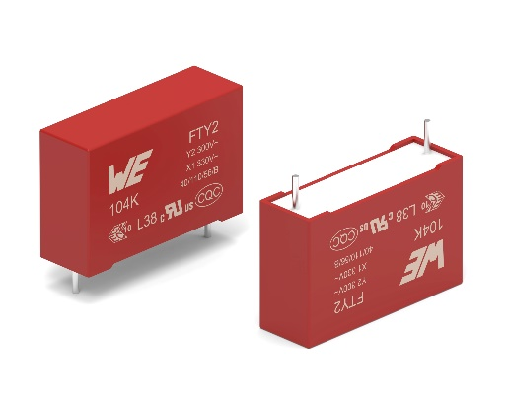Image source: Würth Elektronik
Würth Elektronik is launching another series of film capacitors known as WCAP-FTY2.

About the Würth Elektronik eiSos Group
Würth Elektronik eiSos Group is a manufacturer of electronic and electromechanical components for the electronics industry and a technology company that spearheads pioneering electronic solutions. Würth Elektronik eiSos is one of the largest European manufacturers of passive components and is active in 50 countries. Production sites in Europe, Asia and North America supply a growing number of customers worldwide.
The product range includes passive components, power modules, digital isolators, optoelectronics, electromechanical components, thermal management solutions, sensors and wireless modules. The portfolio is rounded off by customer-specific solutions.
The unrivaled service orientation of the company is characterized by the availability of all catalog components from stock without minimum order quantity, free samples and extensive support through technical sales staff and selection tools.
Würth Elektronik is part of the Würth Group, the global market leader in the development, production, and sale of fastening and assembly materials, and employs around 7,500 people. In 2024, the Würth Elektronik Group generated sales of 1.02 Billion Euro.
Würth Elektronik: more than you expect!
Further information at www.we-online.com

Further information:  Würth Elektronik eiSos GmbH & Co. KG  Sarah Hurst  Clarita-Bernhard-Strasse 9  81249 Munich  Germany  Phone: +49 7942 945-5186  E-mail: sarah.hurst@we-online.de  www.we-online.com | Press contact:  HighTech communications GmbH  Brigitte Basilio  Brunhamstrasse 21  81249 Munich  Germany  Phone: +49 89 500778-20  E-mail: b.basilio@htcm.de  www.htcm.de

