FOR THE MEDIA
ASMPT at Productronica 2025
Beginning of a new era: ASMPT takes off
Singapore, December 1, 2025 – ASMPT, the global market and technology leader for manufacturing equipment in the semiconductor and electronics industries, once again defined the standards of semiconductor and electronics manufacturing at this year’s Productronica trade fair in Munich. The newly developed SIPLACE V placement platform impressed the trade visitors with significant performance, flexibility and quality improvements under real production conditions, and the hybrid SIPLACE CA2 placement machine was honored with a Global Technology Award. The two highly innovative precision bonders AMICRA NANO and MEGA for advanced packaging solutions in optoelectronics and photonics applications also attracted a lot of attention.
“For 50 years, the Productronica has been the leading global trade fair for our industry – a yardstick for technologies, markets, and the entire industry, which is largely driven by electronics manufacturing. It also offers a central platform for affirming the innovative strength and competitiveness of Europe in the increasingly consolidating semiconductor and electronics manufacturing sector. As the only supplier that covers the entire value chain from SEMI to SMT with integrated hardware and software solutions, we demonstrated in an impressive manner the key role ASMPT will play in tomorrow’s intelligent and sustainable manufacturing operations,” said Guenter Lauber, ASMPT CSO and SMT Segment Chairman. “The 2025 Productronica clearly exceeded our expectations. We were particularly pleased to see the enthusiasm with which many visitors from all over the world experienced our totally new SIPLACE V in action for the first time.”
Newly developed: The SIPLACE V
The SIPLACE V, which has been newly developed from the ground up, provides a significant performance boost for the intelligent factory. In key industries, it enables performance increases of up to 30 percent under demanding real-life production conditions. In a footprint of merely 1.1 by 2.4 meters, its optimized placement heads can assemble up to 105,000 components per hour with a precision of 25 µm @ 3 σ. Thanks to its broad component spectrum, which ranges from 016008M chips to large BGAs and OSCs, it offers the widest possible scope of applications. And since the future-oriented architecture of the SIPLACE V opens up generous performance reserves for future automation and AI functions, it also provides long-term investment protection – all while being fully compatible with existing hardware and software solutions from ASMPT.
Award winner: The SIPLACE CA2
With its SIPLACE CA2, ASMPT demonstrated at the Productronica how placement technology and semiconductor manufacturing can be combined in an intelligent solution. The hybrid placement platform processes both taped SMDs and dies taken directly off the sawed wafer in a single process step, thus making the entire die taping process superfluous – an advantage that reduces costs and minimizes waste significantly. The machine’s forward-looking concept also impressed the jury of the Global Technology Awards, which honored the hybrid platform with one of its prestigious prizes.
Growth market: Advanced packaging
The trade audience was equally impressed by two highly innovative precision bonders at the ASMPT booth. With this MEGA multi-chip bonding solution, ASMPT is opening up a new class of chip placement precision and productivity in semiconductor production. The MEGA, which performs tasks that used to require an entire machine line, is ideally suited for forward-looking applications in the areas of AI, smart mobility, and hyperconnectivity.
For the production of co-packaged optics, ASMPT presented the ultra-precise AMICRA NANO die and flip-chip bonder. The platform combines placement accuracy in the sub-micrometer range with eutectic high-speed AuSn bonding, making it possible to reliably manufacture highly miniaturized opto-electronic components that execute the transition between optical and electrical signal processing. They are essential for modern data centers and networks that require energy-efficient and powerful data transmission with minimal latency.
Illustrations for downloading
The following print-ready artwork is available on the internet for downloading:
https://kk.htcm.de/press-releases/asmpt/

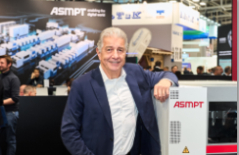 | 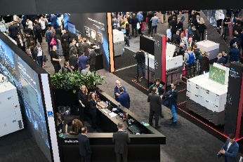
Guenter Lauber, ASMPT CSO and SMT Segment Chairman is delighted with the high level of interest in the new SIPLACE V placement platform.  Image credit: ASMPT | Trade visitors from all over the world visited the ASMPT booth to learn about the latest solutions from ASMPT Semiconductor Solutions, ASMPT SMT Solutions, and Critical Manufacturing.  Image credit: ASMPT
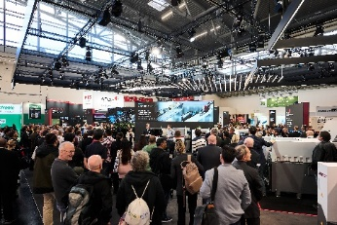 | 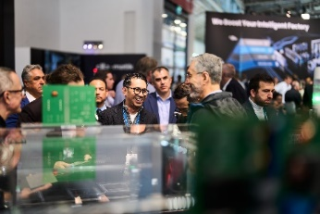
A real crowd magnet was the ASMPT Show, where ASMPT presented its latest solutions for electronics and semiconductor manufacturing four times a day.  Image credit: ASMPT | Also attracting lots of interest was ASMPT’s optimized OSC Package, with which process-reliable placements of large and complex components and BGAs can be seamlessly integrated into SMT lines.  Image credit: ASMPT
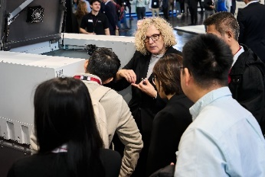 | 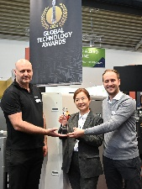
The SIPLACE V attracted numerous visitors, many of whom used the event to get first-hand information about the new placement platform.  Image credit: ASMPT | The forward-looking concept of the hybrid SIPLACE CA2 placement platform was honored with the prestigious award by the jury of the Global Technology Awards.  Image credit: ASMPT
About ASMPT Limited (“ASMPT”)
ASMPT Limited is a leading global supplier of hardware and software solutions for the manufacture of semiconductors and electronics. Headquartered in Singapore, ASMPT’s offerings encompass the semiconductor assembly & packaging, and SMT (surface mount technology) industries, ranging from wafer deposition to the various solutions that organize, assemble and package delicate electronic components into a vast range of end-user devices, which include electronics, mobile communications, computing, automotive, industrial and LED (displays). ASMPT partners with customers very closely, with continuous investments in R&D helping to provide cost-effective, industry-shaping solutions that achieve higher productivity, greater reliability, and enhanced quality. ASMPT is a founding member of the Semiconductor Climate Consortium.
To learn more about ASMPT, please visit www.asmpt.com.

About ASMPT SMT Solutions
The mission of the SMT Solutions segment within ASMPT is to implement and support the Intelligent Factory at electronics manufacturers worldwide.
ASMPT solutions support the networking, automation, and optimization of central workflows with hardware, software and services that enable electronics manufacturers to transition to the Intelligent Factory in stages and enjoy dramatic improvements in productivity, flexibility, and quality. With its integrated open automation concept, ASMPT opens the door for its customers to economically feasible automation, entirely in accordance with their individual requirements – modular, flexible, and vendor-independent.
The product range includes hardware and software such as SIPLACE placement solutions, DEK printing solutions, inspection and storage solutions, and the WORKS Software Suite. With WORKS, ASMPT offers electronics manufacturers high-quality software for planning, controlling, analyzing and optimizing all processes on the shop floor. Maintaining close relationships with customers and technology partners is a central component of ASMPT’s strategy.
For more information about ASMPT SMT Solutions, visit smt.asmpt.com.
About ASMPT Semiconductor Solutions (“ASMPT SEMI”)
ASMPT SEMI is the leading provider of forward-looking solutions for advanced packaging and semiconductor assembly. With its commitment to innovation and customer satisfaction, ASMPT SEMI offers a comprehensive range of products and services that meet the evolving needs of the microelectronics industry. Expert knowledge covers areas such as flip-chip and wafer-level packaging, advanced interconnect technologies, and more. ASMPT SEMI’s state-of-the-art solutions enable customers to achieve higher performance, greater reliability, and improved cost-efficiency in the manufacturing of their semiconductor devices.
ASMPT SEMI sees itself as a trailblazer and driver of the intelligence revolution. With its advanced packaging and assembly technologies, the division creates the invisible links that make intelligent applications in the areas of artificial intelligence, smart mobility and hyperconnectivity possible.
For more information about ASMPT SEMI, visit semi.asmpt.com.

Media contacts:
ASMPT ROA Press Office
SMT Solutions
ASMPT SMT Singapore Pte. Ltd.
Janet Loh
Phone: +65 6877 3948
E-mail: Janet.loh@asmpt.com
Website: smt.asmpt.com

Global ASMPT Press Office
ASMPT Limited
Susanne Oswald
Rupert-Mayer-Strasse 48
81379 Munich
Germany
Tel: +49 89 20800-26439
E-mail: susanne.oswald@asmpt.com
Website: asmpt.com

