Press release
Schröder Group exhibition review
Automation and tapered bending inspire visitors at Blechexpo
Wessobrunn-Forst (Germany), November 5, 2025 – The Schröder Group draws a thoroughly positive conclusion from this year's Blechexpo. In addition to numerous German visitors, a particularly large number of sheet metal workers from the Baltic States visited the company's stand this time. Overall, visitors showed great interest in the MAK 4 Evolution UD, which offers the highest degree of automation achievable in sheet metal folding without the use of robots, thanks to its up-and-down folding beam, Advanced Handling System (AHS), and tool changer.
Another attraction for visitors was the tapered bending function on the PowerBend Multi motorized folding machine. Thanks to its adjustable stop, it can be used to produce profiles that can be inserted into one another, for example.
Visitor highlights with new features
Two proven machines from the Schröder Group were once again very popular: the 134/15/2 mm motorized slip bending roll, known for its high repeat accuracy, and the PowerBend Professional. The latter, valued by both craftsmen and industrial users, was presented with the new hemming function: hollow folds can now be produced in a single step with the folding beam – eliminating the need for an additional step with the clamping beam.
More exhibition machines
Numerous visitors were also impressed by the great flexibility and versatility of the PowerBend Industrial when processing complex profiles. With an opening height of 850 mm on the clamping beam, this machine offers the possibility of using tools up to 400 mm. The PDC 3200 × 3.0 mm motorized shear with automatic blade gap calculation and maximum precision also attracted a lot of attention, as it allows even thin sheets to be cut with virtually no burrs.

Young talents on exhibition tour
The exhibition ended with a special highlight: to enable the Schröder Group's trainees to experience Blechexpo up close, they traveled to Stuttgart by bus with their instructors—a welcome opportunity to experience state-of-the-art sheet metal processing live.
Following the successful Blechexpo trade fair, the Schröder Group is already busy preparing for its next major appearance: at DACH+HOLZ International in Cologne from February 24 to 27, 2026, the company will once again be presenting its innovative sheet metal processing solutions in Hall 8, Booth 8.326.

Available images
The following images are available for download in printable format at:
https://kk.htcm.de/press-releases/schroeder/
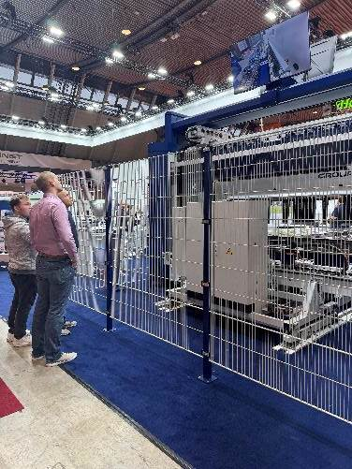Image source: Schröder Group  MAK 4 Evolution UD with folding beam  and clamping beam tool changer |  | 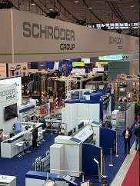Image source: Schröder Group  The Schröder Group once again showcased a broad cross-section of its product portfolio at Blechexpo.
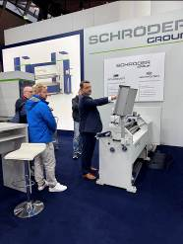Images source: Schröder Group  One of the smallest and most popular machines at the exhibition stand: Schröder-Fasti slip bending roll 134/15/2 mm | 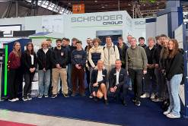Image source: Schröder Group  Sabrina and Markus Hibler (CEO of Hans Schröder Maschinenbau) were delighted to welcome the trainees and trainers to the exhibition.

About Schröder Group
The Schröder Group consists of Hans Schröder Maschinenbau GmbH, which is located in Wessobrunn-Forst, Germany, SCHRÖDER-FASTI Technologie GmbH, located in Wermelskirchen, Germany and the SMU GmbH, located in Leinburg-Weißenbrunn.
Founded in 1949, Hans Schröder Maschinenbau GmbH unifies traditional and modern approaches in machine building: Successfully managed as a quality and customer-oriented, family-owned company, Hans Schröder Maschinenbau is specialized in the development of modern machine concepts for bending and cutting sheet metal.
The successful integration of the Fasti Company in 2006 and its worldwide presence make the Schröder Group one of today‘s leading providers of machines for bending, cutting, beading, flanging, and circular bending all types of sheet metal. The company‘s precision machines range from proven solutions for craftsmen to innovative, high-performance machines for automatic industrial production processes. 2021 the Schröder Group was expanded by the tool manufacturer SMU GmbH. Overall, the Schröder Group currently employs more than 300 people at various locations at home and abroad.
Further information is available at https://www.schroedergroup.eu/en/.

Press contact:
Schröder Group
Hans Schröder Maschinenbau GmbH
Janina Biró
Feuchten 2
82405 Wessobrunn-Forst
Germany
T: +49 8809 9220-68
E-mail: jj@schroedergroup.eu
Website: www.schroedergroup.eu

HighTech communications GmbH
Brigitte Basilio
Brunhamstraße 21
81249 München
Germany
T: +49 89 500778-20
E-mail: b.basilio@htcm.de
Website: www.htcm.de

