PRESS RELEASE
Würth Elektronik ICS Germany honored by EcoVadis
Gold Medal for Sustainability Performance
Niedernhall (Germany), 4 November 2025 – Würth Elektronik ICS has undergone its most recent evaluation by EcoVadis and has been awarded the Gold Medal for its sustainability performance. After receiving a Silver rating last year, the provider of electromechanical and electronic solutions for signal and power distribution in commercial vehicles and mobile machinery improved its score by twelve points, reaching 81 out of 100. This places Würth Elektronik ICS among the top five percent of companies evaluated worldwide in the last 12 months. A key improvement contributing to this success was the documented assessment of suppliers regarding social and environmental criteria.
EcoVadis is an international rating platform for sustainability and Corporate Social Responsibility (CSR), providing independent and transparent evaluations based on clear criteria. Founded in 2007 in Paris, EcoVadis measures companies’ sustainability performance across four core areas: Environment, Labor & Human Rights, Ethics, and Sustainable Procurement.
Key Improvements
Würth Elektronik ICS earned the Gold Medal primarily due to three major improvements: the systematic evaluation of suppliers based on social and environmental criteria, the implementation of CMRT/EMRT processes and templates for responsible sourcing (CMRT = Conflict Minerals Reporting Template, EMRT = Extended Minerals Reporting Template), and the completion of its initial Scope 3 emissions calculations according to the Greenhouse Gas Protocol. Scope 3 includes indirect emissions across the entire value chain, making it particularly complex to assess.
“We are proud of the progress we’ve made in our sustainability journey over the past two years,” said Ali Khaqan, Sustainability Officer at Würth Elektronik ICS. “The EcoVadis Gold Medal reflects our commitment to continuous improvement and strengthens the visibility of our efforts with customers and partners.”
The EcoVadis rating is based on international sustainability standards such as the ten principles of the UN Global Compact, the conventions of the International Labour Organization (ILO), the Global Reporting Initiative (GRI) standard, and ISO 26000. The ratings provide an evidence-based and comparable analysis of sustainability performance.

Available images
The following images can be downloaded from the Internet in printable quality: https://kk.htcm.de/press-releases/wuerth-ics/
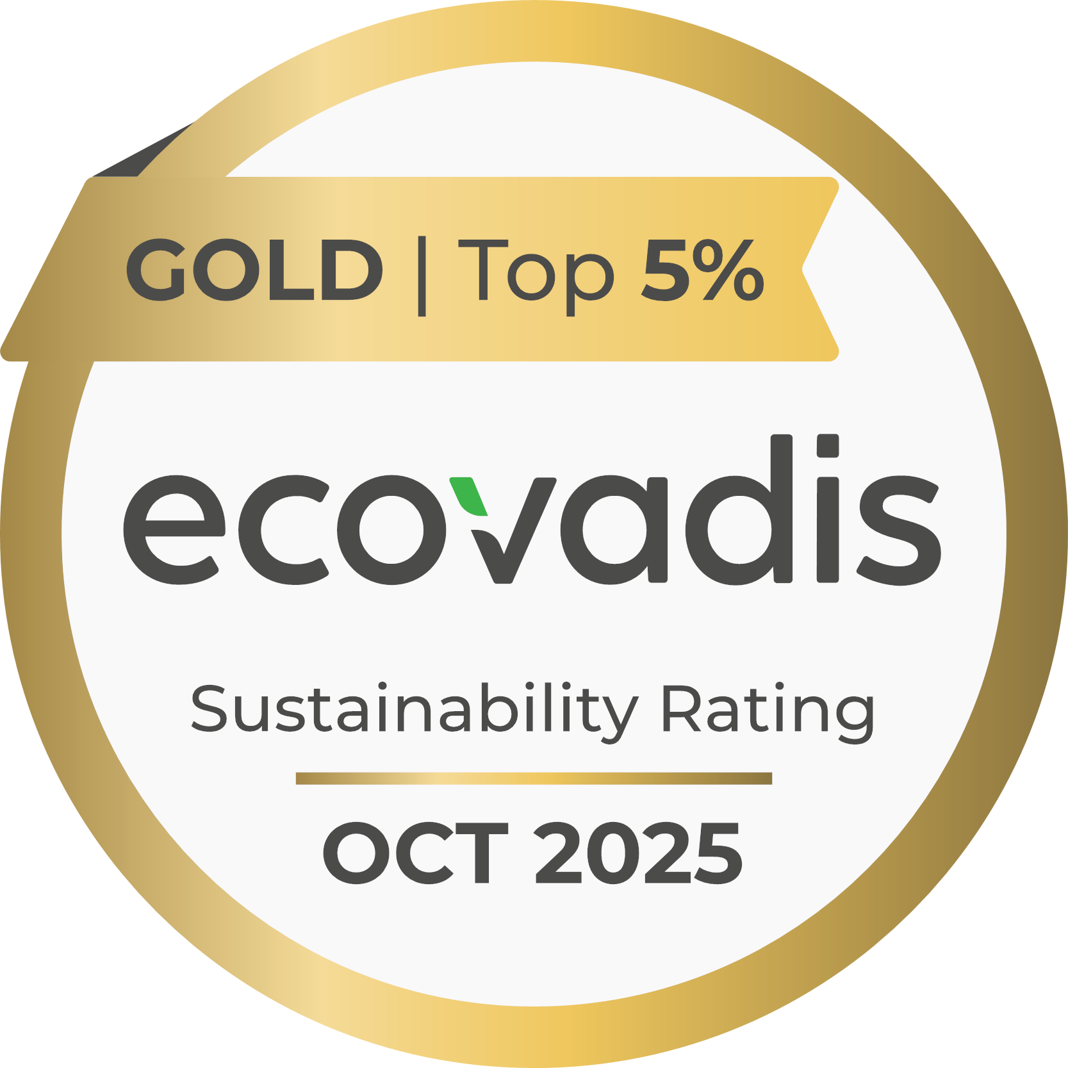
Image source: Würth Elektronik ICS

Würth Elektronik ICS has been awarded the EcoVadis Gold Medal for sustainability performance.

About Würth Elektronik ICS GmbH & Co. KG
Würth Elektronik ICS is a system supplier for electromechanical and electronic solutions for signal and power distribution, control, and display and operating solutions. The company’s key customers include well-known manufacturers of construction and agricultural machinery as well as commercial vehicles. Sectors such as industrial technology or renewable energies also benefit from products and services provided by ICS. The company is headquartered in Niedernhall-Waldzimmern (Germany). Further subsidiaries are located in France, Great Britain, Italy, the USA, China, and India.
Würth Elektronik is part of the Würth Group, the global market leader in the development, production, and sale of fastening and assembly materials, and employs around 7,500 people. In 2024, the Würth Elektronik Group generated sales of 1.02 Billion Euro.
Würth Elektronik: more than you expect!
Further info at www.we-online.com/ics

More information:  Würth Elektronik ICS GmbH & Co. KG  Sandra Herter  Gewerbepark Waldzimmern  Würthstrasse 1  74676 Niedernhall  Germany  Phone: +49 7940 9810-1503  E-mail: sandra.herter@we-online.de  www.we-online.com/ics | Press contact:  HighTech communications GmbH  Marcus Planckh  Brunhamstrasse 21  81249 Munich  Germany  Phone: +49 89 500778-22  E-mail: m.planckh@htcm.de  www.htcm.de

