PRESS RELEASE
Zeltwanger Maschinenbau uses hyperMILL® from OPEN MIND
NC code simulation
Wessling (Germany), November 5, 2025 – As a leading service provider, Zeltwanger Maschinenbau GmbH specializes in complex high-quality component machining from the semiconductor, automotive, medical technology and micro-automation sectors. Utilizing CAD/CAM technologies hyperMILL® MAXX Machining, hyperMILL® TURNING Solutions and hyperMILL® VIRTUAL Machining, the company exploits the full potential of OPEN MIND software and also acts as a beta tester.
Zeltwanger's customers are demanding. For a company in the semiconductor industry that specializes in laser technology, the contract manufacturer supplies various components that all require the highest precision - from pin-sized stainless-steel parts to 250 kg workpieces machined from three-ton aluminum blocks. “µm tolerances are the order of the day for us,” says Wolfgang Pfeiffer, Head of CAM Programming at Zeltwanger Maschinenbau. “As the batch sizes range from one to series runs of around 500 units, we have to generate between 20 and 60 executable, reliable NC programs each week. To handle this workload, we program in two shifts and need CAM software that supports us, quickly and reliably.” Zeltwanger has been using hyperMILL® since 2008, and the CAM programming team of ten has expanded its capabilities with optional software modules such as TURNING Solutions and VIRTUAL Machining.
Turn-milling for cost-effective complete machining
Zeltwanger also utilizes turn-mill centers. Wolfgang Pfeiffer explains the advantages: “By combining turning and milling on a single machine, many parts can be completely machined in a single set-up. This eliminates downtimes when changing machines and prevents reclamping errors.” Programming turn-mill centers is one of the most demanding tasks, but hyperMILL® provided the answer with its TURNING Solutions and the TURN-MILL Machining module. “The turning functions are similar to milling for the most part, so that it was virtually self-explanatory for our experienced colleagues,” continues Wolfgang Pfeiffer. This provides the programmers with reliable toolpaths and a dependable simulation for these collision-prone machines. hyperMILL® offers the perfect tool for milling/turning centers with the MILL-TURN Machining module. The high-performance milling strategies can be combined with turning operations, allowing complete machining with efficiency, precision and safety.
Accuracy assured
With hyperMILL® VIRTUAL Machining, the NC code can be reliably generated, optimized and simulated. This enables Zeltwanger to achieve maximum reliability in milling, turning and hybrid machining. Wolfgang Pfeiffer says: “The software only provides access to successfully tested and, therefore, safe, collision-free programs.”
Zeltwanger uses the software module intensively and is now a beta tester for hyperMILL® VIRTUAL Machining. This is particularly the case in the field of mill-turning, an area that OPEN MIND is continuing to expand in the use of virtual machines.

Available images
The following images are available for download in printable format at:
https://kk.htcm.de/press-releases/open-mind/
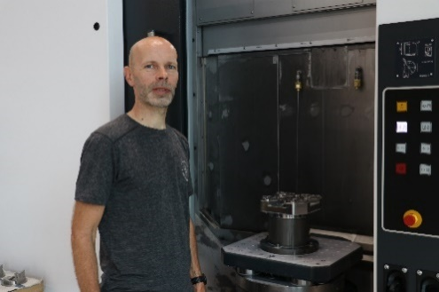  Source: OPEN MIND  Wolfgang Pfeiffer, Head of CAM Programming at Zeltwanger Maschinenbau | 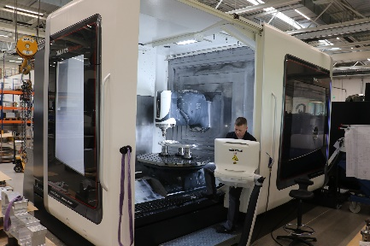  Source: OPEN MIND  The NC codes for the 5-axis DMG Mori DMU125 µPrecision machining center are optimized in hyperMILL® VIRTUAL Machining and checked for collisions.
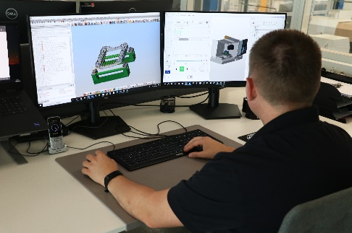
Source: OPEN MIND

All milling, mill-turn or turn-mill programs are created at Zeltwanger by using hyperMILL®.

About Zeltwanger Maschinenbau GmbH
The company is part of the Zeltwanger Group, which comprises eight cooperating companies, employs over 470 staff, and generated €81 million in revenue in 2023. Zeltwanger Maschinenbau processes any metallic material, with aluminum and stainless steel leading the list. Around 170 employees ensure that demanding customers from the semiconductor and automotive, medical device technology, and micro-automation sectors are supplied with components and assemblies of the highest quality.

About OPEN MIND Technologies AG
OPEN MIND Technologies AG is one of the world’s leading developers of powerful CAD/CAM solutions for machine and controller-independent programming.
OPEN MIND develops optimized CAD/CAM solutions that include innovative and unique features that can deliver significantly higher performance in both programming and machining.
hyperMILL® is a completely modular CAD/CAM solution that provides state-of-the-art CAM technologies on its own CAD platform: from 2.5D, 3D and 5-axis machining as well as turning strategies and solutions for additive manufacturing, HSC and HPC machining. Whether automation, simulation or virtual machine – trendsetting technologies expand the product range and enable continuous digital process chains. Special applications, seamless interaction with all popular CAD solutions and exceptional customer service rounds out the company’s products and capabilities.
According to the “NC Market Analysis Report 2024” compiled by CIMdata, hyperMILL® is a leading, worldwide CAD/CAM solution. Innovative CAD/CAM technologies fulfill the highest demands in the aerospace, automotive, tool and mold manufacturing, production machining, medical, job shops, energy and semiconductor industries.
OPEN MIND's majority stake in manufacturing execution system (MES) developer Hummingbird expands the CAD/CAM manufacturer's product portfolio and enhances the range of connected digitalized manufacturing technologies.
OPEN MIND is a Mensch und Maschine company and has subsidiaries and qualified sales partners on all continents.
You can find more information at www.openmind-tech.com.

OPEN MIND Technologies UK Ltd., Oxford
Unit 3
Bicester Business Park
Telford Road
Bicester
Oxfordshire OX26 4LN
England
Phone: +44 1869 290 003
Fax: +44 1869 369 429
E-mail: Info.UK@openmind-tech.com

OPEN MIND Technologies USA, Inc.
1492 Highland Avenue, Unit 3
Needham MA 02492
USA
Phone: +1 339 225 4557 office
Phone: +1 888 516 1232 x0 toll-free
Fax: +1 270 912 5822
E-mail: Info.Americas@openmind-tech.com

OPEN MIND Technologies Asia Pacific Pte Ltd
MOVA Building, 22 Jalan Kilang #03-00
Singapore 159419
Phone: +65 6742 95-56
E-mail. Info.Asia@openmind-tech.com

OPEN MIND CADCAM Technologies India Private Ltd
No.610 & 611, 6th Floor, ‘B’ Wing, No.6, Mittal Tower
M.G. Road, Bangalore
560001, Karnataka
Phone: +91 80 2676 6999
E-mail: Info.India@openmind-tech.com

Head office:
OPEN MIND Technologies AG, Argelsrieder Feld 5, 82234 Wessling, Germany
Tel.: (+49-8153) 933-500, Fax: (+49-8153) 933-501
E-mail: Info@openmind-tech.com, website: www.openmind-tech.com

Press contact:
HighTech communications GmbH
Brigitte Basilio
Brunhamstrasse 21
81249 Munich
Germany
Tel.: (+49-89) 500778-20
E-mail: b.basilio@htcm.de
Website: www.htcm.de

