PRESS RELEASE
Dr. Christof M. Stotko to take over from Karl Tochtermann
as CEO of S+P Samson GmbH
Passing the baton at label manufacturer
Kissing, 1 November 2025 – After more than 35 years at the company and 16 years at the helm of S+P Samson GmbH, Karl Tochtermann will be leaving the company on 31 December 2025. As its CEO he has been making a major contribution to the label manufacturer since 2009 and advanced the company’s successful development. On 1 November 2025, Dr. Christof M. Stotko will be taking over as CEO.

As well as a PHD in industrial engineering, he brings more than 20 years of international sales and management experience in small and medium-sized companies to the role. “I am very much looking forward to the new task and working with the dedicated team at S+P Samson. Together we want to expand our strong market position and advance our high level of innovative capacity in the label industry”, says Dr. Stotko.

Karl Tochtermann is looking back with gratitude at his many years at S+P Samson: “It was a great pleasure and honour to help shape the company over several decades. I would like to thank all of our employees as well as our customers and partners for the trust they have placed in me.

S+P Samson GmbH would like to thank Karl Tochtermann for his extraordinary commitment and his major contribution to the company’s history and wish him all the best for the next stage in his life.

Available images
The following printable images are available for downloading at:
http://www.htcm.de/kk/spsamson/

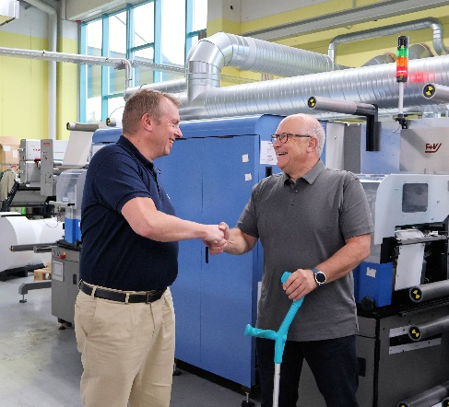
Image source: S+P Samson
Dr. Christof M. Stotko (left) takes over from Karl Tochtermann (right) as the CEO of S+P Samson GmbH

S+P Samson GmbH
Founded in 1978, S+P Samson GmbH is a manufacturer of identification systems for extreme industrial requirements and operates worldwide. The company develops and sells labels and tags that enable reliable product identification in environments with high temperatures, chemical or mechanical stresses. The robust labels and tags ensure long-term traceability and identification in industrial production processes and supply chains. With its GRAPHIPLAST® plastic labels and tags, S+P Samson is a market leader. The company offers individual identification concepts that are characterised by the optimum interaction between label/tag and printing system. The ID4track® RFID labels and tags are extremely robust and suitable for the tracking and identification of products over large distances and in demanding environments. S+P Samson GmbH now has nearly 100 employees and operates from its 10,600 m2 (114,000 sq ft) premises at Kissing near Augsburg, Southern Germany. The company also has a presence in Italy, in the US, Canada, Brazil, the UAE and, in China.
Further details are available at https://sp-samson.com

Media contact:
S+P Samson GmbH
Nadja Hörmann
Marketing Manager
Industriestrasse 32
86438 Kissing, Germany
Phone: +49 8233 846-187
Email: nadja.hoermann@sp-samson.com

HighTech communications GmbH
Marcus Planckh
Brunhamstrasse 21
81249 München, Germany
Phone: +49 89 500778-22
Email: m.planckh@htcm.de
www.htcm.de

