FOR THE MEDIA
ASMPT at Productronica 2025
A new era in semiconductor and electronics production
Munich (Germany), October 23, 2025 — At this year's Productronica trade fair, ASMPT, the global market and technology leader in manufacturing equipment for the semiconductor and electronics industries, will present a completely newly developed SIPLACE placement platform delivering significant productivity improvements in key industries, as well as the new DEK printer for oversized circuit boards. Other highlights include innovations in advanced packaging with a hybrid placement machine and trendsetting multi-chip and precision bonders for the optoelectronic and photonics segments. Innovative software for intelligent and fully integrated production processes from the machine to the line, factory and enterprise levels completes the company’s portfolio.
The new SIPLACE platform enables performance increases of up to 30 percent in the automotive industry as well as in IT equipment and network infrastructure production. The improvements apply not only to standard benchmarks but are achievable under demanding production conditions. The platform impresses with its floorspace performance, quality and flexibility. It is also compatible – existing feeders and the entire software package from the SIPLACE production world remain usable.
“The digital transformation is rapidly advancing, driven by artificial intelligence, networked communication, electromobility, and new high-performance data centers. At the same time, the demands on electronics manufacturers are increasing as well and presenting them with major challenges,” says Thomas Bliem, VP R&D at ASMPT SMT Solutions. “This is why the industry needs a technology boost right now – and that's what we are delivering with the new SIPLACE platform, which enables real productivity increases and fits seamlessly into our holistic concept of the intelligent factory.”
Advanced packaging — the link between two worlds
Advanced packaging continues to be one of the most important drivers of innovation at ASMPT in both placement technology and semiconductor manufacturing equipment – two areas that are increasingly merging.
The hybrid SIPLACE CA2 platform is a prime example of this trend. By combining the assembly of SMDs from tapes and of dies directly off the sawed wafer, it brings advanced packaging into the high-volume production environment. A buffer separates the die separation from the placement process, which enables the machine to process up to 54,000 dies and 76,000 SMDs per hour. And by eliminating the die taping process, the SIPLACE CA2 can generate significant cost and material savings.
The MEGA multi-chip bonding solution employs patented look-through pattern detection technology for substrates measuring up to 280 × 300 mm. With this machine, ASMPT is opening up a new class of precision in chip placement. A single MEGA carries out tasks that used to require an entire machine line. For customers, this means more yields, more quality, and more efficiency. The revolutionary MEGA platform is ideally suited for many forward-looking applications in the areas of artificial intelligence, smart mobility, and hyperconnectivity.
For the production of optoelectronic components, ASMPT presents the AMICRA NANO precision bonder, offering ultra-precise placement for co-packaged optics assembly combined with eutectic high-speed AuSn bonding. With its innovative hybrid bonding technology, the AMICRA NANO combines maximum precision with performance and flexibility in the production of miniaturized components for the transition point between optical and electrical information transfers which are critical for modern data centers and networks that require energy-efficient and powerful data transmission with minimal latency.
Other highlights at the booth
ASMPT also presents a new DEK solder paste printer for oversize circuit boards. It meets the high demands of high-performance computing and AI applications with maximum precision and speed — even as the boards’ designs are becoming increasingly complex.
The improved OSC Package for SIPLACE placement machines enables the safe and precise processing of even high volumes of odd-shaped components BGAs and demanding shapes with support from state-of-the-art vision and inspection systems.
Also at the joint booth: The complete software portfolio with the WORKS Software Suite and Factory Solutions for future-proof SMT production. Together, they enable the digital transformation to the intelligent factory with applications for material flow and process optimization as well as efficient staff deployment. In addition, trade visitors will be able to see live demos of the most modern Manufacturing Operations Platform, from ASMPT software subsidiary Critical Manufacturing that was developed specifically for the requirements of the electronics and semiconductor manufacturing industries. Combining MES, connectivity, automation, and analytics, Critical Manufacturing helps manufacturers build the connected, intelligent factories of the future, where people and AI collaborate seamlessly to make Industry 4.0 a reality.
Illustrations for downloading
The following print-ready artwork is available on the internet for downloading:
https://kk.htcm.de/press-releases/asmpt/

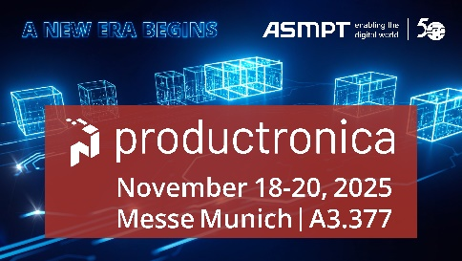 | 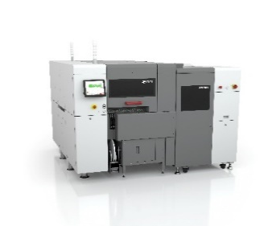
With a newly developed SIPLACE placement platform and a new DEK solder paste printer, ASMPT presents real game changers for the intelligent factory.  Image credit: ASMPT | The hybrid SIPLACE CA2 places SMDs and dies directly off the wafer for advanced packaging applications in high-volume lines.  Image credit: ASMPT
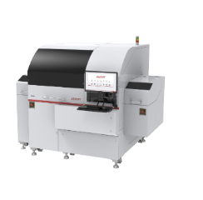 | 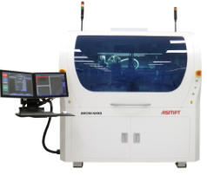
As an automatic high precision multi-chip die bonder for diverse multi-chip packages, the MEGA perfectly meets the requirements for the next generation of server clusters and AI edge devices such as smartphones and advanced driver assistance systems (ADAS), as well as data and telecommunication applications.  Image credit: ASMPT | The AMICRA NANO precision bonder was specifically designed for the production of co-packaged optics and features a ultra-precision placement accuracy of ± 0.2 µm @ 3 σ.  Image credit: ASMPT

About ASMPT Limited (“ASMPT”)
ASMPT Limited is a leading global supplier of hardware and software solutions for the manufacture of semiconductors and electronics. Headquartered in Singapore, ASMPT’s offerings encompass the semiconductor assembly & packaging, and SMT (surface mount technology) industries, ranging from wafer deposition to the various solutions that organize, assemble and package delicate electronic components into a vast range of end-user devices, which include electronics, mobile communications, computing, automotive, industrial and LED (displays). ASMPT partners with customers very closely, with continuous investments in R&D helping to provide cost-effective, industry-shaping solutions that achieve higher productivity, greater reliability, and enhanced quality. ASMPT is a founding member of the Semiconductor Climate Consortium.
To learn more about ASMPT, please visit www.asmpt.com.

About ASMPT SMT Solutions
The mission of the SMT Solutions segment within ASMPT is to implement and support the Intelligent Factory at electronics manufacturers worldwide.
ASMPT solutions support the networking, automation, and optimization of central workflows with hardware, software and services that enable electronics manufacturers to transition to the Intelligent Factory in stages and enjoy dramatic improvements in productivity, flexibility, and quality. With its integrated open automation concept, ASMPT opens the door for its customers to economically feasible automation, entirely in accordance with their individual requirements – modular, flexible, and vendor-independent.
The product range includes hardware and software such as SIPLACE placement solutions, DEK printing solutions, inspection and storage solutions, and the WORKS Software Suite. With WORKS, ASMPT offers electronics manufacturers high-quality software for planning, controlling, analyzing and optimizing all processes on the shop floor. Maintaining close relationships with customers and technology partners is a central component of ASMPT’s strategy.
For more information about ASMPT SMT Solutions, visit smt.asmpt.com.

About ASMPT Semiconductor Solutions (“ASMPT SEMI”)
ASMPT SEMI is the leading supplier in advanced packaging and semiconductor assembly solutions. With a commitment to innovation and customer satisfaction, ASMPT SEMI provides a comprehensive range of products and services that cater to the evolving needs of the microelectronics industry. Their expertise spans across areas such as flip-chip and wafer-level packaging, advanced interconnect technologies, and more. ASMPT SEMI's cutting-edge solutions enable customers to achieve higher performance, increased reliability, and improved cost-efficiency when producing their semiconductor devices.
ASMPT SEMI sees itself as a pioneer and driving force of the Intelligence Revolution. With its advanced packaging and assembly technologies, the business segment creates the invisible connections that enable intelligent applications in Artificial Intelligence, Smart Mobility and Hyperconnectivity.
For more information about ASMPT SEMI, visit semi.asmpt.com.

Media contacts:
Global ASMPT Press Office
ASMPT Limited
Susanne Oswald
Rupert-Mayer-Strasse 48
81379 Munich
Germany
Tel: +49 89 20800-26439
E-mail: susanne.oswald@asmpt.com
Website: asmpt.com

HighTech communications GmbH
Barbara Ostermeier
Brunhamstrasse 21
81249 Munich
Germany
Tel.: +49-89 500778-10|
E-mail: b.ostermeier@htcm.de
Website: www.htcm.de

