MEDIA INFORMATION

S+P Samson receives patent for its innovative SecuBond® labels
Full control of the adhesive
Kissing, 22 October 2025 – S+P Samson, a leading manufacturer of industrial identification solutions, has solved the problem of adhesive bleeding with its new SecuBond labelling system. The system for the controlled application of pressure-sensitive adhesives developed by S+P Samson has now been protected by the European Patent Office. SecuBond labels feature a zone, typically 1 mm wide, at the edge of labels where no adhesive is applied. Tests carried out under extreme conditions have shown that this does not affect the bonding properties of the labels.
Pressure-sensitive adhesives are known for their flowability, which is a desired effect, but leads to problems caused by what is referred to as adhesive bleeding. This can result in label rolls sticking together, the contamination of printers and malfunctions during automated label processing. SecuBond provides a reliable solution for all of these issues. With its patented SecuBond technology, S+P Samson has introduced intermittent adhesive application. This means that virtually any configuration is possible for adhesive fields. Numerous tests have shown that it does not affect the bonding properties if 1 mm or 1.5 mm wide edges remain free of adhesive. Fixing under pressure also ensures that there is no sub-surface migration of water. Shear force tests have shown that SecuBond labels equal the durability and performance of conventional labels in all aspects. The intermittent application of adhesive makes it easier to peel the labels from the release paper and ensures reliable processing in automated systems. The ability to configure the adhesive field freely also provides more flexibility, for instance, by leaving a space for a grip tab.

Available images
The following printable images are available for downloading at:
http://www.htcm.de/kk/spsamson/

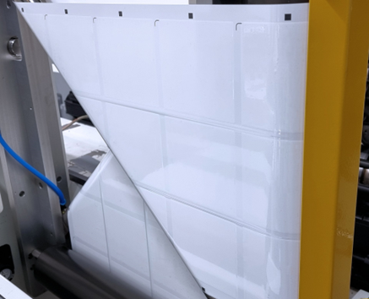  Image source: S+P Samson  As SecuBond labels have the adhesive applied intermittently, this leaves a strip that remains free from adhesive for clean processing. | 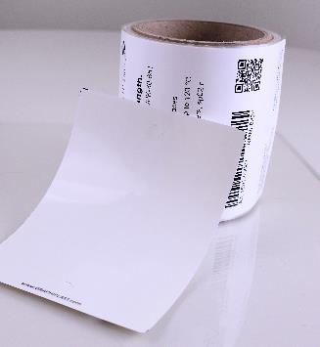  Image source: S+P Samson  SecuBond labels feature a strip that is free from adhesive.

S+P Samson GmbH
Founded in 1978, S+P Samson GmbH is a manufacturer of identification systems for extreme industrial requirements and operates worldwide. The company develops and sells labels and tags that enable reliable product identification in environments with high temperatures, chemical or mechanical stresses. The robust labels and tags ensure long-term traceability and identification in industrial production processes and supply chains. With its GRAPHIPLAST® plastic labels and tags, S+P Samson is a market leader. The company offers individual identification concepts that are characterised by the optimum interaction between label/tag and printing system. The ID4track® RFID labels and tags are extremely robust and suitable for the tracking and identification of products over large distances and in demanding environments. S+P Samson GmbH now has nearly 100 employees and operates from its 10,600 m2 (114,000 sq ft) premises at Kissing near Augsburg, Southern Germany. The company also has a presence in Italy, in the US, Canada, Brazil, the UAE and, in China.
Further details are available at https://sp-samson.com

Media contact:
S+P Samson GmbH
Nadja Hörmann
Marketing Manager
Industriestrasse 32
86438 Kissing, Germany
Phone: +49 8233 846-187
Email: nadja.hoermann@sp-samson.com

HighTech communications GmbH
Marcus Planckh
Brunhamstrasse 21
81249 München, Germany
Phone: +49 89 500778-22
Email: m.planckh@htcm.de
www.htcm.de

