FOR THE MEDIA
Launch of the ASMPT SMT Customer Portal
Digital services centrally bundled for intelligent manufacturing
Singapore, October 8, 2025 – ASMPT SMT Solutions has introduced its new ASMPT SMT Customer Portal. It serves as a central access point for the company’s digital services that combine for the first time all relevant applications, services and information in one location. With its single sign-on, role-based access and an easy-to-use dashboard, ASMPT provides a Customer Portal that’s unique in the industry. The aim is to fundamentally simplify access to digital services and make electronics manufacturing processes more efficient and transparent.
In the future, users will be able to access all ASMPT services ranging from the Webshop with its 3D parts catalog to technical documentation to software tools and repair and license management via a single login. A dashboard provides quick and easy orientation by bundling the most important information such as open orders, ongoing service jobs, and training statuses. Supplemental functions such as FAQs and direct app links provide additional navigational help.
Role-based functions for different areas
The portal is designed in such a way that contents and functions are matched to each user’s respective role so that employees in production, service, purchasing or HR see the information and applications that are relevant to them. This differentiated presentation helps to ensure that decisions on all levels are made based on data that’s reliable and up to date.
Self-service for more independence
A central aspect of the portal is the ability for users to process numerous requests on their own. They can report technical faults and track their progress, see the spare parts order and digitally follow their different stages, from creation to delivery. User and permissions management is also handled by the customers themselves. Site managers can add new users, create role profiles, and manage their access rights. This streamlines internal and external interfaces while accelerating corporate processes.
Expanded service functions
Another component of the new portal is the integration of training and education offerings from the ASMPT Academy. While access to digital courses will be added in the near future, customers can already manage learning progress and track course bookings. Enhanced by statistical evaluations, this increases the degree of transparency regarding employees’ qualifications.
Unique service experience
With its new ASMPT SMT Customer Portal, ASMPT offers for the first time a central platform that brings together its digital services on one site, creating a uniform user experience. Users benefit from consistent processes and the clear presentation of all relevant information while saving time because they must log on only once. ASMPT is thus setting a new standard for digital service offerings in intelligent manufacturing.
For more detailed information and to register, visit our landing page at [https://smt.asmpt.com/en/myasmpt/customer-portal/].

Illustrations for downloading
The following print-ready artwork is available on the internet for downloading:
https://kk.htcm.de/press-releases/asmpt/

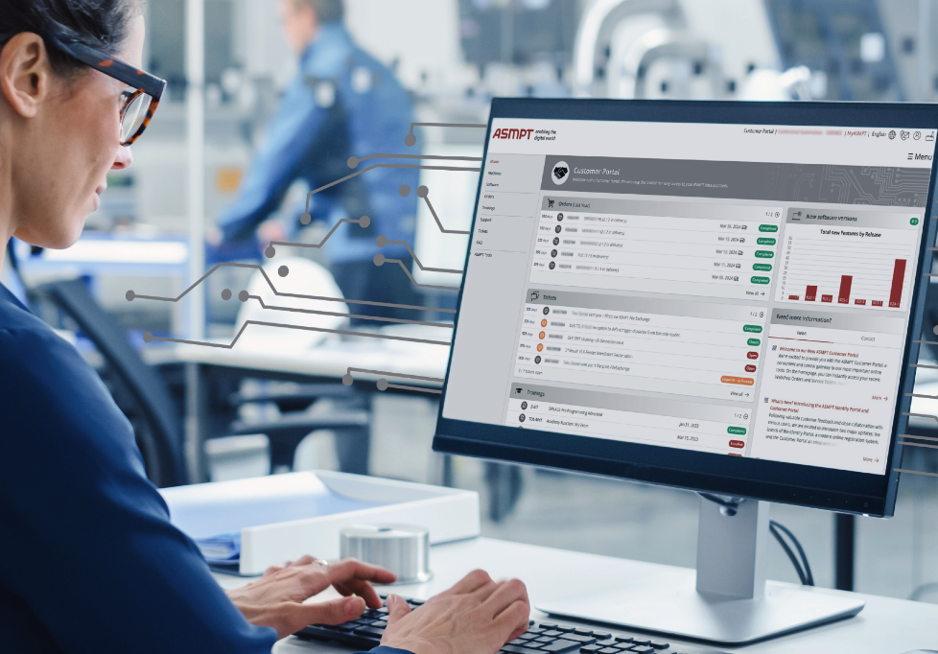

The new ASMPT SMT Customer Portal: Fast, intuitive and accessible 24/7.

Image credit: ASMPT

About ASMPT Limited (“ASMPT”)
ASMPT Limited is a leading global supplier of hardware and software solutions for the manufacture of semiconductors and electronics. Headquartered in Singapore, ASMPT’s offerings encompass the semiconductor assembly & packaging, and SMT (surface mount technology) industries, ranging from wafer deposition to the various solutions that organize, assemble and package delicate electronic components into a vast range of end-user devices, which include electronics, mobile communications, computing, automotive, industrial and LED (displays). ASMPT partners with customers very closely, with continuous investments in R&D helping to provide cost-effective, industry-shaping solutions that achieve higher productivity, greater reliability, and enhanced quality. ASMPT is a founding member of the Semiconductor Climate Consortium.
To learn more about ASMPT, please visit www.asmpt.com.

The ASMPT SMT Solutions segment
The mission of the SMT Solutions segment within ASMPT is to implement and support the Intelligent Factory at electronics manufacturers worldwide.
ASMPT solutions support the networking, automation, and optimization of central workflows with hardware, software and services that enable electronics manufacturers to transition to the Intelligent Factory in stages and enjoy dramatic improvements in productivity, flexibility, and quality. With its integrated open automation concept, ASMPT opens the door for its customers to economically feasible automation, entirely in accordance with their individual requirements – modular, flexible, and vendor-independent.
The product range includes hardware and software such as SIPLACE placement solutions, DEK printing solutions, inspection and storage solutions, and the WORKS Software Suite. With WORKS, ASMPT offers electronics manufacturers high-quality software for planning, controlling, analyzing and optimizing all processes on the shop floor. Maintaining close relationships with customers and technology partners is a central component of ASMPT’s strategy.
For more information about ASMPT SMT Solutions, visit smt.asmpt.com.

Media contacts:
ASMPT ROA Press Office
SMT Solutions
ASMPT SMT Singapore Pte. Limited
Janet Loh
Phone: +65 6877 3948
E-mail: Janet.loh@asmpt.com
Website: smt.asmpt.com

Global ASMPT Press Office
ASMPT Limited
Susanne Oswald
Rupert-Mayer-Strasse 48
81379 Munich
Germany
Tel: +49 89 20800-26439
E-mail: susanne.oswald@asmpt.com
Website: asmpt.com

