PRESS RELEASE
OPEN MIND complete service: software and implementation
Perfect tool management with Hummingbird MES
Wessling (Germany), October 8, 2025 – Digitalization enables complete customized solutions for manufacturers and OPEN MIND Technologies AG is now presenting a digital tool management suite in its portfolio. The offering from one of the leading providers of CAD/CAM and MES solutions is aimed at manufacturing companies that use hyperMILL® or other CAM systems with a tool database. With the ‘Tool Logistics,’ module in Hummingbird MES users can achieve highly efficient digital tool management in just five steps.
A lack of transparency in tool management leads to time losses due to searching and provision allocation, plus costs incurred through inefficient warehousing with excess tool stocks or premature tool changes. In the worst case scenarios, manufacturers can witness significant downtime due to missing or incorrect data. It is here that modernization is a must. OPEN MIND experts can implement digital processes based on CAM and MES to deliver highly efficient digital tool management in five simple steps.
Analysis of the current situation
The first step is to analyze existing processes and systems. This involves reviewing available tool and storage data, or how tool storage and setup processes are organized. Potential improvements are identified, and a detailed roadmap for system implementation is developed, including the definition of the system structure and the assignment of responsibilities.
Standardization of data in the tool database
Standardizing data in the hyperMILL® or other CAM system tool database is a necessary prerequisite for error-free, efficient processes. A dedicated workshop provides support in this area.

System integration
All modules of the tool management system are prepared, configured, and tested in a development environment. The interface to hyperMILL® is standard and can be used immediately. All other interfaces, such as connections to machines and presetting devices, are also configured and tested with full training provided.
Commissioning and coaching
The combination of planned commissioning and practical coaching ensures a smooth start with the new tool management system. The data management system is the tool database of the CAM solution. The Hummingbird ‘Tool Logistics’ module is used, for example, to organize remaining tool life or tool measurement as well as the tool and holder storage and logistics. Feedback from machine operators can also be recorded if deviations in cutting values or tool life occur in practice.
Check results
After an initial integration phase, a check is carried out to see whether the processes have been implemented as planned. A measurable success is, for example, when the variety of tools or usage on the shop floor has been reduced. The integration of additional systems can now also be checked, for example by connecting tool storage cabinets or enabling direct communication between the machine and the system via OPC UA. The expansion towards intelligent control through bidirectional communication between Hummingbird and the machine tool is a further possible step towards consistently digital and automated processes. It also opens up the option of introducing further components of the modular Hummingbird MES to reap even greater efficiencies.
Precise and well-maintained data form the basis of consistent tool management. The hyperMILL® tool database, in combination with the TOOL Builder provides users with the ideal conditions for this. Thanks to the integrated synchronization solution, the data can be used consistently and reliably directly in Hummingbird at any time without an additional interface.
Holistic solution
“The actual management of the tool inventory is then carried out entirely in Hummingbird,” explains Maximilian Waizenegger, Director of Business Development at OPEN MIND Technologies AG. “Our specialists provide support in maintaining the database and implementing the manufacturing processes. In this way, they create a comprehensive solution from which our customers benefit in the long term. Everything from a single source!”

Available images
The following images are available for download in printable format at:
https://kk.htcm.de/press-releases/open-mind/
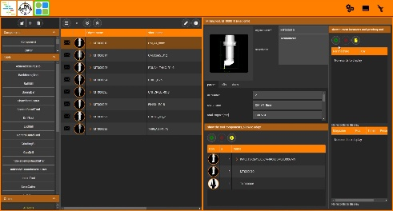
Source: OPEN MIND

Tool information in Hummingbird

Available videos
You can find the following videos on our YouTube channel:
https://youtu.be/2dR8Jd1BLIc?si=n1xFZKSaSXl0wB1W
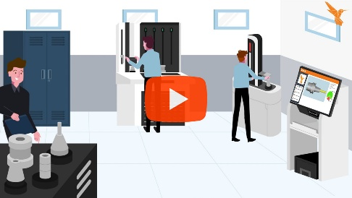
Source: OPEN MIND
Hummingbird module: Tool logistics

About OPEN MIND Technologies AG
OPEN MIND Technologies AG is one of the world’s leading developers of powerful CAD/CAM solutions for machine and controller-independent programming.
OPEN MIND develops optimized CAD/CAM solutions that include innovative and unique features that can deliver significantly higher performance in both programming and machining.
hyperMILL® is a completely modular CAD/CAM solution that provides state-of-the-art CAM technologies on its own CAD platform: from 2.5D, 3D and 5-axis machining as well as turning strategies and solutions for additive manufacturing, HSC and HPC machining. Whether automation, simulation or virtual machine – trendsetting technologies expand the product range and enable continuous digital process chains. Special applications, seamless interaction with all popular CAD solutions and exceptional customer service rounds out the company’s products and capabilities.
According to the “NC Market Analysis Report 2025” compiled by CIMdata, hyperMILL® is a leading, worldwide CAD/CAM solution. Innovative CAD/CAM technologies fulfill the highest demands in aerospace, automotive, tool and mold manufacturing, production machining, medical, job shops, energy and semiconductor industries.
OPEN MIND's majority stake in manufacturing execution system (MES) developer Hummingbird expands the CAD/CAM manufacturer's product portfolio and enhances the range of connected digitalized manufacturing technologies.
OPEN MIND is a Mensch und Maschine company and has subsidiaries and qualified sales partners on all continents.
You can find more information at www.openmind-tech.com.

OPEN MIND Technologies UK Ltd., Oxford
Unit 3
Bicester Business Park
Telford Road
Bicester
Oxfordshire OX26 4LN
England
Phone: +44 1869 290 003
Fax: +44 1869 369 429
E-mail: Info.UK@openmind-tech.com

OPEN MIND Technologies USA, Inc.
1492 Highland Avenue, Unit 3
Needham MA 02492
USA
Phone: +1 339 225 4557 office
Phone: +1 888 516 1232 x0 toll-free
Fax: +1 270 912 5822
E-mail: Info.Americas@openmind-tech.com

OPEN MIND Technologies Asia Pacific Pte Ltd
MOVA Building, 22 Jalan Kilang #03-00
Singapore 159419
Phone: +65 6742 95-56
E-mail. Info.Asia@openmind-tech.com

OPEN MIND CADCAM Technologies India Private Ltd
No.610 & 611, 6th Floor, ‘B’ Wing, No.6, Mittal Tower
M.G. Road, Bangalore
560001, Karnataka
Phone: +91 80 2676 6999
E-mail: Info.India@openmind-tech.com

Head office:
OPEN MIND Technologies AG, Argelsrieder Feld 5, 82234 Wessling, Germany
Tel.: (+49-8153) 933-500, Fax: (+49-8153) 933-501
E-mail: Info@openmind-tech.com, website: www.openmind-tech.com

Press contact:
HighTech communications GmbH
Brigitte Basilio
Brunhamstrasse 21
81249 Munich
Germany
Tel.: (+49-89) 500778-20
E-mail: b.basilio@htcm.de
Website: www.htcm.de

