FOR THE MEDIA
ASMPT at productronica India
Transform your SMT production with ASMPT
Singapore, September 30, 2025 – The hardware, software and Intelligent Factory concept presented by market and technology leader ASMPT drew strong interest from trade visitors at this year’s productronica India.
At the joint booth with long-standing distribution partner Maxim SMT, the spotlight was on the fast, precise, and process-stable DEK TQ solder paste printer platform and the SIPLACE TX high-speed placement solution. The SIPLACE CP20 and SIPLACE CPP placement heads on display also proved particularly well suited to the high-volume production that characterizes the Indian market, offering manufacturers maximum flexibility and productivity in demanding high-volume production.
Integrative concepts for high-volume production
Many visitors took the opportunity to gain a detailed understanding of a complete ASMPT production line in personal technical discussions. Of particular interest was the integrated concept of the intelligent factory, where standardized interfaces across all ASMPT machines continuously collect and process data, making it available where it can be used to enhance quality, prevent errors, and eliminate production bottlenecks.
Comprehensive software portfolio
ASMPT’s extensive software portfolio attracted strong interest from the expert audience. At the core is the WORKS Software Suite, which supports all line-related processes, complemented by the Factory Solutions for holistic optimization across the entire manufacturing environment – including critical areas such as material intralogistics. Live demonstrations featured WORKS Optimization, the intelligent inline expert system for end-to-end process improvement; the Factory Equipment Center, an integrated asset and maintenance management system; the Material Flow Optimizer, ensuring efficient intralogistics and smooth material supply; and SMT Analytics, providing in-depth analysis of the entire SMT production process across all lines.
“We were very pleased with the strong interest shown in our insights and the solutions we showcased for state-of-the-art electronics manufacturing,” summarized Neeraj Bhardwaj, General Manager for India at ASMPT SMT Solutions. “The lively response confirms that we are on the right track in this important growth market.”

Illustrations for downloading
The following images are available for download in printable format at:
https://kk.htcm.de/press-releases/asmpt/

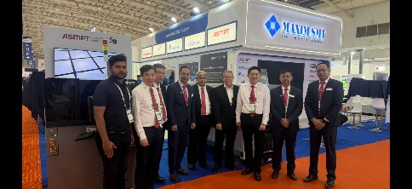 | 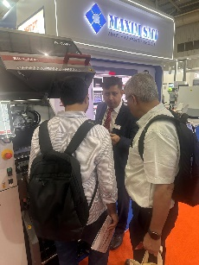
ASMPT Team at productronica India 2025  Image credit: ASMPT | Insightful discussions taking place at the booth in productronica  Image credit: ASMPT
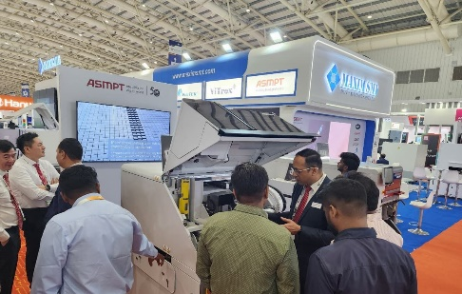 | 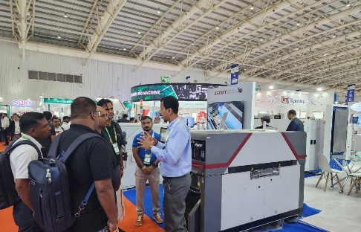
Maximum flexibility and productivity with the SIPLACE TX placement solution  Image credit: ASMPT | Introducing ASMPT hardware and software solutions at Productronica India 2025  Image credit: ASMPT

About ASMPT Limited (“ASMPT”)
ASMPT Limited is a leading global supplier of hardware and software solutions for the manufacture of semiconductors and electronics. Headquartered in Singapore, ASMPT’s offerings encompass the semiconductor assembly & packaging, and SMT (surface mount technology) industries, ranging from wafer deposition to the various solutions that organize, assemble and package delicate electronic components into a vast range of end-user devices, which include electronics, mobile communications, computing, automotive, industrial and LED (displays). ASMPT partners with customers very closely, with continuous investments in R&D helping to provide cost-effective, industry-shaping solutions that achieve higher productivity, greater reliability, and enhanced quality. ASMPT is a founding member of the Semiconductor Climate Consortium.
To learn more about ASMPT, please visit www.asmpt.com.

The ASMPT SMT Solutions segment
The mission of the SMT Solutions segment within ASMPT is to implement and support the Intelligent Factory at electronics manufacturers worldwide.
ASMPT solutions support the networking, automation, and optimization of central workflows with hardware, software and services that enable electronics manufacturers to transition to the Intelligent Factory in stages and enjoy dramatic improvements in productivity, flexibility, and quality. With its integrated open automation concept, ASMPT opens the door for its customers to economically feasible automation, entirely in accordance with their individual requirements – modular, flexible, and vendor-independent.
The product range includes hardware and software such as SIPLACE placement solutions, DEK printing solutions, inspection and storage solutions, and the WORKS Software Suite. With WORKS, ASMPT offers electronics manufacturers high-quality software for planning, controlling, analyzing and optimizing all processes on the shop floor. Maintaining close relationships with customers and technology partners is a central component of ASMPT’s strategy.
For more information about ASMPT SMT Solutions, visit smt.asmpt.com.

Media contacts:
ASMPT ROA Press Office
SMT Solutions
ASMPT SMT Singapore Pte. Limited
Janet Loh
Phone: +65 6877 3948
E-mail: Janet.loh@asmpt.com
Website: smt.asmpt.com

Global ASMPT Press Office
ASMPT Limited
Susanne Oswald
Rupert-Mayer-Strasse 48
81379 Munich
Germany
Phone: +49 89 20800-26439
E-Mail: susanne.oswald@asmpt.com
Website: asmpt.com

