
Press Release
Industrial radar from Symeo at the SPS 2025
25 to 27 November 2025
Hall 7A, Booth 406

From distance measurement to imaging
Neubiberg, Germany, 30 September 2025 – Symeo will be exhibiting at booth 406 in hall 7A at SPS in Nuremberg from 25 to 27 November 2025. In addition to its industrial radar sensors for distance measurement, the topics of functional safety and imaging will dominate. Two demonstrators at the trade fair stand make the advantages of the technology tangible to visitors. One simulates adverse weather conditions and shows how radar remains unaffected, while the other presents LPR-SAFE, a distance measurement system that complies with ISO 13849 for functional safety.
Symeo’s main aim at this year’s SPS is to engage and inspire visitors by showcasing use cases for radar-based imaging. The reason for this is the development of an HD imaging radar based on SAR technology and the presentation of the high-resolution 77-GHz MIMO radar evaluation platform AVR-QDM-110. The latter is currently proving its worth in two pilot projects: monitoring a railway crossing and a loading area in a seaport.
MIMO radar
AVR-QDM-110 consists of a MIMO antenna array, a multi-channel radar transceiver based on four state-of-the-art 77-GHz radar MMICs, and a powerful digital processing platform. The MIMO radar enables the output of raw data or 3D point cloud data. The associated Python software library for processing and visualizing the data stream forms the basis for implementing user-specific application software, while also reducing development time.
Functional safety
Symeo presents LPR-SAFE with a demonstrator. The system comprises a safe function block for a PLC that validates the results of two redundant pairs of radar sensors operating in secondary radar mode. It is used for precise and functionally safe distance measurement, for example, in conjunction with crane systems. LPR-SAFE can be equipped with either four LPR-1DHP-291 radar sensors for a range of up to 300 m or four LPR-1D24 that provide a range of up to 1000 m. The system is currently being certified in accordance with ISO 13849.
“Above all, we are the most experienced partner for industrial radar technology and the partner of choice for extremely fail-safe and durable sensor technology. It is with this confidence that we are also presenting concepts and prototypes at the trade fair that will pave the way for future safety solutions,” says Thomas Hörl-Weinhold, VP Industry Business Development at Symeo.

Available image material
The following printable images are available for download on the Internet:
https://kk.htcm.de/press-releases/symeo/

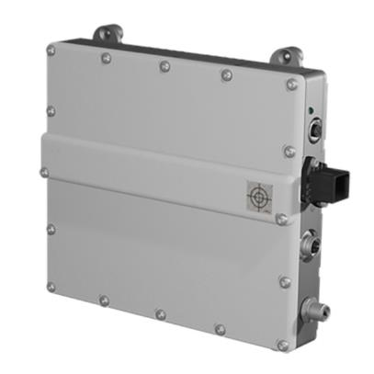
Image source: Symeo
New at SPS: The MIMO radar evaluation platform AVR-QDM-110.

Symeo
Symeo develops and markets products and solutions for precise, non-contact, maintenance-free position detection, distance measurement, and collision avoidance. Symeo’s products feature extremely robust designs to make them suitable for applications in harsh industrial environments.
Symeo’s LPR® radar sensor technology offers a wireless and real-time-capable measuring system that is ideally suited for industrial applications. Symeo has many years of experience in the development of cost-efficient and customer-specific industrial solutions on the basis of LPR® technology.
The company delivers standardized products and complete solutions to system integrators, original equipment manufacturers (OEMs), and end customers worldwide.
Headquarters: Symeo GmbH, Prof.-Messerschmitt-Strasse 3 a, 85579 Neubiberg, Germany
Phone: (+49-89) 6607-7960, Fax: (+49-89) 66077-96190
E-mail: info@symeo.com, Website: www.symeo.com

Press contact:
HighTech communications GmbH
Marcus Planckh
Brunhamstrasse 21 (Building 202/2nd floor)
81249 Munich
Germany
Phone: (+49-89) 500-77822
E-mail: m.planckh@htcm.de
Website: www.htcm.de/en/

