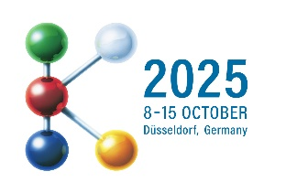
PRESS RELEASE
Hufschmied at the K 2025 trade fair
Plastic machining at its best
Hall 3, Booth A93
Bobingen (Germany), September 24, 2025 – Hufschmied Zerspanungssysteme GmbH will be exhibiting at K 2025, the world's leading trade fair for the plastics and rubber industry, from October 8 to 15, 2025. This time, a drone developed in-house will serve as a practical example at booth A93 in hall 3 of the Düsseldorf Exhibition Center. There are also plans to present a Hyperloop-related joint project with KraussMaffei. The focus will be on three tools: 110FPRV “Per Plex,” the special tool for acrylic machining; HC402, a roughing/finishing tool with low heat generation; and HC403BDSR “Wolverine,” an aluminum roughing tool with exceptionally high chip volume.
The 110FPRV Plexiglas cutter has an innovative cutting-edge geometry and is a combined roughing and finishing tool. Machining polymethyl methacrylate (PMMA), also known as acrylic glass or, after the best-known brand, Plexiglas, is tricky. The reason: as with other thermoplastics or composite materials containing thermoplastics, there is always a risk that Plexiglas will become too hot during machining and melt. Hufschmied has developed plastic machining tools with low friction between the tool and the workpiece, which dissipate the heat generated via the chip. 110FPRV also scores points for its very smooth running and crystal-clear surfaces without additional polishing.
For difficult cases
The double-edged HC402 HSC torus milling tool from the Proto-Line, a product family for prototype construction, is another example of a tool that prevents adhesion and melting thanks to its cutting geometry and polished flutes. It is suitable, for example, for the gentle, burr-free machining of Dibond plates and enables high-precision machining of glass fiber-reinforced polyamide.
Aluminum “wolverine” for mold making
With its extreme material removal rates (3xD full groove milling), the HC403BDSR solid carbide high-performance roughing cutter is a real “aluminum wolverine.” The cutting edge with corded teeth is particularly stable thanks to a corner radius, and a special face geometry allows high ramp angles when plunging. Hufschmied developed a new coating called “ALX1” for this tool. Polished flutes and central internal cooling ensure that chips are removed optimally.

Available images
The following images can be downloaded from the Internet in printable quality:
https://kk.htcm.de/press-releases/hufschmied/
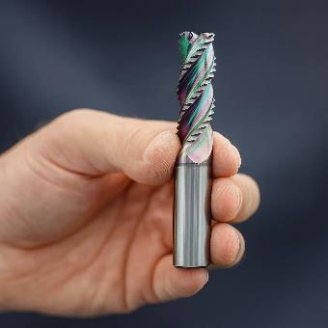  Image source:  Hufschmied Zerspanungssysteme  HC403BDSR Wolverine, a solid carbide high-performance roughing cutter for aluminum | 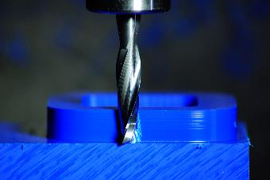 Image source:  Hufschmied Zerspanungssysteme  The HC402 HSC torus milling tool machines demanding technical plastics without melting them.

About Hufschmied Zerspanungssysteme GmbH
Established in 1991 and headquartered in Bobingen near Augsburg, Hufschmied Zerspanungssysteme GmbH is a manufacturer of high-quality tools for machinable production and friction stir welding. By specializing at an early stage in the machining of plastics, fiberglass materials and carbon fiber, Hufschmied has become a leader in Europe in the development of solutions for new materials. The company is an established system supplier to renowned machine tool manufacturers. Tools and manufacturing process consulting from Hufschmied are particularly valued in the automotive and aerospace industries as well as in medical technology. The company is involved in numerous organizations, including Composites United Deutschland e. V. Hufschmied's manufacturing operations are located in Bobingen, Winterlingen and Sigmaringen on the Swabian Alb. Hufschmied is certified according to ISO 9001:2015 (quality management) and ISO 14001:2015 (environmental management).

Hufschmied Zerspanungssysteme GmbH – One Cut Ahead
For more information: www.hufschmied.net

Additional information:  Hufschmied Zerspanungssysteme GmbH  Marco Beigl  Edisonstrasse 11d  86399 Bobingen  Germany  Phone: +49 8234 9664-0  Telefax: +49 8234 9664-99  E-Mail: info@hufschmied.net  www.hufschmied.net | Press contact:  HighTech communications GmbH  Brigitte Basilio  Brunhamstrasse 21  81249 Munich  Germany  Phone: +49 89 500778-20  E-Mail: b.basilio@htcm.de  www.htcm.de

