FOR THE MEDIA
Intelligent alternative-component solution from ASMPT and Viscom for Schaeffler AG
Different supplier, same process
Atlanta (USA), September 25, 2025 – In a joint project with Viscom, ASMPT has implemented an innovative solution for automatically adapting SMT and inspection processes at Schaeffler AG. The goal was to network the SMT production lines in such a way that they would be able to flexibly react to components from different suppliers without the need for manual intervention.
Schaeffler AG, a leading motion technology company headquartered in Herzogenaurach, Germany, manufactures innovative products in the fields of electromobility, chassis technology, CO₂-efficient drivetrain technology, and renewable energies.
The project focused on setting up a fully networked and data-driven SMT line with SIPLACE SX placement machines from ASMPT and AOI systems from Viscom that would be able to automatically adapt to equivalent components with different component shapes or from different suppliers without any manual assists. The technical basis for the solution is provided by the ‘Alternative Components’ function of the SIPLACE SX in combination with the traceability functionality in ASMPT’s WORKS Integration software, which provides complete track-and-trace data for each individual component, including supplier information.
Viscom’s AOI systems process the data in real time and automatically generate an adapted inspection program for the respective component. The result is a fully automatic, continuous production process that can handle changes in suppliers of equivalent components.

Technology partnership that sends a message
The joint project of Schaeffler, ASMPT, the market and technology leader for hardware and software solutions in semiconductor and electronics manufacturing, and Viscom as a specialist for high-precision AOI systems impressively demonstrates how modern connectivity and data-based process control can make electronics production more efficient, flexible, and future-proof.
“The success of this cooperation clearly shows how acting in partnership on an equal footing leads to practical and intelligent automation solutions with tangible added value for quality, process stability, and the future viability of our production,” said Thomas Marktscheffel, Director Product Management Software Solutions at ASMPT SMT Solutions.

Illustrations for downloading
The following print-ready artwork is available on the internet for downloading:
https://kk.htcm.de/press-releases/asmpt/
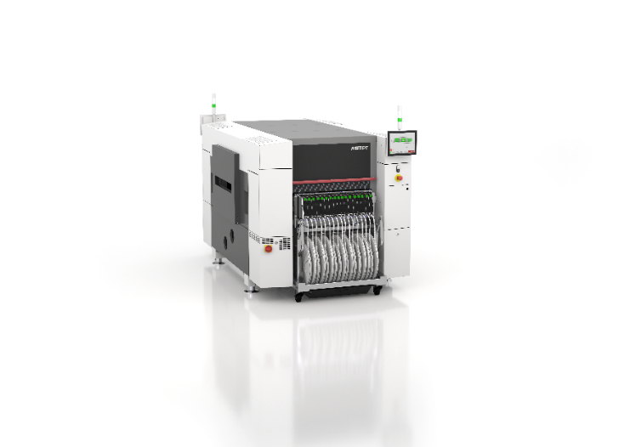 | 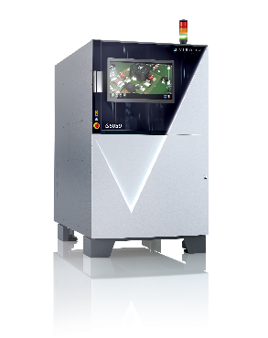
With their high-resolution cameras, SIPLACE SX placement machines identify components even if they are  delivered with a slightly different component shape.  Image credit: ASMPT | Viscom’s AOI systems feature smart networking with exceptional computing power and reliable measurement accuracy for maximum quality in SMT production.  Image credit: Viscom
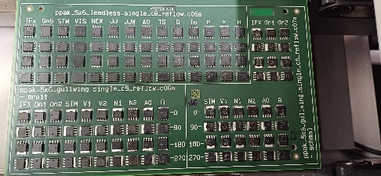

Test board for validating ASMPT’s and Viscom’s new ‘Alternative Components’ function at Schaeffler.

Image credit: ASMPT

About ASMPT Limited (“ASMPT”)
ASMPT Limited is a leading global supplier of hardware and software solutions for the manufacture of semiconductors and electronics. Headquartered in Singapore, ASMPT’s offerings encompass the semiconductor assembly & packaging, and SMT (surface mount technology) industries, ranging from wafer deposition to the various solutions that organize, assemble and package delicate electronic components into a vast range of end-user devices, which include electronics, mobile communications, computing, automotive, industrial and LED (displays). ASMPT partners with customers very closely, with continuous investments in R&D helping to provide cost-effective, industry-shaping solutions that achieve higher productivity, greater reliability, and enhanced quality. ASMPT is a founding member of the Semiconductor Climate Consortium.
To learn more about ASMPT, please visit www.asmpt.com.

The ASMPT SMT Solutions segment
The mission of the SMT Solutions segment within ASMPT is to implement and support the Intelligent Factory at electronics manufacturers worldwide.
ASMPT solutions support the networking, automation, and optimization of central workflows with hardware, software and services that enable electronics manufacturers to transition to the Intelligent Factory in stages and enjoy dramatic improvements in productivity, flexibility, and quality. With its integrated open automation concept, ASMPT opens the door for its customers to economically feasible automation, entirely in accordance with their individual requirements – modular, flexible, and vendor-independent.
The product range includes hardware and software such as SIPLACE placement solutions, DEK printing solutions, inspection and storage solutions, and the WORKS Software Suite. With WORKS, ASMPT offers electronics manufacturers high-quality software for planning, controlling, analyzing and optimizing all processes on the shop floor. Maintaining close relationships with customers and technology partners is a central component of ASMPT’s strategy.
For more information about ASMPT SMT Solutions, visit smt.asmpt.com.

Media contacts:
AMCAS ASMPT Press Office
SMT Solutions
Mark Ogden
Phone: +1 (770) 797 3189
E-mail: ogden.mark@asmpt.com
Website: smt.asmpt.com

Global ASMPT Press Office
ASMPT Limited
Susanne Oswald
Rupert-Mayer-Strasse 48
81379 Munich
Germany
Phone: +49 89 20800-26439
E-Mail: susanne.oswald@asmpt.com
Website: asmpt.com

