FOR THE MEDIA
ASMPT at SEMICON West 2025
Showcasing Advanced Packaging Solutions for AI and High-Performance Computing
Billerica (USA), September 23, 2025 – ASMPT, a global provider of advanced packaging and semiconductor assembly solutions, will participate in SEMICON West 2025. Under the theme “Empower the Intelligence Revolution,” the company will showcase its advanced packaging portfolio on October 7–9, 2025 at booth #479 at the Phoenix Convention Center, demonstrating its commitment to driving innovations in AI, cloud computing, and high-performance computing technologies.
With the increasing demand for AI applications, AI accelerators and memory modules require improved performance, greater functionality and better power efficiency. This is achieved through high-density interconnects and heterogeneous integration. At SEMICON West, ASMPT will highlight its advanced packaging solutions designed to provide ultra-high bandwidth, low latency and dense integration – key for next-generation 2.5D and 3D-IC devices.
ASMPT’s advanced packaging portfolio includes the FIREBIRD thermo-compression bonding system featuring its innovative active oxide removal technology (AOR TCB™), the newly launched ALSI LASER1206 fully automatic laser dicing platform, the AMICRA NANO die attach solution offering ±0.2 µm precision, the NEXX Stratus™ P500 panel plating system, and the hybrid SIPLACE CA2 placement platform. These solutions help semiconductor manufacturers master complex integration tasks and support AI application development.
“At SEMICON West 2025, ASMPT will demonstrate how its packaging technologies address the growing demands of AI-driven applications,” said Jean-Marc Peallat, Regional Head, ASMPT Semiconductor Solutions Americas. “The event also provides an excellent opportunity to engage with industry experts, exchange ideas and contribute to the future of semiconductor manufacturing.”.

Illustrations for downloading
The following print-ready artwork is available on the internet for downloading:
https://kk.htcm.de/press-releases/asmpt/

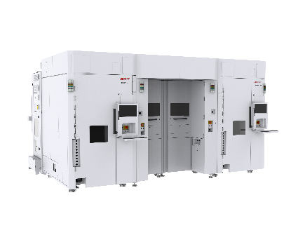 | 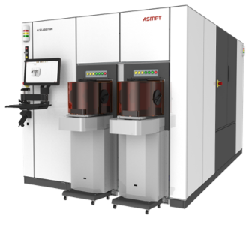
AOR TCB with FIREBIRD Series,  Next evolution of IC interconnect solutions for heterogeneous integration  Image credit: ASMPT | ALSI LASER1206, the fully automatic laser dicing and grooving system.  Image credit: ASMPT
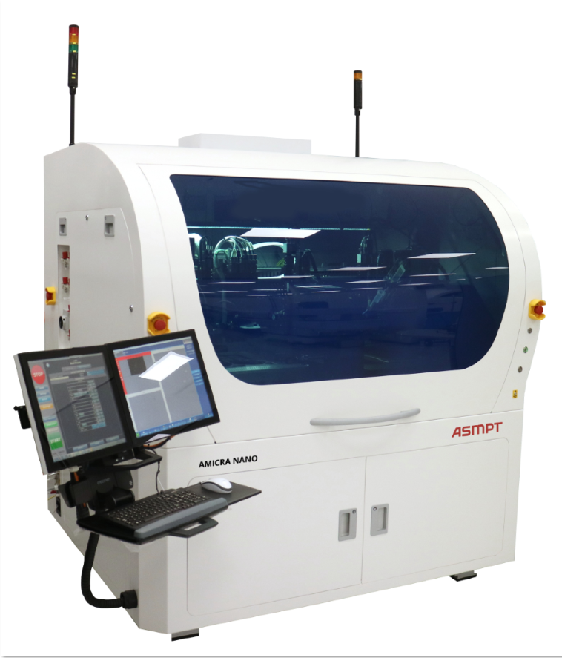 | 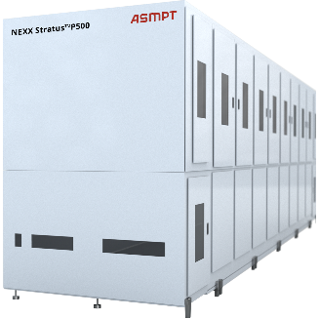
AMICRA NANO, Ultra-precision placement for co-packaged optics assembly  Image credit: ASMPT | NEXX Stratus™ P500, Advanced electroplating for dense IC packages  Image credit: ASMPT
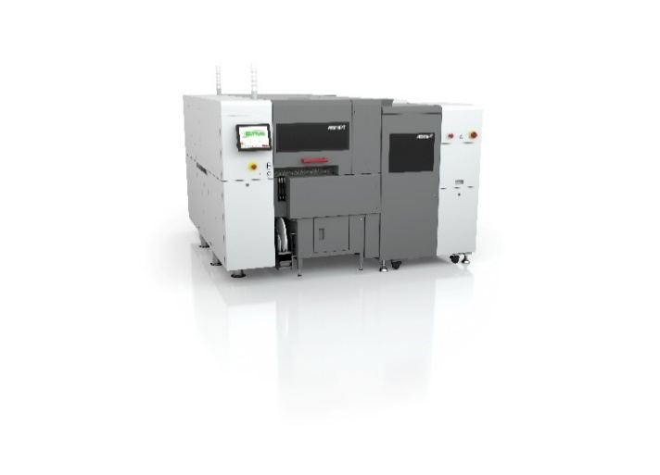
The SIPLACE CA2 boosts productivity in advanced packaging by combining classic surface-mount technology with die-attach and flip-chip assembly.

Image credit: ASMPT

About ASMPT Limited (“ASMPT”)
ASMPT Limited is a leading global supplier of hardware and software solutions for the manufacture of semiconductors and electronics. Headquartered in Singapore, ASMPT’s offerings encompass the semiconductor assembly & packaging, and SMT (surface mount technology) industries, ranging from wafer deposition to the various solutions that organize, assemble and package delicate electronic components into a vast range of end-user devices, which include electronics, mobile communications, computing, automotive, industrial and LED (displays). ASMPT partners with customers very closely, with continuous investments in R&D helping to provide cost-effective, industry-shaping solutions that achieve higher productivity, greater reliability, and enhanced quality. ASMPT is a founding member of the Semiconductor Climate Consortium.
To learn more about ASMPT, please visit www.asmpt.com.
About ASMPT Semiconductor Solutions (“ASMPT SEMI”)
ASMPT SEMI is the leading provider of forward-looking solutions for advanced packaging and semiconductor assembly. With its commitment to innovation and customer satisfaction, ASMPT SEMI offers a comprehensive range of products and services that meet the evolving needs of the microelectronics industry. Expert knowledge covers areas such as flip-chip and wafer-level packaging, advanced interconnect technologies, and more. ASMPT SEMI’s state-of-the-art solutions enable customers to achieve higher performance, greater reliability, and improved cost-efficiency in the manufacturing of their semiconductor devices.
ASMPT SEMI sees itself as a pioneer and driving force of the Intelligence Revolution. With its advanced packaging and assembly technologies, the business segment creates the invisible connections that enable intelligent applications in Artificial Intelligence, Smart Mobility, and Hyperconnectivity.
For more information about ASMPT SEMI, visit semi.asmpt.com.
Media contacts:
Global ASMPT Press Office
ASMPT Limited
Susanne Oswald
Rupert-Mayer-Strasse 48
81379 Munich / Germany
Tel: +49 89 20800-26439
E-mail: susanne.oswald@asmpt.com
Website: asmpt.com

HighTech communications GmbH
Barbara Ostermeier
Brunhamstrasse 21
81249 Munich / Germany
Tel.: +49-89 500778-10|
E-mail: b.ostermeier@htcm.de
Website: www.htcm.de

