FOR THE MEDIA

ASMPT Joins "JOINT3" Consortium to Develop Next-Generation Semiconductor Packaging

Global Advanced Packaging Leader Brings Proven Thermo-Compression Bonding Expertise to Next-Generation Panel-Level Innovation Platform

TOKYO, September 3, 2025 – ASMPT Limited (ASMPT), a leading global supplier of hardware and software solutions for the manufacture of semiconductors and electronics, today announced its participation in the "JOINT3" consortium to develop next-generation semiconductor packaging.

JOINT3 is a co-creation evaluation framework established by Resonac Corporation (President and CEO: Hidehito Takahashi, hereinafter "Resonac") with the aim of accelerating the development of materials, equipment, and design tools optimized for panel-level organic interposers through collaboration among material, equipment, and design companies. JOINT3 brings together global leaders across the semiconductor supply chain. Using a prototype line for 515 x 510mm panel-level organic interposers, the consortium promotes the development of materials, equipment, and design tools optimized for panel-level organic interposers.

In recent years, packaging for back-end processes have emerged as a key technology in the field of next-generation semiconductors. This includes 2.xD packages, whereby multiple semiconductor chips are arranged in parallel and connected via interposers, demand for which is expected to grow in line with the need for increased data communication capacity and speed. As semiconductor performance improves, interposers are becoming larger, and there is a shift from silicon interposers to organic interposers made from organic materials.

Conventional manufacturing methods involve cutting rectangular pieces from circular wafers. However, as interposers increase in size, the number of them that can be obtained from a single wafer decreases, posing a significant challenge. To address this issue, a manufacturing process that transitions from circular wafer shapes to square panel shapes is gaining attention, as it allows for an increased number of interposers to be produced from a given area of wafer.

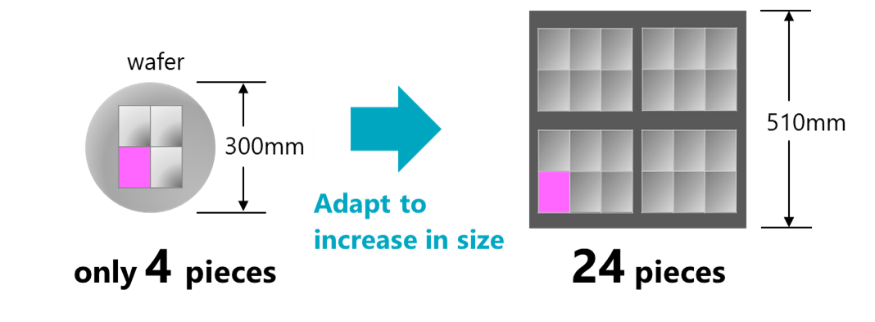

ASMPT's Strategic Contribution to Panel-Level Innovation

As the consortium's dedicated advanced packaging assembly solutions provider, ASMPT brings its market-leading thermo-compression bonding (TCB) expertise to enable panel-level manufacturing capabilities. With more than 500 TCB systems deployed in mass production worldwide, ASMPT has established the industry standard for precision heterogeneous integration across 2D, 2.5D, and 3D packaging formats.

"ASMPT's participation in JOINT3 represents a natural extension of our leadership in advanced packaging technologies," said Lim Choon Khoon, Advanced Packaging Chief Counsel for ASMPT Semiconductor Solutions (SEMI). "Our proven track record spanning chip-to-substrate, chip-to-wafer, and HBM applications, combined with our unique position as the consortium's sole back-end assembly specialist, enables us to serve as the critical bridge between panel-level packaging innovation and manufacturing reality. This collaboration with Resonac and the JOINT3 partners underscores our commitment to enabling next-generation packaging solutions that meet the demanding requirements of AI and high-performance computing applications."

ASMPT SEMI's FIREBIRD TCB platform is capable of sub-micron placement accuracy and is equipped with ASMPT’s proprietary residue-free fluxless AOR process for fine pitch TCB bonding on panel. These capabilities directly address the unique challenges of panel-level processing, including thermal uniformity across large substrates up to 515x510mm, compensation for panel warpage, and high-throughput requirements for cost-effective manufacturing.

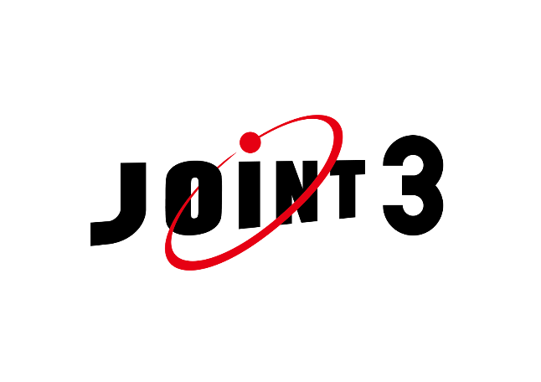
Overview of JOINT3
Name | JOINT3 (JOINT:Jisso Open Innovation Network of Tops)
Objectives | Accelerate the development of materials, equipment, and design tools optimized for panel-level organic interposers through co-creation with participating companies.
Participating Companies (listed in alphabetical order) | 27 companies (as of September 3, 2025)
 | Resonac Corporation, AGC Inc., Synopsys, Inc., Applied Materials, Inc., ASMPT, Brewer Science, Inc., Canon Inc., Comet Yxlon, EBARA CORPORATION, Furukawa Electric Co., Ltd., Hitachi High-Tech Corporation, JX Advanced Metals Corporation, Nippon Mining & Metals Corporation, Kao Corporation, Lam Research, LINTEC Corporation, MEC COMPANY LTD., Mitutoyo Corporation, NAMICS Corporation, Nikko-Materials Co., Ltd., OKUNO CHEMICAL INDUSTRIES CO., LTD., Tokyo Electron Ltd., Tokyo Ohka Kogyo Co., Ltd., TOWA Corporation, ULVAC, Inc., Ushio Inc., ZUKEN Inc., 3M Company
Location | - Advanced Panel Level Interposer Center “APLIC”  (Yuki City, Ibaraki Prefecture, Japan (within the Resonac Shimodate Plant (Minami-yuki)))  - Packaging Solution Center  (Kawasaki City, Kanagawa Prefecture, Japan)
Activities | - Developing materials, equipment, and design tools for organic interposers using a panel-level (515 x 510 mm) prototype production line  - Promoting development through co-creation by having material and equipment manufacturers produce common prototypes  - Utilizing JOINT3 as a “training ground” for technology and equipment manufacturers to further enhance technologies related to panel-level organic interposers

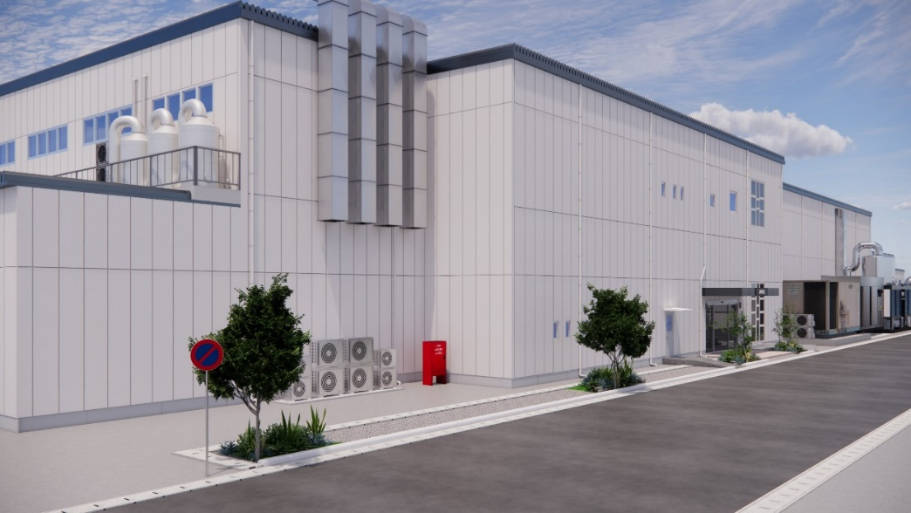
APLIC building exterior

About Resonac
Resonac is a functional chemical company established as a result of the integration of Showa Denko and former Hitachi Chemical in January 2023. The Company's sales revenue of semiconductor and electronic materials business for 2024 was about 450 billion yen. The Company is a world-class leader particularly in semiconductor materials for packaging process. The integration of the two companies has enabled Resonac to design functions of materials as well as to develop them in-house, going all the way back to raw materials. The trade name "RESONAC" was created as a combination of two English words, namely, the word of "RESONATE" and "C" as the first letter of CHEMISTRY. The Company will make the most of its co-creative platform, and accelerate technological innovation with semiconductor manufacturers, material manufacturers, and equipment manufacturers inside and outside Japan.

For detail, please refer to our Website.
Resonac Holdings Corporation: https://www.resonac.com/

About ASMPT Limited
ASMPT Limited is a leading global supplier of hardware and software solutions for the manufacture of semiconductors and electronics. Headquartered in Singapore, ASMPT's offerings encompass the semiconductor assembly & packaging, and SMT (surface mount technology) industries, ranging from wafer deposition to the various solutions that organise, assemble and package delicate electronic components into a vast range of end-user devices. ASMPT partners with customers very closely, with continuous investment in R&D helping to provide cost-effective, industry-shaping solutions that achieve higher productivity, greater reliability, and enhanced quality.
ASMPT is listed on the Stock Exchange of Hong Kong (HKEX stock code: 0522), and is one of the constituent stocks of the Hang Seng TECH Index, Hang Seng Composite MidCap Index under the Hang Seng Composite Size Indexes, the Hang Seng Composite Information Technology Industry Index under Hang Seng Composite Industry Indexes, the Hang Seng Corporate Sustainability Benchmark Index, and the Hang Seng HK 35 Index. To learn more about ASMPT, please visit us at www.asmpt.com.

For media enquiries:
Global ASMPT Press Office
ASMPT Ltd
Lim Ee Guan
Director, Corporate Communications
E-Mail: eg.lim@asmpt.com

Global ASMPT Semiconductor Solutions Press Office
ASMPT Ltd
Jessica Ho
Semiconductor Solutions E-Mail: semi_stratmkt@asmpt.com

Resonac Holdings Corporation
Media Relations Group, Brand Communication Department
Phone: +81-3-6263-8002

