PRESS RELEASE

Würth Elektronik expands its range of filter chokes
Space-Saving EMC Solution
Waldenburg (Germany), September 3, 2025 – Würth Elektronik expands its family of common-mode data lines chokes. The new component packages of the WE-CMDC series enable effective noise suppression at a rated current up to 10 A, making these compact filter components ideal for modern high-current applications.
Now available in 7060, 9070, 1513, and 1211 packages, the compact WE-CMDC series of common-mode data line filters features an especially flat profile and high impedance up to 2,500 ohms. They have been specifically developed for DC power supplies, DC/DC converters, as well as for data and signal lines, and are qualified to AEC-Q200 Grade 1. Their compact design and height between 3.5 and 6 mm makes the WE-CMDC chokes ideal for space-sensitive designs without compromising on performance.
Diverse application options and EMC expertise
The compact filter components are ideal for applications in industrial electronics, including power supplies, automation, and control systems. Manufacturers of telecommunications equipment such as routers, gateways, and PoE systems, as well as providers of household appliances, IoT products, wearables, and smart home solutions, also benefit from the enhanced electromagnetic interference suppression options.
The expanded product range once again demonstrates Würth Elektronik’s outstanding position in the field of EMC. For this often challenging area, the manufacturer offers not only the suitable components but also design support and advice.
“By constantly bringing new values and options to the market, we align our product offering to market and application needs” explains Alexander Gerfer, CTO at Würth Elektronik eiSos. “True to our claim ‘More than you expect’, we are constantly expanding our range so that every customer can find exactly the component in the catalog that best suits their design.”
The new inductors are now available from stock without a minimum order quantity. Developers can receive free samples.

Available images
The following images can be downloaded from the Internet in printable quality: https://kk.htcm.de/press-releases/wuerth/
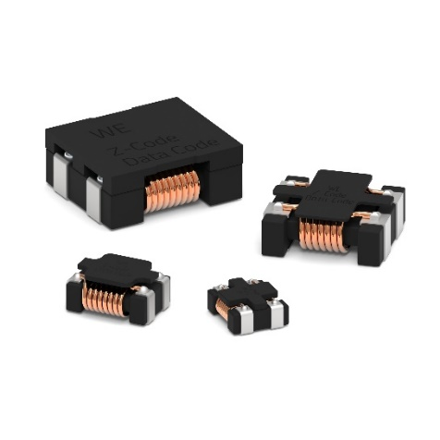
Image source: Würth Elektronik
Small chokes with a big interference suppression effect: WE-CMDC – now also available in 7060, 9070, and 1513 packages.

About the Würth Elektronik eiSos Group
Würth Elektronik eiSos Group is a manufacturer of electronic and electromechanical components for the electronics industry and a technology company that spearheads pioneering electronic solutions. Würth Elektronik eiSos is one of the largest European manufacturers of passive components and is active in 50 countries. Production sites in Europe, Asia and North America supply a growing number of customers worldwide.
The product range includes passive components, power modules, digital isolators, optoelectronics, electromechanical components, thermal management solutions, sensors and wireless modules. The portfolio is rounded off by customer-specific solutions.
The unrivaled service orientation of the company is characterized by the availability of all catalog components from stock without minimum order quantity, free samples and extensive support through technical sales staff and selection tools.
Würth Elektronik is part of the Würth Group, the global market leader in the development, production, and sale of fastening and assembly materials, and employs around 7,500 people. In 2024, the Würth Elektronik Group generated sales of 1.02 Billion Euro.
Würth Elektronik: more than you expect!
Further information at www.we-online.com

Further information:  Würth Elektronik eiSos GmbH & Co. KG  Sarah Hurst  Clarita-Bernhard-Strasse 9  81249 Munich  Germany  Phone: +49 7942 945-5186  E-mail: sarah.hurst@we-online.de  www.we-online.com | Press contact:  HighTech communications GmbH  Brigitte Basilio  Brunhamstrasse 21  81249 Munich  Germany  Phone: +49 89 500778-20  E-mail: b.basilio@htcm.de  www.htcm.de

