
PRESS RELEASE
Hufschmied at CAMX 2025
CFRP Machining – No More Manual Reworking
Booth B12
Bobingen (Germany), Chicago, IL – August 14, 2025 – Hufschmied Machining Systems will be exhibiting at CAMX 2025 in Orlando, Florida, from September 9 to 11. The Composites and Advanced Materials Expo is the largest and most comprehensive trade fair for composite materials and advanced materials in North America. At booth B12 in the Orange County Convention Center, Europe's leading manufacturer of material-specific tools will primarily provide information about solutions for efficient machining of CFRP. Hufschmied will also use the trade fair to expand its cooperation with machine tool manufacturer CMS (booth C76) to the US market.
When machining CFRP, conventional tools repeatedly face the challenges of fraying, delamination, or chipping of the material. Hufschmied has solved these problems with special geometries and coatings and offers the best results for milling fiber-reinforced composites with tool series such as FIBER-LINE, HEXACUT, and T-REX: clean cut edges without reworking.
Cooperation to be expanded
"In CFRP, high-strength carbon fibers alternate with a soft matrix material. Machining is complicated not only by the different properties of these materials but also depending on the angle at which the cutting edge engages the fibers. We have solutions to cope with these challenges, “ explains Daniel Sanchez, National Sales Manager at Hufschmied Machining Systems. ”Efficient machining depends on the material, tool, machine, and milling strategy. We work closely to collaborate and advise our customers and partners on process optimization. One of our partners in Europe is CMS, we look forward to expanding this relationship in the USA as well."
At the beginning of the year, Hufschmied Zerspanungssysteme GmbH and CMS S. p. A. entered into a groundbreaking technical partnership. Since then, a CMS ARES machine has been installed at the tool manufacturer's technology center in Bobingen, where tests are carried out for joint customers to optimize machining processes.

Available images
The following images can be downloaded from the Internet in printable quality:
https://kk.htcm.de/press-releases/hufschmied/
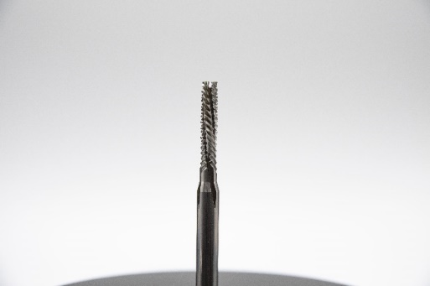
Image source: Hufschmied Zerspanungssysteme

T-REX (194/198) is a tool optimized for machining fiber-reinforced composite materials.

About Hufschmied Zerspanungssysteme GmbH
Established in 1991 and headquartered in Bobingen near Augsburg, Hufschmied Zerspanungssysteme GmbH is a manufacturer of high-quality tools for machinable production and friction stir welding. By specializing at an early stage in the machining of plastics, fiberglass materials and carbon fiber, Hufschmied has become a leader in Europe in the development of solutions for new materials. The company is an established system supplier to renowned machine tool manufacturers. Tools and manufacturing process consulting from Hufschmied are particularly valued in the automotive and aerospace industries as well as in medical technology. The company is involved in numerous organizations, including Composites United Deutschland e. V. Hufschmied's manufacturing operations are located in Bobingen, Winterlingen and Sigmaringen on the Swabian Alb. Hufschmied is certified according to ISO 9001:2015 (quality management) and ISO 14001:2015 (environmental management).

Hufschmied Zerspanungssysteme GmbH – One Cut Ahead
For more information: www.hufschmied.net

Additional information:  HZS - Hufschmied Tools Corp.  Daniel Sanchez  150 North Michigan Avenue, 35th Floor  Chicago, Illinois, 60601  USA  Phone: +1-312-763-2160  E-Mail: d.sanchez@hufschmied.net  www.hufschmied.net  Hufschmied Zerspanungssysteme GmbH  Marco Beigl  Edisonstrasse 11d  86399 Bobingen  Germany  Phone: +49 8234 9664-0  Telefax: +49 8234 9664-99  E-Mail: info@hufschmied.net  www.hufschmied.net | Press contact:  HighTech communications GmbH  Brigitte Basilio  Brunhamstrasse 21  81249 Munich  Germany  Phone: +49 89 500778-20  E-Mail: b.basilio@htcm.de  www.htcm.de

