PRESS RELEASE

Changes in Management Positions at Würth Elektronik eiSos Group
New roles for Dirk Knorr and Sebastian Valet
Waldenburg (Germany), August 14, 2025 – Würth Elektronik, a leading manufacturer of electronic and electromechanical components for the electronics industry, announces two new appointments at the management level: Dirk Knorr has taken over the position of COO of the Würth Elektronik eiSos Group, and Sebastian Valet has taken over his previous position as Managing Director of Würth Elektronik eiSos GmbH & Co. KG.
After completing his training as an industrial electronics technician and subsequently graduating with a degree in industrial engineering, Dirk Knorr initially worked as a project manager for a solutions provider before joining Würth Elektronik in 2005. Knorr has extensive expertise in quality and risk management. As part of his role as Managing Director Germany, he has driven forward digitization projects and initiated logistics adjustments at the Waldenburg site, among other things.
In his new role, Knorr will be responsible for the company's core operational pillars, including IT, digital transformation, production, logistics, quality, and eiSos Group compliance standards.
Sebastian Valet holds a degree in business administration and has been with the Würth Group since 1999, where his career path led him to Würth Elektronik in 2002. As export manager, Valet played a key role in the internationalization of Würth Elektronik and established the markets in Israel, Turkey, and Australia before taking over several commercial departments at the headquarters in Waldenburg. Most recently, he was responsible for supply chain management, internal sales, export control, and legal & compliance.
Digital solutions and new ideas
“I am committed to the further expansion of digital solutions in the future,” Knorr affirms. “The use of artificial intelligence will continue to change our working world and increase its effectiveness. It is also important to be even closer to our global customers and markets.”
“I will draw on my many years of management experience at Würth Elektronik to the fullest extent in order to generate new momentum and drive our growth in Germany,” Valet resolves. “We will continue to focus on close customer relationships and further expand our service leadership through digital tools.”

Following the change in leadership, the management team at Würth Elektronik eiSos now consists of the following members:
- Thomas Garz, Chief Executive Officer (CEO), Würth Elektronik eiSos Group
- Alexander Gerfer, Chief Technology Officer (CTO), Würth Elektronik eiSos Group
- Dirk Knorr, Chief Operating Officer (COO), Würth Elektronik eiSos Group
- Sebastian Valet, Managing Director of Würth Elektronik eiSos GmbH & Co. KG
- Josef Wörner, Managing Director of Würth Elektronik eiSos GmbH & Co. KG

Available images
The following images can be downloaded from the Internet in printable quality: https://kk.htcm.de/press-releases/wuerth/
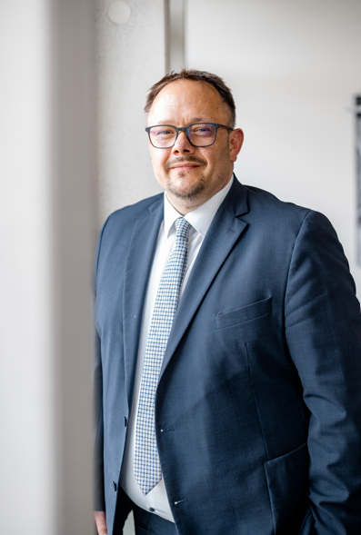 Image source: Frank Blümler  Dirk Knorr becomes COO of the Würth Elektronik eiSos Group. | 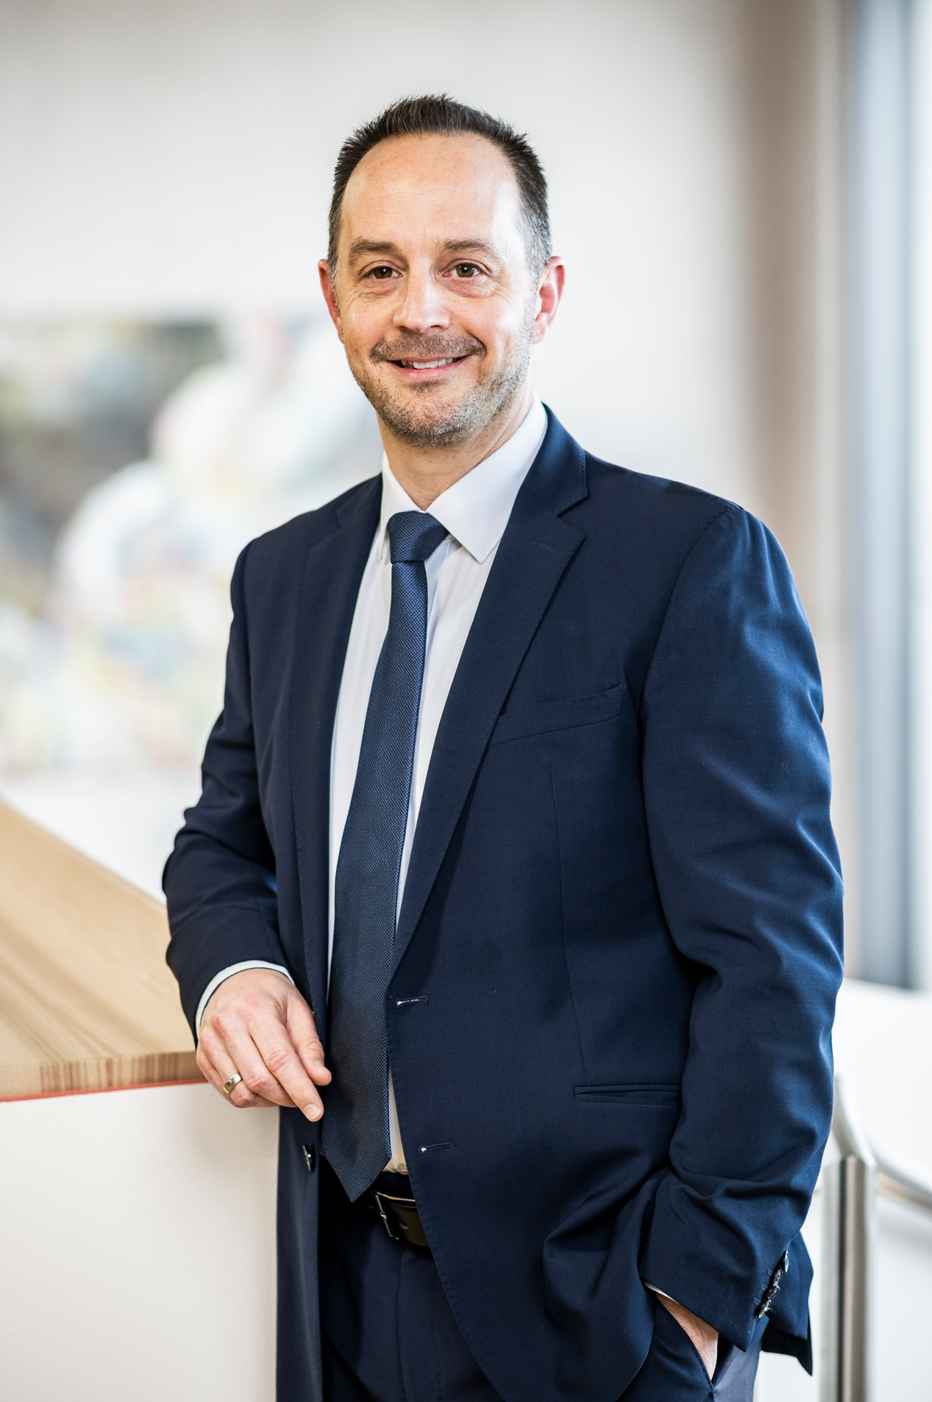 Image source: Würth Elektronik  Dirk Knorr's previous position as Managing Director of Würth Elektronik eiSos GmbH & Co. KG will be taken over by Sebastian Valet.

About the Würth Elektronik eiSos Group
Würth Elektronik eiSos Group is a manufacturer of electronic and electromechanical components for the electronics industry and a technology company that spearheads pioneering electronic solutions. Würth Elektronik eiSos is one of the largest European manufacturers of passive components and is active in 50 countries. Production sites in Europe, Asia and North America supply a growing number of customers worldwide.
The product range includes passive components, power modules, digital isolators, optoelectronics, electromechanical components, thermal management solutions, sensors and wireless modules. The portfolio is rounded off by customer-specific solutions.
The unrivaled service orientation of the company is characterized by the availability of all catalog components from stock without minimum order quantity, free samples and extensive support through technical sales staff and selection tools.
Würth Elektronik is part of the Würth Group, the global market leader in the development, production, and sale of fastening and assembly materials, and employs around 7,500 people. In 2024, the Würth Elektronik Group generated sales of 1.02 Billion Euro.
Würth Elektronik: more than you expect!
Further information at www.we-online.com

Further information:  Würth Elektronik eiSos GmbH & Co. KG  Sarah Hurst  Clarita-Bernhard-Strasse 9  81249 Munich  Germany  Phone: +49 7942 945-5186  E-mail: sarah.hurst@we-online.de  www.we-online.com | Press contact:  HighTech communications GmbH  Brigitte Basilio  Brunhamstrasse 21  81249 Munich  Germany  Phone: +49 89 500778-20  E-mail: b.basilio@htcm.de  www.htcm.de

