FOR THE MEDIA
ASMPT exhibits at SEMICON India
Leading-Edge Packaging for Advanced Technologies
Singapore, August 12, 2025 – ASMPT, the world’s leading provider of hardware and software solutions for semiconductor and electronics manufacturing, will be exhibiting at SEMICON India (September 2-4, 2025) under the theme “Empower the Intelligence Revolution.” This refers to the fact that current developments in areas such as AI, smart mobility and hyperconnectivity require chips and components for which ASMPT is the leading manufacturer of cutting-edge advanced packaging and semiconductor manufacturing technologies. The company will showcase two machines at booth 1223 of the Yashobhoomi (IICC) in New Delhi: the fine-pitch wire bonding solution AERO PRO and the ultra-fast die bonding solution INFINITE.

Fine-Pitch Wire Bonder First Time in India
ASMPT Semiconductor Solutions introduces its latest high-performance wire bonder: the AERO PRO. Developed for high-density semiconductor designs, this machine delivers the highest bonding accuracy and exceptional speed for wires with diameters of 0.5 mil (≈12.7 µm). Thanks to integrated real-time monitoring and preventive maintenance functions, the system is ideally suited for use in intelligent, networked production environments. To accommodate complex designs such as system-in-package (SiP) and multi-chip modules (MCMs) as well as applications like ball grid arrays (BGAs), land grid arrays (LGAs), memory modules or quad flat packages (QFPs) with external leads, the AERO PRO supports mixed-wire bonding. For uniform 22-µm bond balls, the AERO PRO employs the innovative and patented X-POWER 2.0 transducer, a newly developed lightweight and vibration-optimised ultrasonic transducer that transfers the energy with great precision in X and Y directions. Featuring real-time process monitoring and predictive maintenance, AERO PRO seamlessly integrates with automated material handling and manufacturing execution systems (MES) to enhance yield and operational efficiency.
With outstanding precision, reliability, repeatability, and intelligent automation capabilities, the AERO PRO is a premier solution designed to meet the rapidly evolving demands of AI edge devices and smart mobility applications.
Flagship Die Bonder
The second machine on the ASMPT booth is the die bonder INFINITE, which achieves top performance in throughput and quality with intelligent features, especially in adhesive application and placement. INFINITE is a universal, high-speed die bonder designed to meet the rigorous demands of sophisticated semiconductor packaging. Supporting a broad array of packaging formats such as BGA, LGA, SiP, MEMS, and QFN, it ensures consistent quality in producing AI chips, 5G modules, and HPC devices. Its intelligent iSense and iTouch features provide precise adhesive dispensing and force regulation, essential for the reliable packaging of safety-critical ADAS, LiDAR components, and SiC/GaN power modules used in electric vehicles. Moreover, INFINITE plays a critical role in assembling high-precision RF, photonics, and high-speed logic modules needed for advanced telecom infrastructure and hyperconnectivity solutions. This combination of precision, adaptability, and intelligent control makes INFINITE a key enabler of cutting-edge technologies driving the Intelligence Revolution.
Empowering the Intelligence Revolution
“We are delighted to present AERO PRO in India for the first time. Together with INFINITE, these solutions represent our advanced wire bonding and die bonding technologies, designed to integrate logic, memory, sensors, and photonics with high precision and efficiency to support India’s growing semiconductor ecosystem”, said Kenneth Koh, Head of Strategic Marketing at ASMPT Semiconductor Solutions. “At ASMPT SEMI solutions, we enable advanced, intelligence-driven innovations that enhance performance, promote miniaturisation, and improve energy efficiency across data centers, vehicles, and global networks—driving progress in AI, smart mobility, and hyperconnectivity.”

Illustrations for downloading
The following print-ready artwork is available on the internet for downloading:
https://kk.htcm.de/press-releases/asmpt/

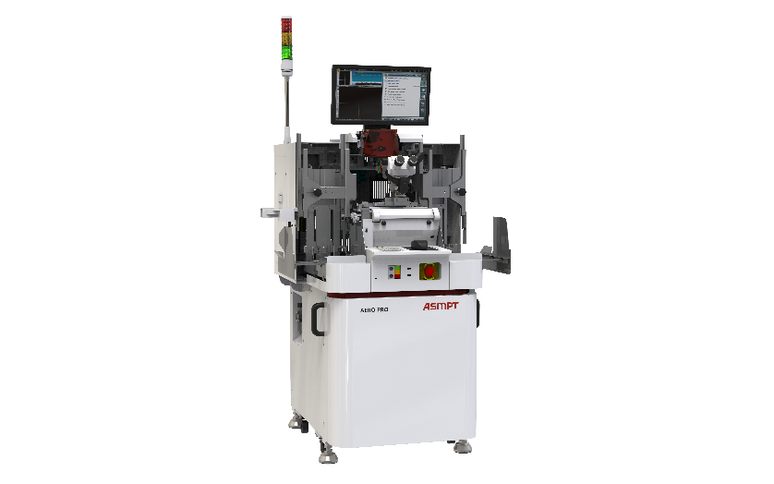 | 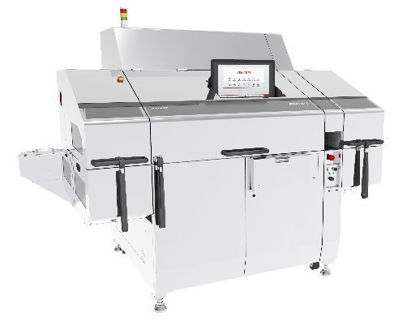
AERO PRO, innovative wire bonding solution for high-end IC contacting  Image credit: ASMPT | INFINITE high-speed die bonder: reliable packaging for the Intelligence Revolution  Image credit: ASMPT

About ASMPT Limited (“ASMPT”)
ASMPT Limited is a leading global supplier of hardware and software solutions for the manufacture of semiconductors and electronics. Headquartered in Singapore, ASMPT’s offerings encompass the semiconductor assembly & packaging, and SMT (surface mount technology) industries, ranging from wafer deposition to the various solutions that organize, assemble and package delicate electronic components into a vast range of end-user devices, which include electronics, mobile communications, computing, automotive, industrial and LED (displays). ASMPT partners with customers very closely, with continuous investments in R&D helping to provide cost-effective, industry-shaping solutions that achieve higher productivity, greater reliability, and enhanced quality. ASMPT is a founding member of the Semiconductor Climate Consortium.
To learn more about ASMPT, please visit www.asmpt.com.

About ASMPT Semiconductor Solutions (“ASMPT SEMI”)
ASMPT SEMI is the leading provider of forward-looking solutions for advanced packaging and semiconductor assembly. With its commitment to innovation and customer satisfaction, ASMPT SEMI offers a comprehensive range of products and services that meet the evolving needs of the microelectronics industry. Expert knowledge covers areas such as flip-chip and wafer-level packaging, advanced interconnect technologies, and more. ASMPT SEMI’s state-of-the-art solutions enable customers to achieve higher performance, greater reliability, and improved cost-efficiency in the manufacturing of their semiconductor devices.
For more information about ASMPT SEMI, visit semi.asmpt.com.

Media contacts:
Global ASMPT Semiconductor Solutions Press Office
ASMPT Limited Hong Kong
Jessica Ho
Semiconductor Solutions
E-Mail: semi_stratmkt@asmpt.com
Website: semi.asmpt.com

Global ASMPT Press Office
ASMPT Ltd.
Susanne Oswald
Rupert-Mayer-Strasse 48
81379 Munich
Germany
Phone: +49 89 20800-26439
E-Mail: susanne.oswald@asmpt.com
Website: asmpt.com

