PRESS RELEASE

Extensions to the Würth Elektronik switch program
Push-Button Switches and a Main Switch
Waldenburg (Germany), August 13, 2025 – Würth Elektronik expands its switch program. The popular SMT-mountable short-travel push-button switches are now joined by a new size version: the “WS-TASV SMT Tact Switch 4.5*3.2 mm”. The switches are available in three versions with different actuation forces. The range of power switches is expanded with a rocker switch for a particularly space-saving device panel cut-out.
The short-travel push-buttons from Würth Elektronik are suitable both for switching functions on and off as well as for use as signal transmitters. Designed for operating temperatures from -40 to +85 °C, the tactile switches are available with actuation forces of 170, 330, and 520 gf. These short-travel switches, commonly used in remote controls, occupy an area of 4.5 × 3.2 mm and are 2.5 mm high. A new automated production process ensures strict tolerances are maintained. The service life test under full load (50 mA / 16 V_{DC}) showed an electrical service life of 100,000 cycles. The push-button switches have also passed a 48-hour salt spray test and a five-cycle reflow soldering test. The plastic material is UL94-approved for flammability.
Rugged main switch
The new WS-RSTV (Rocker Switch THT Vertical), designed for a device panel cut-out of just 19.2 × 6.8 mm, features a 4.75 mm (0.187") quick-connect terminal. The hot-stamped color marking integrated into the plastic is available with a horizontal or vertical “1”. This switch, with an electrical service life of 10,000 cycles, has also been tested under full load. The operating temperature ranges from 0 to +85 °C. The plastic material PA66 complies with UL94 flammability test standards and has undergone a glow wire test at 850 °C in accordance with IEC 60695-2-11 under the 61058-1 standard, as well as a UV test in accordance with IEC 60068-2-5. Available certifications include UL/ENEC 61058-1 and CQC16002160972. The contact material is a silver-plated copper alloy.
Service
Both switch innovations are now available from stock without a minimum order quantity. Würth Elektronik offers free samples on request. Various documents on circuitry, safety, and test results are available on the product pages in the online catalog at www.we-online.com/components.

Available images
The following images can be downloaded from the Internet in printable quality: https://kk.htcm.de/press-releases/wuerth/
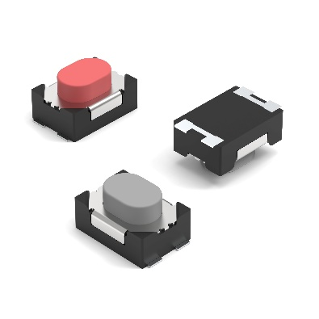  Image source: Würth Elektronik  Würth Elektronik expands its range of short-travel push-button switches. | 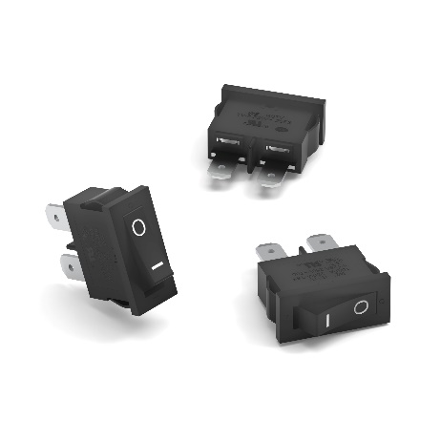  Image source: Würth Elektronik  This power switch only requires a small device panel cut-out.

About the Würth Elektronik eiSos Group
Würth Elektronik eiSos Group is a manufacturer of electronic and electromechanical components for the electronics industry and a technology company that spearheads pioneering electronic solutions. Würth Elektronik eiSos is one of the largest European manufacturers of passive components and is active in 50 countries. Production sites in Europe, Asia and North America supply a growing number of customers worldwide.
The product range includes passive components, power modules, digital isolators, optoelectronics, electromechanical components, thermal management solutions, sensors and wireless modules. The portfolio is rounded off by customer-specific solutions.
The unrivaled service orientation of the company is characterized by the availability of all catalog components from stock without minimum order quantity, free samples and extensive support through technical sales staff and selection tools.
Würth Elektronik is part of the Würth Group, the global market leader in the development, production, and sale of fastening and assembly materials, and employs around 7,500 people. In 2024, the Würth Elektronik Group generated sales of 1.02 Billion Euro.
Würth Elektronik: more than you expect!
Further information at www.we-online.com

Further information:  Würth Elektronik eiSos GmbH & Co. KG  Sarah Hurst  Clarita-Bernhard-Strasse 9  81249 Munich  Germany  Phone: +49 7942 945-5186  E-mail: sarah.hurst@we-online.de  www.we-online.com | Press contact:  HighTech communications GmbH  Brigitte Basilio  Brunhamstrasse 21  81249 Munich  Germany  Phone: +49 89 500778-20  E-mail: b.basilio@htcm.de  www.htcm.de

