PRESS RELEASE

Würth Elektronik publishes its AppNote on SEPIC
Tips for Designing SEPIC Converters
Waldenburg (Germany), August 20, 2025 – In Application Note ANP135 “The SEPIC with coupled and uncoupled inductors”, Würth Elektronik addresses the operation of a Single-Ended Primary-Inductor-Converter (SEPIC) in both continuous and discontinuous conduction modes (CCM and DCM). The 28-page document also includes design considerations and guidelines with focus on the power magnetics.
The SEPIC is a non-isolated switching power supply topology generating an output voltage that can be higher, equal or lower than the input voltage. Typical applications include battery-powered devices and chargers, automotive power systems, photovoltaic converters, LED lighting, and power factor correction stages. This new Application Note from Würth Elektronik provides a detailed analysis of the SEPIC converter with particular emphasis on the implementation with a coupled inductor, such as the WE-MCRI. It also includes an analysis of “ripple current steering” technique and the key role that the leakage inductance plays in the converter, all supported by SPICE simulations and measurements on a real DC-DC SEPIC converter prototype.
Coupled or uncoupled
Unlike topologies with a single inductor, such as buck, boost or buck-boost converters, the SEPIC power stage requires two inductors. These can be implemented as uncoupled, separate inductors, or alternatively configured as a coupled power inductor with two windings on a common core. This configuration not only reduces the number of components but also requires less inductance to generate the same ripple current amplitude compared to a solution with uncoupled inductors. Moreover, the magnetic coupling of the windings enables the implementation of “ripple current steering”. This is a technique in which the ripple current of the input winding can be “steered” to the output winding, helping to reduce conducted EMI noise. “When designing a SEPIC with coupled inductors, it is important to understand the influence of the coupling factor on the converter performance. In contrast to typical scenarios, a higher leakage inductance can be of advantage in this case,” explains Eleazar Falco, Senior Application Engineer at Würth Elektronik eiSos and author.

Available images
The following images can be downloaded from the Internet in printable quality: https://kk.htcm.de/press-releases/wuerth/
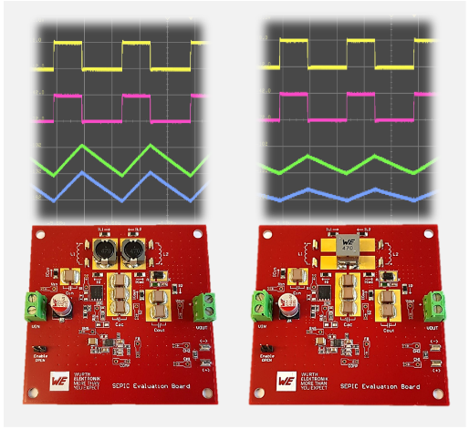Image source: Würth Elektronik
SEPIC boards for Würth Elektronik's new application note: with two uncoupled inductors (left), with a coupled inductor (right).

About the Würth Elektronik eiSos Group
Würth Elektronik eiSos Group is a manufacturer of electronic and electromechanical components for the electronics industry and a technology company that spearheads pioneering electronic solutions. Würth Elektronik eiSos is one of the largest European manufacturers of passive components and is active in 50 countries. Production sites in Europe, Asia and North America supply a growing number of customers worldwide.
The product range includes passive components, power modules, digital isolators, optoelectronics, electromechanical components, thermal management solutions, sensors and wireless modules. The portfolio is rounded off by customer-specific solutions.
The unrivaled service orientation of the company is characterized by the availability of all catalog components from stock without minimum order quantity, free samples and extensive support through technical sales staff and selection tools.
Würth Elektronik is part of the Würth Group, the global market leader in the development, production, and sale of fastening and assembly materials, and employs around 7,500 people. In 2024, the Würth Elektronik Group generated sales of 1.02 Billion Euro.
Würth Elektronik: more than you expect!
Further information at www.we-online.com

Further information:  Würth Elektronik eiSos GmbH & Co. KG  Sarah Hurst  Clarita-Bernhard-Strasse 9  81249 Munich  Germany  Phone: +49 7942 945-5186  E-mail: sarah.hurst@we-online.de  www.we-online.com | Press contact:  HighTech communications GmbH  Brigitte Basilio  Brunhamstrasse 21  81249 Munich  Germany  Phone: +49 89 500778-20  E-mail: b.basilio@htcm.de  www.htcm.de

