PRESS RELEASE

Würth Elektronik protects MEMS humidity sensor with its filter cap
For Longer Service Life and in Harsher Operating Environments
Waldenburg (Germany), August 6, 2025 – Würth Elektronik offers an accessory for its WSEN-HIDS humidity sensor, the WSEN-ACCE filter cap. The protective cap shields the high-precision humidity and temperature sensor from dust, water, and mechanical damage. The WSEN-ACCE filter cap is securely mounted with its pins in the holes of the circuit board or is glued in place as part of a sealed housing. The cap ensures that humidity measurements remain stable and accurate even under challenging conditions. Its protective function extends the sensor’s service life in demanding environments such as industrial or agricultural applications.
Requests from customers wishing to use the MEMS (micro-electro-mechanical systems) sensor, which measures just 1.5 × 1.5 × 0.5 mm, in dusty environments led to the development of the WSEN-ACCE filter cap. The robust cap is made of high-quality plastic (PBT) and contains a finely tuned filter that allows water molecules to pass through to the sensor while keeping out unwanted particles. With a pore size of just 1.5 microns, the integrated filter fabric made of PTFE and polyester ensures precise and interference-free measurement – even in challenging environments. Although water molecules must first pass through the filter to reach the sensor, the measurement is only delayed by a few seconds. In practical use, this minimal time delay has no impact on the reliability of the measurement results.
The sensor cap meets protection class IP67 and the highest level of lipophobicity according to AATCC 118-1992. How these properties can be utilized in an encapsulated application is described in detail in the available documentation.
Calibrated and temperature-compensated
Thanks to its calibration and integrated temperature compensation, the WSEN-HIDS humidity sensor provides long-term stable measurement of humidity and temperature. The sensor delivers calibrated measurement data with an impressive accuracy of ±1.8% RH in the 20 to 80% relative humidity range. Thanks to the integrated analog-to-digital converter, the measurement data can be transmitted directly via an I²C interface to common microcontrollers, enabling fast and easy system integration. The sensor is based on advanced MEMS technology: A dielectric polymer absorbs and releases water molecules in proportion to the relative humidity of the environment. This changes the permeability of a capacitor structure. Würth Elektronik offers an evaluation board, a FeatherWing board, and a software development kit for this sensor.

Available images
The following images can be downloaded from the Internet in printable quality: https://kk.htcm.de/press-releases/wuerth/
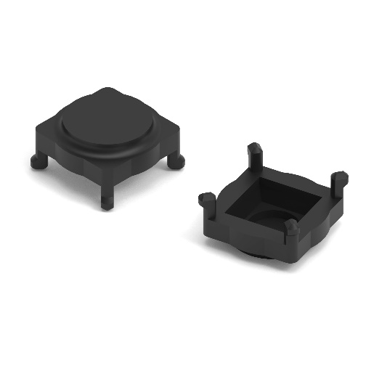  Image source: Würth Elektronik  The WSEN-ACCE filter cap is an easy-to-integrate accessory for Würth Elektronik’s WSEN-HIDS humidity sensor. | 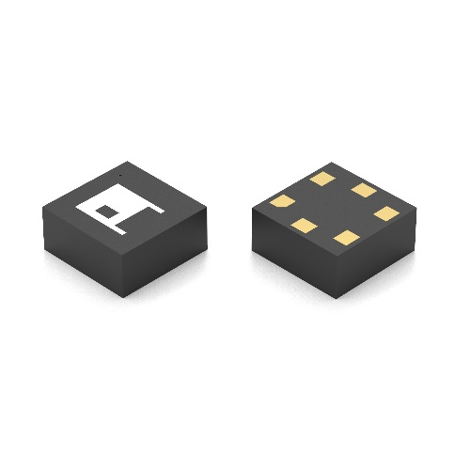  Image source: Würth Elektronik  WSEN-HIDS, the calibrated and temperature-compensated humidity sensor, can now be reliably used in harsh environments thanks to its new protective cap.

About the Würth Elektronik eiSos Group
Würth Elektronik eiSos Group is a manufacturer of electronic and electromechanical components for the electronics industry and a technology company that spearheads pioneering electronic solutions. Würth Elektronik eiSos is one of the largest European manufacturers of passive components and is active in 50 countries. Production sites in Europe, Asia and North America supply a growing number of customers worldwide.
The product range includes passive components, power modules, digital isolators, optoelectronics, electromechanical components, thermal management solutions, sensors and wireless modules. The portfolio is rounded off by customer-specific solutions.
The unrivaled service orientation of the company is characterized by the availability of all catalog components from stock without minimum order quantity, free samples and extensive support through technical sales staff and selection tools.
Würth Elektronik is part of the Würth Group, the global market leader in the development, production, and sale of fastening and assembly materials, and employs around 7,500 people. In 2024, the Würth Elektronik Group generated sales of 1.02 Billion Euro.
Würth Elektronik: more than you expect!
Further information at www.we-online.com

Further information:  Würth Elektronik eiSos GmbH & Co. KG  Sarah Hurst  Clarita-Bernhard-Strasse 9  81249 Munich  Germany  Phone: +49 7942 945-5186  E-mail: sarah.hurst@we-online.de  www.we-online.com | Press contact:  HighTech communications GmbH  Brigitte Basilio  Brunhamstrasse 21  81249 Munich  Germany  Phone: +49 89 500778-20  E-mail: b.basilio@htcm.de  www.htcm.de

