FOR THE MEDIA
ASMPT Semiconductor Solutions at ECOC 2025
Maximum precision for photonics
Regensburg (Germany), August 14, 2025 – ASMPT will be present when the ECOC 2025 Exhibition, Europe’s leading trade fair for optical communication, opens its doors in Copenhagen from September 29 to October 1. At Booth 1131 in Hall C of the Bella Center, the global market and technology leader in hardware and software solutions for semiconductor and electronics production will present forward-looking technologies for silicon photonics and co-packaged optics (CPO). The premiere of the MEGA-P multi-chip bonder will be a special highlight at the ASMPT booth.
With its long-standing expertise in interconnect technologies and its deep understanding of the challenges in optoelectronics manufacturing, ASMPT provides powerful answers to the growing need for the efficient integration of optical components, especially with regard to applications like high-speed data transmission, data centers, and future AI infrastructures.
MEGA-P: High-precision multi-chip packaging in a single platform
At ECOC 2025, ASMPT will unveil its new MEGA-P platform, a versatile solution for the precise and efficient packaging of complex multi-chip modules in the areas of photonics, sensor technology, and optical communication.
Thanks to its modular architecture, the MEGA-P combines a broad range of processes in a single system, including the application of adhesives, 3D post-dispense inspection, and a “look-through” bond head for maximum precision and UV curing. This allows even complex designs to be implemented flexibly and efficiently, for example in applications that call for the integration of lenses or photonic components.
With its intelligent process architecture and integrated automation, the MEGA-P combines several previously separate machine functions while maintaining high precision and adaptability. Users benefit from faster setups, more throughput and maximum flexibility in the face of changing requirements.
“The complexity of modern semiconductors poses new challenges, particularly where bonding technology is concerned,” explains Dr. Johann Weinhändler, Regional Head ASMPT Semiconductor Solutions and CEO of ASMPT AMICRA. “With the MEGA-P platform we have created a solution for tasks that previously required a complete machine line while delivering maximum flexibility thanks to its modular design.”
Precise solutions for co-packaged optics
At the ASMPT booth, visitors can also learn about high-precision manufacturing solutions for co-packaged optics, including the AMICRA NANO and AMICRA NOVA Pro systems, each of which is tailored to different requirements in optoelectronics integration.
The AMICRA NANO is designed for the greatest placement accuracy, making it ideal for research, prototyping and complex development projects. It enables the reliable processing of the finest structures and supports modern hybrid bonding processes for applications like the precise integration of photonics and electronics in the smallest of spaces.
The AMICRA NOVA Pro is designed for volume-oriented production. It features high processing speeds paired with high precision, making it particularly suitable for advanced packaging applications. With its automation and flexible material processing capabilities, it makes the mass production of photonics more flexible and scalable.

Illustrations for downloading
The following print-ready artwork is available on the internet for downloading:
https://kk.htcm.de/press-releases/asmpt/

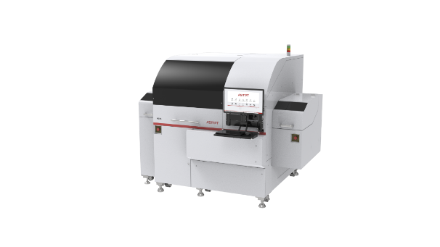 | 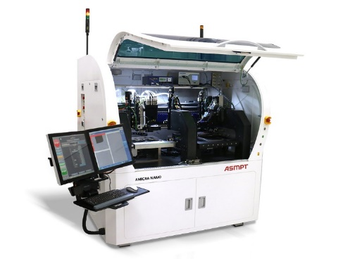
The MEGA-P chip bonder features high flexibility and a modular design while taking up little space (2,550 × 2,085 × 1970 mm or 100.4 × 82 ×77.6 inches).  Image credit: ASMPT | The AMICRA NANO high-precision die and flip-chip bonder was specially designed for the production of co-packaged optics and features a placement accuracy of ±0.2 µm @ 3 σ.  ± 0.2 μm at 3 σ.  Image credit: ASMPT
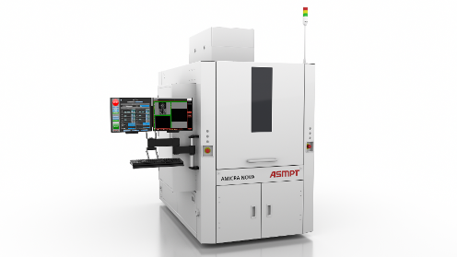
The AMICRA NOVA Pro meets the growing demand for die-bond- and flip-chip-capable machines with high throughput (UPH1000) and maximum precision in the 1-micron range.

Image credit: ASMPT

About ASMPT Limited (“ASMPT”)
ASMPT Limited is a leading global supplier of hardware and software solutions for the manufacture of semiconductors and electronics. Headquartered in Singapore, ASMPT’s offerings encompass the semiconductor assembly & packaging, and SMT (surface mount technology) industries, ranging from wafer deposition to the various solutions that organize, assemble and package delicate electronic components into a vast range of end-user devices, which include electronics, mobile communications, computing, automotive, industrial and LED (displays). ASMPT partners with customers very closely, with continuous investments in R&D helping to provide cost-effective, industry-shaping solutions that achieve higher productivity, greater reliability, and enhanced quality. ASMPT is a founding member of the Semiconductor Climate Consortium.
To learn more about ASMPT, please visit www.asmpt.com.

About ASMPT Semiconductor Solutions (“ASMPT SEMI”)
ASMPT SEMI is the leading provider of forward-looking solutions for advanced packaging and semiconductor assembly. With its commitment to innovation and customer satisfaction, ASMPT SEMI offers a comprehensive range of products and services that meet the evolving needs of the microelectronics industry. Expert knowledge covers areas such as flip-chip and wafer-level packaging, advanced interconnect technologies, and more. ASMPT SEMI’s state-of-the-art solutions enable customers to achieve higher performance, greater reliability, and improved cost-efficiency in the manufacturing of their semiconductor devices.
For more information about ASMPT SEMI, visit semi.asmpt.com.

Media contacts:
Global ASMPT Press Office
ASMPT Ltd
Susanne Oswald
Rupert-Mayer-Strasse 48
81379 Munich
Germany
Tel: +49 89 20800-26439
E-mail: susanne.oswald@asmpt.com
Website: asmpt.com

HighTech communications GmbH
Barbara Ostermeier
Brunhamstrasse 21
81249 Munich
Germany
Tel.: +49-89 500778-10|
E-mail: b.ostermeier@htcm.de
Website: www.htcm.de

