FOR THE MEDIA
ASMPT introduces MEGA multi-chip bonding platform
Multi-chip packaging with maximum precision and flexibility
Regensburg (Germany), August 6, 2025 – ASMPT SEMI, a leading provider of forward-looking solutions for advanced packaging and semiconductor assembly, sets the standard in precision and speed with its new MEGA multi-chip bonding platform. The new device family is characterized by high flexibility, a modular structure, and low space requirements. With 12k UPH, the MEGA-G version is designed for maximum speed. With the MEGA-P and its unprecedented precision of ±2 µm, ASMPT SEMI targets primarily photonics manufacturers.
The MEGA platform offers various epoxy dispensing and stamping functions as well as the ability to use multiple adhesives side-by-side while monitoring their application with a 3D inspection system. Even immediate fixation via UV curing is available. The picking and bonding arms operate independently of each other, with a flip-pick arm and a rotation unit for precise alignment located between them.
Flexibility also in feeding options
With its automatic bonding tool change capability, up to ten bonding tool buffers and five ejection tools, this extraordinarily versatile machine quickly adapts to new tasks. The MEGA is also highly flexible with regard to its wafer supply and the way it handles dies and substrates. For example, dies can be supplied via waffle packs, Gel-Paks, or an optional tape feeder station. The multi-chip bonder processes wafers with diameters of up to 12 inches and dies measuring 0.15 × 0.15 mm to 10 × 10 mm, as well as substrates measuring up to 130 × 300 mm.
The MEGA’s customizable options meet the packaging requirements of sophisticated multi-chip components and make it the bonder of choice for optical transceivers, photonics, sensors, and other highly advanced applications. To accomplish this, the MEGA-P model uses a patented high-precision bonding head with integrated optics that achieves a placement accuracy of ±2 µm and ±0.1 degrees.
“The MEGA multi-chip bonder performs, in a single machine, tasks that used to require a whole line of machines,” explains Dr. Johann Weinhändler, Regional Head ASMPT Semiconductor Solutions Europe and CEO of ASMPT AMICRA in Regensburg, Germany. “We have made sure that chip manufacturers still retain maximum flexibility. The machine’s modular structure also makes it customizable to the user’s specific needs, ensuring that one does not have to pay for functions that are not needed.”

Illustrations for downloading
The following print-ready artwork is available on the internet for downloading:
https://kk.htcm.de/press-releases/asmpt/

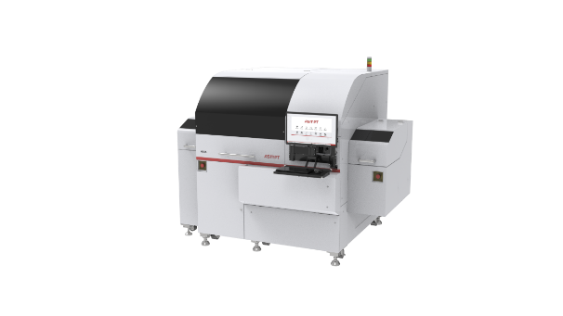
As a die bonder for high-performance computer chips, the MEGA perfectly meets the requirements for the next generation of server clusters and AI edge devices such as smartphones and advanced driver assistance systems (ADAS), as well as data and telecommunication applications.

Image credit: ASMPT

About ASMPT Limited (“ASMPT”)
ASMPT Limited is a leading global supplier of hardware and software solutions for the manufacture of semiconductors and electronics. Headquartered in Singapore, ASMPT’s offerings encompass the semiconductor assembly & packaging, and SMT (surface mount technology) industries, ranging from wafer deposition to the various solutions that organize, assemble and package delicate electronic components into a vast range of end-user devices, which include electronics, mobile communications, computing, automotive, industrial and LED (displays). ASMPT partners with customers very closely, with continuous investments in R&D helping to provide cost-effective, industry-shaping solutions that achieve higher productivity, greater reliability, and enhanced quality. ASMPT is a founding member of the Semiconductor Climate Consortium.
To learn more about ASMPT, please visit www.asmpt.com.

About ASMPT Semiconductor Solutions (“ASMPT SEMI”)
ASMPT SEMI is the leading provider of forward-looking solutions for advanced packaging and semiconductor assembly. With its commitment to innovation and customer satisfaction, ASMPT SEMI offers a comprehensive range of products and services that meet the evolving needs of the microelectronics industry. Expert knowledge covers areas such as flip-chip and wafer-level packaging, advanced interconnect technologies, and more. ASMPT SEMI’s state-of-the-art solutions enable customers to achieve higher performance, greater reliability, and improved cost-efficiency in the manufacturing of their semiconductor devices.
For more information about ASMPT SEMI, visit semi.asmpt.com.

Media contacts:
Global ASMPT Press Office
ASMPT Ltd
Susanne Oswald
Rupert-Mayer-Strasse 48
81379 Munich
Germany
Tel: +49 89 20800-26439
E-mail: susanne.oswald@asmpt.com
Website: asmpt.com

HighTech communications GmbH
Barbara Ostermeier
Brunhamstrasse 21
81249 Munich
Germany
Tel.: +49-89 500778-10|
E-mail: b.ostermeier@htcm.de
Website: www.htcm.de

