FOR THE MEDIA
ASMPT Earns Global Recognition for Outstanding Customer Service in 2025 TechInsights Survey
Awarded Commitment to Excellent Customer Service
Billerica (USA), July 31, 2025 – ASMPT has been recognised for excellence in the 2025 TechInsights Global Semiconductor Supplier Survey for the 12th consecutive year. This year, it was ranked third for excellence in customer service among large equipment suppliers.
The annual TechInsights Global Semiconductor Supplier Survey gathered over 28,000 responses from semiconductor manufacturers and subsystem users, covering more than 46 percent of the global chip market. Participants evaluated suppliers on criteria such as product quality, customer service, and performance.

“This recognition validates the trust our customers place in us and reflects our continued focus on innovation and service,” said Jean-Marc Peallat, PhD, Regional Head ASMPT Semiconductor Solutions Americas, and General Manager ASMPT AEi Inc. in Billerica, Massachusetts. “Our goal is to support our clients as they navigate rapid advancements in AI, packaging, and process technologies.”

ASMPT was recognised for its innovative strength, strong customer relationships and adaptability in a volatile supply chain landscape, given the rapid technological advances in AI and advanced packaging. The ranking emphasises ASMPT's important role in driving the development of the semiconductor industry.

Illustrations for downloading
The following print-ready artwork is available on the internet for downloading:
https://kk.htcm.de/press-releases/asmpt/

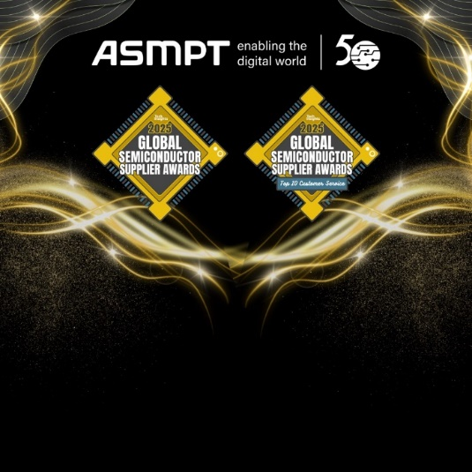 | 
ASMPT marking twelve years of exceptional customer satisfaction in the 2025 TechInsights Customer Satisfaction Survey  Image credit: ASMPT | Jean-Marc Peallat, PhD, Regional Head ASMPT Semiconductor Solutions Americas, and General Manager ASMPT AEi Inc. in Billerica, Massachusetts (USA)  Image credit: ASMPT

About TechInsights
Regarded as the most trusted source of actionable, in-depth intelligence related to semiconductor innovation and surrounding markets, TechInsights’ content informs decision makers and professionals whose success depends on accurate knowledge of the semiconductor industry—past, present, or future. Over 650 companies and 100,000 users access the TechInsights Platform, the world’s largest vertically integrated collection of unmatched reverse engineering, teardown, and market analysis in the semiconductor industry. This collection includes detailed circuit analysis, imagery, semiconductor process flows, device teardowns, illustrations, costing and pricing information, forecasts, market analysis, and expert commentary. TechInsights’ customers include the most successful technology companies who rely on TechInsights’ analysis to make informed business, design, and product decisions faster and with greater confidence. For more information, visit www.techinsights.com.

About ASMPT Limited (“ASMPT”)
ASMPT Limited is a leading global supplier of hardware and software solutions for the manufacture of semiconductors and electronics. Headquartered in Singapore, ASMPT’s offerings encompass the semiconductor assembly & packaging, and SMT (surface mount technology) industries, ranging from wafer deposition to the various solutions that organise, assemble, and package delicate electronic components into a vast range of end-user devices, which include electronics, mobile communications, computing, automotive, industrial and LED (displays). ASMPT partners with customers very closely, with continuous investment in R&D helping to provide cost-effective, industry-shaping solutions that achieve higher productivity, greater reliability, and enhanced quality.
To learn more about ASMPT, please visit us at asmpt.com.

About ASMPT Semiconductor Solutions (“ASMPT SEMI”)
ASMPT SEMI is the leading supplier in advanced packaging and semiconductor assembly solutions. With a commitment to innovation and customer satisfaction, ASMPT SEMI provides a comprehensive range of products and services that cater to the evolving needs of the microelectronics industry. Their expertise spans across areas such as flip-chip and wafer-level packaging, advanced interconnect technologies, and more. ASMPT SEMI's cutting-edge solutions enable customers to achieve higher performance, increased reliability, and improved cost-efficiency when producing their semiconductor devices.
For more information about ASMPT SEMI, visit semi.asmpt.com.

Media contacts:
Global ASMPT Press Office
ASMPT Ltd
Susanne Oswald
Rupert-Mayer-Strasse 48
81379 Munich
Germany
Tel: +49 89 20800-26439
E-mail: susanne.oswald@asmpt.com
Website: asmpt.com

HighTech communications GmbH
Barbara Ostermeier
Brunhamstrasse 21
81249 Munich
Germany
Tel.: +49-89 500778-10|
E-mail: b.ostermeier@htcm.de
Website: www.htcm.de

.

