PRESS RELEASE
hyperMILL® Integrates MachiningCloud Data for Enhanced Manufacturing Efficiency
CAMARILLO, CA (USA), Wessling (Germany), July 31, 2025 – OPEN MIND Technologies, the developer of the leading CAD/CAM software hyperMILL®, and MachiningCloud, the leading provider of cutting tool data, today announced a significant integration that allows hyperMILL® users to access and utilize comprehensive tooling data directly from the MachiningCloud platform.
This integration streamlines the tool selection and programming process within hyperMILL®; by accessing detailed tool specifications, recommended cutting parameters, and 3D models, hyperMILL® users can significantly reduce programming time, minimize errors, and optimize machining strategies for greater efficiency and higher quality parts.
MachiningCloud offers a vast and growing library of cutting tool data from the world's leading manufacturers. Alan Levine, Managing Director OPEN MIND Technologies USA shared his thoughts to this partnership: “We are happy to announce this collaboration as this integration ensures that hyperMILL® users have access to the latest tool catalogs and application data, facilitating the selection of the most appropriate tools for their specific machining tasks.”
“Our mission at MachiningCloud is to empower manufacturers with the digital tools they need to thrive,” stated Matthew Nicholson, director of Sales and Marketing at MachiningCloud. “This collaboration with OPEN MIND and the integration with hyperMILL® provides a direct and seamless connection to our extensive tooling knowledge base, enabling hyperMILL® users to leverage the power of digital tooling data for optimized programming and machining.”
Both companies expressed their strong commitment to this partnership and their shared vision of continuously strengthening the integration to provide even greater value to their mutual customers in the future.

Available images
The following images are available for download in printable format at:
https://kk.htcm.de/press-releases/open-mind/
  Source: OPEN MIND  Alan Levine, Managing Director at OPEN MIND Technologies USA |   Source: MachiningCloud  Matthew Nicholson, Director of Sales and Marketing at MachiningCloud

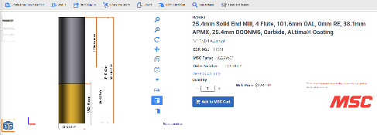
Source: MachiningCloud
Product page in MachiningCloud

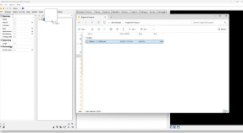  Source: MachiningCloud  Easily import MachiningCloud XML file into hyperMILL® Tool Database | 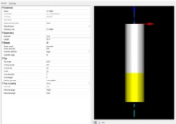  Source: OPEN MIND  Imported tool in hyperMILL®

About MachiningCloud
MachiningCloud is the premier data-driven resource revolutionizing the way manufacturers find, select, and utilize cutting tools, workholding, and machines. More than just a parts catalog, the platform provides a comprehensive and connected digital ecosystem including rich and standardized product data, Intelligent tool selection, comprehensive feeds and speeds, and much more.
By bridging the gap between physical tools and the digital world, MachiningCloud helps manufacturers achieve greater efficiency, reduce costs, and improve overall productivity. It's the essential platform for anyone looking to make smarter, data-driven decisions in their machining operations.
You can find more information at: https://www.machiningcloud.com/

About OPEN MIND Technologies AG
OPEN MIND Technologies AG is one of the world’s leading developers of powerful CAD/CAM solutions for machine and controller-independent programming.
OPEN MIND develops optimized CAD/CAM solutions that include innovative and unique features that can deliver significantly higher performance in both programming and machining.
hyperMILL® is a completely modular CAD/CAM solution that provides state-of-the-art CAM technologies on its own CAD platform: from 2.5D, 3D and 5-axis machining as well as turning strategies and solutions for additive manufacturing, HSC and HPC machining. Whether automation, simulation or virtual machine – trendsetting technologies expand the product range and enable continuous digital process chains. Special applications, seamless interaction with all popular CAD solutions and exceptional customer service rounds out the company’s products and capabilities.
According to the “NC Market Analysis Report 2024” compiled by CIMdata, hyperMILL® is a leading, worldwide CAD/CAM solution. Innovative CAD/CAM technologies fulfill the highest demands in the aerospace, automotive, tool and mold manufacturing, production machining, medical, job shops, energy and semiconductor industries.
OPEN MIND's majority stake in manufacturing execution system (MES) developer Hummingbird expands the CAD/CAM manufacturer's product portfolio and enhances the range of connected digitalized manufacturing technologies.
OPEN MIND is a Mensch und Maschine company and has subsidiaries and qualified sales partners on all continents.
You can find more information at www.openmind-tech.com.

OPEN MIND Technologies UK Ltd., Oxford
Unit 3
Bicester Business Park
Telford Road
Bicester
Oxfordshire OX26 4LN
England
Phone: +44 1869 290 003
Fax: +44 1869 369 429
E-mail: Info.UK@openmind-tech.com

OPEN MIND Technologies USA, Inc.
1492 Highland Avenue, Unit 3
Needham MA 02492
USA
Phone: +1 339 225 4557 office
Phone: +1 888 516 1232 x0 toll-free
Fax: +1 270 912 5822
E-mail: Info.Americas@openmind-tech.com

OPEN MIND Technologies Asia Pacific Pte Ltd
MOVA Building, 22 Jalan Kilang #03-00
Singapore 159419
Phone: +65 6742 95-56
E-mail. Info.Asia@openmind-tech.com

Head office:
OPEN MIND Technologies AG, Argelsrieder Feld 5, 82234 Wessling, Germany
Tel.: (+49-8153) 933-500, Fax: (+49-8153) 933-501
E-mail: Info@openmind-tech.com, website: www.openmind-tech.com

Press contact:
HighTech communications GmbH
Brigitte Basilio
Brunhamstrasse 21
81249 Munich
Germany
Tel.: (+49-89) 500778-20
E-mail: b.basilio@htcm.de
Website: www.htcm.de

