

***NEWS RELEASE***

For Release: **IMMEDIATELY With Art:**  Three Digital Images

Editorial Michael McCue OPEN MIND Alan Levine

Contact: McCue & Associates LLC Contact: OPEN MIND Technologies USA, Inc.

978-733-1353 339-225-4557 [mmccue@mccueassociates.com](mailto:mmccue@mccueassociates.com) [alan.levine@openmind-tech.com](mailto:alan.levine@openmind-tech.com)

**OPEN MIND To Demonstrate Precision Strategies in**

**Advanced *hyper*MILL® 2025 CAD/CAM Software Suite at Meximold**

***Strategies for Higher Machining Safety, Superb Bottle Mold Finishes***

***and Easier Deburring to be Featured.***

*NEEDHAM, MA U.S.A.* *(July 28, 2025) –* [OPEN MIND Technologies](https://www.openmind-tech.com/es/), a leading developer of CAD/CAM software solutions worldwide, will be highlighting the advanced capabilities of its latest *hyper*MILL® 2025 CAD/CAM software suite at **Meximold Booth #100 located at the Querétaro Centro de Congresos in Querétaro, México from October 22-23, 2025.** Efficient programming and machining strategies in high performance *hyper*MILL® enable accurate, efficient 2.5D, 3D, 5-Axis and mill/ turn machining.

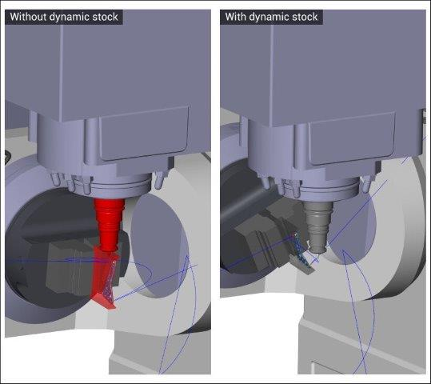For increased machining safety, ***hyper*MILL® VIRTUAL Machining** provides postprocessing, and G-code simulation including a VIRTUAL Machining Optimizer which improves toolpaths that are traditionally calculated in the CAM engine. The Optimizer also incorporates knowledge of the part model, tooling, the toolpath calculation and collision check engine, and the machine tool model (a.k.a. digital twins) with its physical constraints. *hyper*MILL® VIRTUAL Machining Optimizer features linking logic for 5-axis table-table machines, linking individual part programs by automatically calculating smooth and safe connections between a retract move and subsequent insert, including optimization of clearance planes.

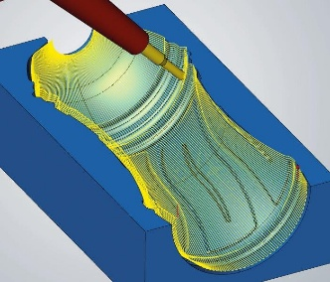Linking movements via *hyper*MILL® VIRTUAL Machining Optimizer have been further enhanced for actual stock conditions with *new* Dynamic Stock technology. Using Dynamic Stock, an updated stock is automatically generated for all machining jobs and accounted for when calculating linking movements.

Linking with *hyper*MILL® Dynamic Stock technology

For optimal surface quality, especially in bottle mold applications, Meximold attendees will also learn about the *hyper*MILL® 5-axis Radial Machining strategy which provides improved handling of 5-axis machining parameters due to True-Shape Technology. An “Interpolate between lines” option allows users to manually determine the axial inclination of the tool simply by defining inclination lines along the center curve. With the option “True-Shape Point Distribution”, users achieve an optimal point distribution for milling, ensuring ideal surface quality and consistent machine movements.

hyperMILL® 5-axis Radial Machining

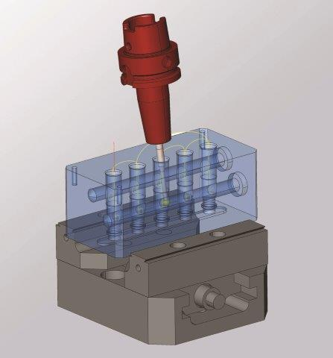A new, fast, easy, and safe **5-axis hole deburring strategy** excels at deburring sharp edges on holes and intersecting holes. By using CAM Plan programming assistance and analysis technology to automatically recognize all the holes, the sharp edges in the model are marked for selecting the desired edges. The hole deburring technology automatically calculates tool paths and supports 3-axis and 5-axis modes. Also, *hyper*MILL® now offers a 5-axis deburring strategy for fast and efficient deburring of component edges. Users may choose between 3-axis machining and a 5-axis option which enables greater reach to more component edges, automatically generating the required inclinations as well as collision avoidance.

5-axis Hole Deburring with *hyper*MILL® 2025

For more information about *hyper*MILL® visit, <https://www.openmind-tech.com/es/>.

About OPEN MIND Technologies AG

OPEN MIND Technologies AG is one of the world’s leading developers of powerful CAD/CAM software solutions for machine and controller-independent programming. OPEN MIND develops optimized CAD/CAM solutions that include innovative and unique features that can deliver significantly higher performance in both programming and machining. *hyper*MILL® is a completely modular CAD/CAM solution that provides state-of-the-art CAM technologies on its own CAD platform: from 2.5D, 3D and 5-axis machining as well as turning strategies and solutions for additive manufacturing, HSC and HPC machining. Whether automation, simulation or virtual machine – trendsetting technologies expand the product range and enable continuous digital process chains. Special applications, seamless interaction with all popular CAD solutions and exceptional customer service rounds out the company’s products and capabilities.

According to the "NC Market Analysis Report 2024" compiled by CIMdata, *hyper*MILL® is a leading, worldwide CAD/CAM solution. Innovative CAD/CAM technologies fulfill the highest demands in the automotive, tool and mold manufacturing, production machining, medical, job shops, energy, semiconductor and aerospace industries.OPEN MIND is a Mensch und Maschine company and has subsidiaries and qualified sales partners on all continents. You can find more information at<https://www.openmind-tech.com/en-us/>.

# # # # #